TOWN OF BERGEN NEWSLETTER
December 2015, January and February 2016

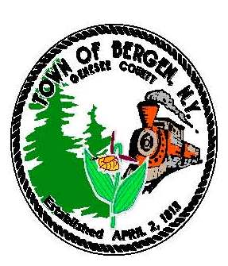

Town News … From the Desk of Town Supervisor Donald Cunningham
This season has seen a nice weather transition compared to a year ago, but soon our highway crew will be servicing roads for snow and ice control. They do a great job keeping our roads maintained during the winter months but we always ask motorists to be extra cautious during snow and freezing conditions. When approaching plow trucks, please maintain a safe distance and be respectful of the operators. Coming Soon - Look for improvements at the Library building. As part of a grant reward and matching funds from the town, the building at 13 S. Lake will continue to see needed upgrades including windows, and paved parking area. The 2016 budget has also been developed to include funds for replacing the tired HVAC system serving that building. Much of this work may not begin until the spring of 2016.
The 2016 Budget
The 2016 budget has been adopted and the Town Board worked hard at developing a budget without an increase in the tax rate. The total tax levy will see an increase due to adjustments in assessments and that increase will be above tax cap levels outlined by the state. The board remains committed to taking care of the needs of the town as a primary objective during budget development and with various adjustments, and anticipated improvements, it was impossible to stay within state recommended limitations. I appreciate the cooperative effort on the part of the board in putting together a comprehensive yet practical budget. Reminder – Shop Genesee County for the holidays, and always, to keep your sales tax dollars local!
America’s Best Communities initiative…
A community revitalization plan was finalized and submitted for consideration to advance LeRoy and Bergen to the next round of this competition. A lot of work was put into this effort involving officials from the Town & Villages of LeRoy and Bergen along with county legislators, representatives from GCEDC, and Camoin Associates. The submitted plan is strong and compelling. It’s been a pleasure working with this committee team and I look forward to continuing into the next round. We will know results in the latter part of January 2016.
A Tribute to Barry Miller…
The sad news came on September 23rd that Barry Miller had been tragically killed in an accident while on an ambulance call and the town lost a faithful community servant. Barry gave 32 years as a volunteer in the Bergen Fire Department, was a member of the Town Board for 8 years, and was actively serving as the County Coroner. Barry was a lifelong resident of Bergen and founded Millers Millworks which he headquartered at the former bean mill
on Lake Ave. next to the railroad. Beyond his business activity and public duties, Barry
was always a “go to” person for any project. He was very giving of his time and resources
and the entire town benefited from his charitable spirit and willingness to help.
Unfortunately this brief newsletter article will scarcely impart all his attributes and
contributions but we grateful for all he gave to our little town and the surrounding area.
It was a pleasure serving with him on the town board and a privilege to be his friend.
He will be sorely missed in Bergen and our thoughts and prayers remain with his family.
Best Wishes for a Merry Christmas and Happy New Year!



Bergen Fire Department by Eric Wies

On September 23, 2015, the Bergen Fire Department experienced a tragic event that resulted in the loss of our brother and friend Barry Miller. Barry was a dedicated 32 year active member of the Department who put serving the community a priority. That was evident up until the moment he lost his life, as that morning we received a call for a person having chest pains in the Town of Riga. As expected, Barry put his day on hold to help out and responded to the medical call. Within 10 minutes of receiving the call to help someone else, Barry’s life was tragically ended in an accident involving our ambulance.
The days leading up to the funeral were a trying time for the members of the Bergen Fire Department. Balancing the grieving process with the desire to honor his life with a full fire department funeral, while ensuring the fire protection in the community was maintained, proved to be the biggest challenge we have ever faced. This challenge could not have been met without the support from the people in the Bergen community. Thank You.

We thank the many people and businesses that donated time, food, and money to support our members and Barry’s family. We thank the local church leaders that provided the spiritual support to our members and the community. We thank the United Methodist Church for opening their doors to accommodate the calling hours and the traffic associated with a fire department line-of-duty death. We thank the Town and Village, along with the countless volunteers that hung black and purple ribbons on every telephone pole from Stone Church to the Town of Sweden. We thank the people that turned out the night of September 23rd to participate in a vigil with us. We thank the H.E. Turner & Co., Inc. Funeral Home for their commitment and countless hours they spent ensuring Barry was laid to rest properly. Thank You.

We would like to offer a special thanks to the team at Miller’s Millworks. A tradition in the fire service is to transport the casket of the fallen brother or sister on a fire truck. We were honored to continue this tradition, but quickly realized that loading and unloading the casket to the top of our fire engine (over 8-feet tall) would prove to be difficult. The team at Miller’s Millworks had a solution. In a matter of days, they designed and built a platform with stairs. The platform was painted black, had non-slip material on the walking surfaces, engraved brass plates, and hand sewn bunting down the sides. Not only was the platform beautiful, it was designed to be quickly taken apart and transported between the locations where the casket was loaded and unloaded. If you happen to run into someone that works for the Millworks, please shake their hand or give them a hug. They deserve it. Thank You.

Last, we thank everyone that simply offered to help, even though we could not find a way to take you up on the offer. Thank You. We would like to inform the community of the game plan going forward in regards to the ambulance. A few days after the funeral a meeting was held with the members of the Rescue Squad and the meeting was closed with a unanimous decision to replace the ambulance, continuing the mission that Barry was so passionate about. Since that date, we have been going through the process to select the new ambulance and hope to have one ordered by the end of 2015.While we don’t know when the new ambulance will be delivered and placed into service, we will continue to respond to emergency medical calls. However, until our new ambulance arrives, Mercy EMS will be responding with us to provide the means to transport the person in need to the hospital.

The Merriam-Webster Dictionary defines the word “community” as “a group of people with a common characteristic or interest living together within a larger society”. In today’s society we seem to forget what it means to be a community, but hopefully after September 23, 2015, everyone in the Town and Village of Bergen will always remember. We know the members of the Bergen Fire Department will.

Based on the turn-out from the community at the calling hours and the funeral, it was apparent that many people in Bergen either knew Barry or were touched by him in some way. If you did not have the privilege to know Barry, the information below should give you a brief glimpse into the life he lived. As you can see, Barry knew the meaning of “community”. The loss of Barry left a huge void in the Bergen Fire Department and in the community. We hope that you will help fill this void and get involved in some way with the community we live in. You could run for a board position with the Town or Village, volunteer for a community event such as Park Days, hand out hot chocolate when the Village Christmas tree is lit, get involved with the school district, join the Bergen Fire Department, or simply help a neighbor in need by shoveling out their driveway. An act as simple has supporting our local businesses has a huge impact. Barry will be missed by everyone who knew him and by those he helped, although we know we will see him again someday. Please visit our Facebook page at https://www.facebook.com/Bergenfiredepartment.

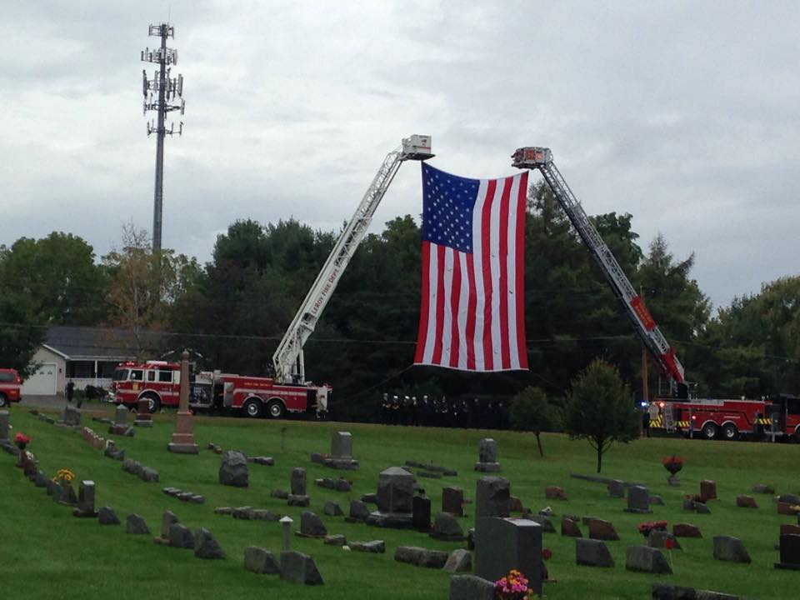
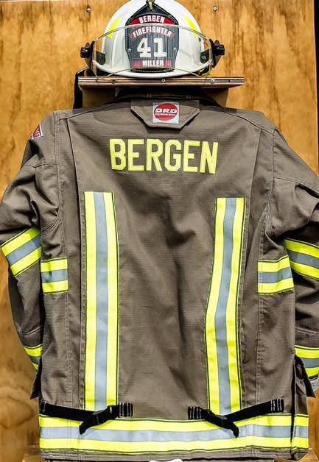
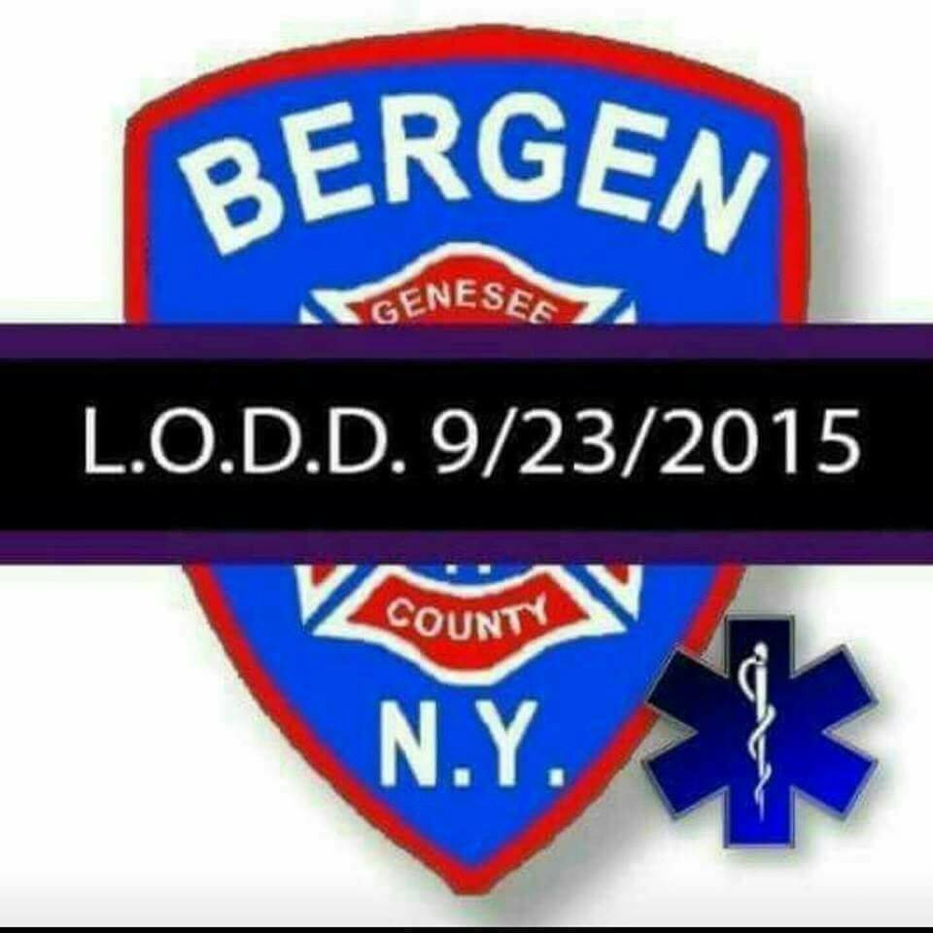
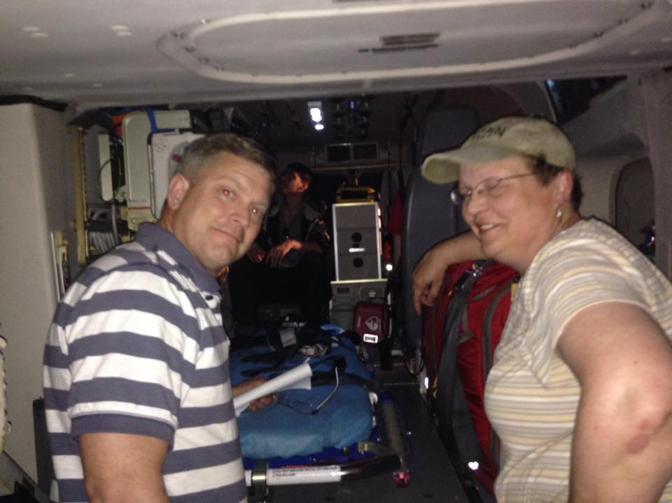
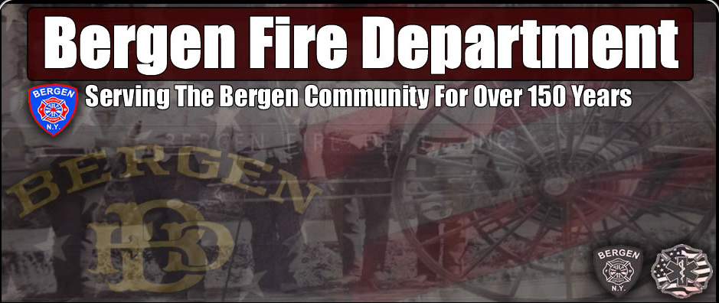

From the Desk of County Legislator Robert Bausch
I would like to begin by thanking the voters in Legislature District 2 for their support on Election Day. It was gratifying that a A significant number of residents took the time to vote. So again, thank you. When the county legislature
reorganizes in January, there will be a few changes. Frank Ferrando from District 7 (east end of the City
of Batavia) did not seek reelection. I have known Frank for many years and have enjoyed working with him. The new legislator will be John Deleo who has served in various capacities for the City of Batavia and brings a wealth of
experience to the legislature. The only other change in the legislature is that Sarah Kingdon, who has served as the Legislative Clerk, is transferring to the County Attorney’s Office. The recruitment process for her replacement is just beginning.

There will be three other changes in county government in January. Don Read, who had been County Clerk for 25 years retired in September. Michael Cianfrini, who was Don’s assistant, was elected to fill the position. Mike is an attorney and had practiced law in Oakfield prior to accepting the Assistant Clerk position. County Court Judge Robert Noonan, who has held his position for 17 years, is retiring January 1st. This position will be on the ballot next November, but the governor can appoint a judge to serve until the election. In the interim, a judge from outside the county will preside in county court.
Lastly, and sadly, with the sudden death of Barry Miller, a county coroner position was vacant. Bergen residents knew and appreciated what Barry contributed in so many areas. However the outpouring of sympathy from across the county made me realize the extent of his involvement in the county and region. He will definitely be missed. Jeffery McIntire from Oakfield was elected to fill that position in the November elections.
A few updates on county business: The 2016 county budget was passed without a property tax increase. The nursing home sale is moving forward, hopefully closing by July 1st. Construction of the new airport terminal is progressing and should be open in early spring as scheduled. Immediately after the terminal is opened, the old terminal will be removed and the area renovated to serve as an apron for the new terminal. In closing, I would like to wish everyone Merry Christmas and Happy New Year and I look forward to serving District 2 residents in the coming year.
Highways & Byways by Superintendent Mike Johnson
Please be reminded that during a “normal” snow event, it will take plow trucks 2 ½ to 3 hours to complete one pass on all roads. As such, it is very possible that everyone will encounter less that pleasant driving conditions at times. Late evenings and early mornings, with very light traffic volumes, will received lower levels of service. Ever y attempt will be made to maintain open and passable roadways, both for normal and emergency traffic. At times, lanes may narrow and accumulate snow. The Town is responsible for snow and ice removal on all Town and County roadways in Bergen as well as State routes. This winter, as in the past, we will strive to provide the same level of the safest possible roadways at all times, within reason and budget constraints.
Also remember to use caution on snow covered roads. Here are a few safety tips: Slow Down, Make safe lane changes, pump your brakes on slick roads, and lastly don’t tailgate, especially the plow truck. If you can’t see him in his side mirror there is a good chance he can’t see you! And for on First Aid rule: Carbon Monoxide is called “the silent Killer” if you go off the road keep your exhaust clear of snow.
Two additional reminders: Mailboxes, if damaged by our plows will be repaired or replaced, within Town Board adopted limits, as soon as weather, time permits. PLEASE, when installing or repairing your mailbox, remember that our trucks require a minimum 17 ½ feet from center of the roadway. Also, take into account the excessive force of the exhausted snow as it strikes your mailbox assembly. Please don’t hesitate to call me at 494-1362 if I may be of service. Highway Department hours are 7:00 am – 3:30 pm Monday thru Friday. However, you may leave a message 24 hours a day on our answering machine, and I will return your call as soon as possible. In closing, the entire highway department would like to wish everyone a healthy and happy holiday season, and a safe winter.

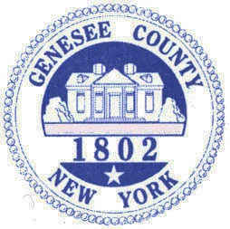

Happy Holidays!! During your holiday rush of activities don’t forget to enjoy the many holiday books and movies available at your Library! We have cook books for meals on the go as well as baking cookbooks for the perfect Christmas cookie! Stop by when the children are on vacation for boredom buster books and craft books to inspire their imaginations. Don’t forget your audio books for the long car rides to Grandma’s house! Search our website at www.byron-bergenpubliclibrary.org and check out Library happenings as well as our on-line catalog or join us on Facebook and Twitter too!
The Holiday Library hours will be:
Tuesday Dec. 22nd10am-12pm and 2pm-8pm
Wednesday Dec. 23rd- 10am-12pm and 2pm-8pm
Thursday Dec. 24th – 10am – 4pm
Friday Dec.25thand Saturday 26th - Closed
Tuesday Dec. 29th 10am-12pm and 2pm-8pm
Wednesday Dec. 30th10am-12pm and 2pm-8pm
Thursday Dec. 31st -10am-4pm
Friday Jan.1^{st and} Saturday Jan. 2nd- Closed.

Holiday Happenings-
Holiday Make and take Craft night on Wednesday December 23rd from 3pm to 6pm- come join us as we make a special gift to give. Call the Library for more information.
Movie Day Wednesday Dec.30th at 2:30pm come watch “Pan” on the big screen! This movie is rated PG and runs 111 minutes. Join us for popcorn and drink too! Registration is appreciated.
Pre-school story time will run Fridays at 10:30am starting on January 15th. Join us for a story, craft and a treat! This is recommended for ages 2-5 but younger children are welcome with their parents/guardian. Registration is appreciated.
Our “Tale for Three Counties” book for 2016 will be Black River by S.M. Hulse. This is a beautifully written novel of emotional force that you will not forget. A fiddler, a prison riot, and broken relationships are the crux of this novel. S.M. Hulse will visit in our area March 10th to both Genesee Community College at 1pm and the Richmond Memorial Library at 7pm. Log on to www.byron-bergenpubliclibrary.org and reserve your copy of the book now. Our community wide book discussion will be held on Thursday, March 3rdat 7pm. Join us as we explore the book and its characters!! Share your views of the book with your neighbors and friends. Refreshment served. No registration needed.
Gadgets and Gear Wednesday February 3rd from 3-6 pm- bring your questions and gadgets- E-readers, phone, laptops and tablets so we can help you get e-books and more using your Library card. Registration is necessary by calling 494-1120 or stopping in.
February Break Happenings! Look upcoming activities during winter break– check us out on the web at www.Byron-BergenPublicLibrary.org.
Babysitting workshop will be held on Wednesday Feb. 17th from 9am to 2pm. This workshop is open to anyone 11yrs. old and up. Cost $45- includes a book to take home to reference. Registration and payment (cash only) is needed by Saturday February 13th- Space is limited so sign up soon!
Did you know that the Library has free digital magazines? Check it out on our website at www.byron-bergenpubliclibrary.org . All you need is a valid Library card. Click on Zinio – sign in with your Library Card and you are on your way!
(Continued)



Getting a new E-Reader for Christmas or have one now…..Check out our catalog for downloadable e-books free with a valid Nioga Library card. Coming soon- Digital movies- music- eBooks- and audio books through HOOPLA!
New children’s books arrive weekly! New DVD’s monthly! All you have to do is stop at our website www.byron-bergenpubliclibrary.org to order all materials!
If you don’t find what you are looking for at the Library, we can order it for you from the NIOGA Library System. The website is www.byron-bergenpubliclibrary.org and click on catalog to see if our system has the book you are looking for. You then can order online, call the Library at 494-1120 or stop in with your request.
The Library has copy /fax service for a small cost, Roadrunner Internet on three computers, Wi-Fi and interlibrary loans from any Library in the NIOGA Library system. Check us out on the web at www.byron-bergenpubliclibrary.org or stop in and we will assist you! You can also friend us on Facebook and follow is on Twitter to keep up with the latest events. For more information on our services or programs, please call the Library at 494-1120.
Happy Reading and Happy Holidays-
Nancy Bailey
Library Manager

Community Christmas Activities

Annual Village Tree Lighting will be held Friday Dec 4th
Carolers meet at 6:30 pm in Hickory Park to escort Mr. and Mrs. Claus to Ward Park
Ward Park festivities include meeting the Clauses, tree lighting, hot cocoa and cookies, elementary band, food donations, decorated trees by community organizations, etc.
Bus provided to ride back to Hickory Park
For further information contact the village office 494-1513

Saturday, December 5th 6:00 PM
Bergen Community Christmas Concert
Bergen First Presbyterian Church
38 Lake Ave, Bergen, NY

Join us for an evening of Christmas music performed by members of the community. Young and old are welcome to attend. Special Family Friendly seating available this year, bring all your little ones! Cookies and cocoa to follow. Questions about attending or performing? Contact Jocelyn Rebisz, 494-6031.

Thursday, December 10th 6:30 – 8:00 pm
Step Boosters Cookies and Milk with Santa – BB Elementary School
Visit with Santa and Mrs. Claus, cookie frosting and hot cocoa

Saturday, December 12th
Santa’s Workshop
9:00 am – 2:00 pm Gillam-Grant Community Center

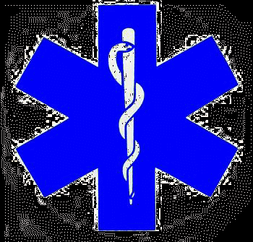




Historian News by Thomas Tiefel
As 2015 draws to a close, I am looking forward to what will hope to be another prosperous year for the Harford Museum in 2016. As usual, the work will continue through the winter months inside to bring the existing exhibits to life. I plan to have some new featured artifacts on display as well as a new featured exhibit. On that note, I wish to give a big thank you and a warm welcome to my Genesee Community College intern, Gina Schelemanow. Gina is a sophomore that is majoring in history. Gina is also a member of the GCC History Club and writer for the club’s online blog. She has wasted no time in getting things at the Historian’s office whipped into shape. Gina has made the backlog of sorting and filing look easy. She also has brought some great ideas to the table as well as serving as a connection with GCC by writing some fantastic stories about Bergen’s past and posting them to the college’s online blog.
I wish to add that I think more online exposure is something definitely worth looking into. As the age of modern tech advances, we must understand what kind of media resources our youth most frequently use. In most of today’s society, the World Wide Web is king. The number of people who actually read hard copy text (newspapers etc) is rapidly dwindling. In the coming months, I will be investigating how and what can be accessible in reaching out to our next generation of historians. To keep history alive is to keep it interesting
Last but not least, I wish to thank everyone who came to visit the Harford Livery Museum this year and tell you all to come back next year to check out what’s new!
Remember to “find us on Facebook!” You can like us at the Harford Museum Face Book Page. Check us out and take a trip down memory lane!
As always, the historian’s office is located at 15 S. Lake Ave in the village of Bergen. If you would like to contact me for any reason, feel free to call 585-494-0080 and I will be happy to assist you!
Happy Holidays!
THE AMERICAN LEGION NEEDS HELP FROM THE COMMUNITY:
Our post is looking for the Town and Village of Bergen residents to stand up for our deceased Veterans
that have been buried in Mr. Rest and St. Brigid’s cemeteries in Bergen. Many of you know that the Veterans flag markers were taken and we would like to have as many of the 218 missing to be replaced for Memorial Day 2016. The cost of the markers is $6994.70 this would put a burden on our funds because way over two thirds of what we have is donated to residents of the Town and Village each year around the holidays for those in need. We also support the Boys and Girls State, scholarships for Byron-Bergen Central School and the soccer program at the Gillam-Grant Community Center to list a few.

Last but not least we have always supported our Veterans Hospitals and Nursing Homes in our area. Area Veterans have come to the post for information on their heath care at the V.A. Hospitals and education funding and are given information they need. No one has ever been turned away or ever will be. They also don’t have to be a member just a Veteran and of course are brothers forever.
We have now set up a memorial fund so that people can send tax deductible donations to the Sackett-Merrill-White Post #575 21 N. Lake Ave., P.O. Box 207 Bergen, NY 14416.
Please support our deceased Veterans buy showing that you care about the country that they kept free for you to live in. Thank you and may God Bless America.
Thomas F. Williamson, Commander

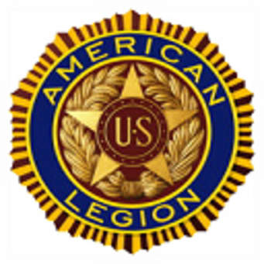

Town Clerk News by Michele M. Smith
I want to thank the residents of Bergen for the over whelming support in my re-election as
Town Clerk. I enjoy serving our community and look forward to another 4 year term.

Town & County Taxes
If you pay your own taxes, you will receive your tax bill shortly after January 1, 2016. If you should receive a tax bill that an escrow company or someone else is supposed to pay, please call me right away. Don’t put it aside and assume that it will be paid. Also, if you have paid off your mortgage and did not receive a tax bill, you should call me. No matter what the situation is, you are responsible for your taxes and penalties, if it is not paid. If you are leaving town for the winter please leave your “winter” address with me so late fees can be avoided. Credit cards (Visa, MasterCard & Discover) are now accepted for payment with a convenience fee.
Tax payments cannot be received before January 1, 2016 per the County Treasurers office, all payments will be stamped after that date. Taxes are due January 31st, since it falls on a Sunday payments will be accepted on Monday without any penalties. All taxes have to be paid to me by March 31st. After March 31st, the unpaid taxes are returned to the County Treasurer. If you are going to pay them to the County Treasurer by mail, you will need to call his office in Batavia. The telephone number is 344-2550, ext. 2211 as there will be additional penalties.

Dog License News:
I hate to “hound” you, but if your dog’s license renewal is due or past due, please take care of it so we don’t have to send you a reminder notice or eventually a court appearance ticket. All dogs, four months of age need to be licensed even those in apartments. Proof of a rabies vaccination and proof of neutering or spaying must be presented at the time of licensing. If you receive an appearance ticket, you will have to pay a fee of $25.00 plus also pay for your dog’s renewal. If there is a problem getting an appointment for a rabies vaccination, etc., please call me. I have an answering machine so you can call anytime day or night.
Office Closing Office Hours
December 25, 2015 – Christmas Monday, Tuesday, Wednesday and Friday
January 1, 2016 – New Years 8:00 am – noon & 1:00 – 4:00
January 18, 2016 – Martin Luther King Jr. Day Saturday 9:00 am - noon
February 15, 2016 – Presidents Day Closed on Thursdays

The Bergen Town Board is looking for a resident that would like to represent
the Town for the Black Creek Watershed Coalition. If interested please contact
the Town Clerk’s office at 494-1121 Ext. 21, more information can be found with
the link: https://www.blackcreekwatershed.org/




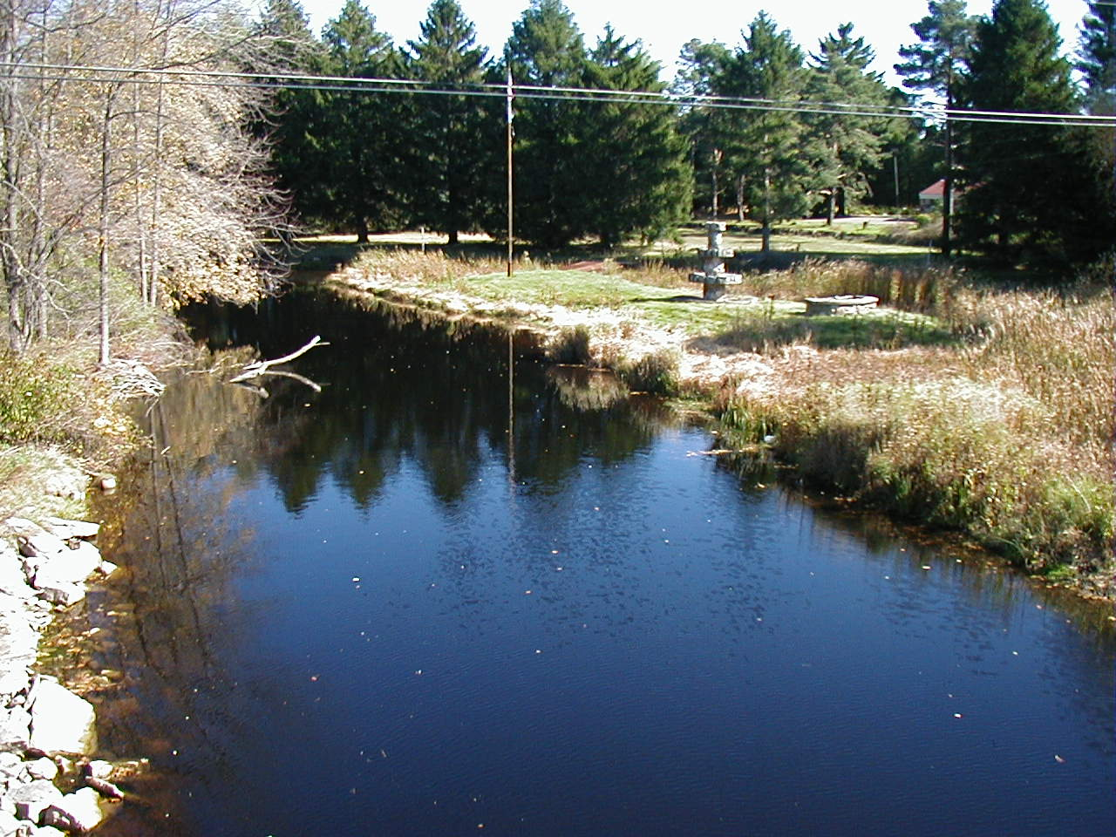
Bergen, NY October 2001

HAPPY HOLIDAYS FROM THE TOWN OF BERGEN
TOWN of BERGEN
10 HUNTER STREET
BERGEN, NY 14416
bergenny.org




The YWCA of Genesee County will be providing satellite domestic violence services in Bergen, NY beginning December 7, 2015. These services include individual advocacy counseling, filing family offense, custody, and support petitions, court accompaniment, safety planning and any other support services needed by those struggling with domestic violence. Genesee County residents can utilize these services at the Bergen Town Hall on Mondays from 8:00am to 4:00pm starting December 7, 2015. Anyone in need of domestic violence services can call the YWCA at (585) 343-5808 or the case manager directly at (585) 813-3175. After hours please call the YWCA Domestic Violence Hotline at (585)343-7513. If you are experiencing any other crisis please contact YWCA’s Care + Crisis Helpline at
1-844-345-4400, (585)344-4400 or chat at ywcagenesee.org.



