TOWN OF BERGEN NEWSLETTER
December 2016, January and February 2017

Michele M. Smith, Editor

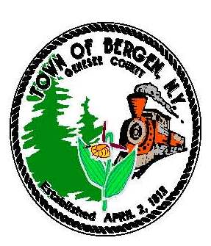

Town News … From the Desk of Town Supervisor Donald Cunningham
Hopefully everyone has enjoyed a nice Thanksgiving holiday and is preparing for the winter to come. Soon snow will be a routine part of the forecast and our highway department is well prepared. Keeping our roads maintained during the winter months is their top priority but we still ask motorists to be extra cautious during snow and freezing conditions. During these conditions drivers should be cautious when approaching plow trucks by maintaining a safe speed and distance, and always be respectful of our operators.
The town board closes out 2016 with several accomplishments.
- The Library building at 13 S. Lake has received window upgrades, and HVAC replacement.
- The parking lot and driveway to the complex around the Library and Harford Barn Museum was paved earlier in the year.
- Window and porch painting was completed at the Historians Office at 15 S. Lake Ave.
- The towns Comprehensive Plan was adopted at our joint meeting with the village trustees in September, and a committee will be formed to guide the recommendations of the plan.
- Income surveys are being conducted to assess the feasibility of financing public water projects.
- Most recently, lighting at the highway garage was upgraded to high efficiency fixtures.
Plans for the coming year include some window replacements for the Historians Office, and improvements at the recreational areas of Robins Brook Park and Drews Nature Center.
The 2017 Budget
The 2017 budget was adopted in November and the efforts of the Town Board for developing a responsible budget that addresses the needs of the town, while being conscientious of the tax rate impact, should be commended. With significant increases in insurance costs, and a strong commitment to addressing deteriorating conditions at our older buildings, maintaining the tax rate was nothing less than a challenge. The tax levy will see an increase due to property assessment adjustments and this will put the budget above the .67% tax cap level outlined by the state. At that level it was impossible to stay within state recommended limitations and be responsible to the needs of town operations. I appreciate the cooperative effort on the part of the board in putting together a comprehensive yet practical budget again this year.
Sales Tax Revenue and Future Town Budgets
Every year I remind readers to shop and buy in Genesee County citing the importance of generating sales tax which gets shared with each town and village. Sales tax sharing is the single biggest revenue piece of our budget and helps control local property taxes. Currently the sales tax revenue agreement is up for renewal, and as part of the agreement, a review committee made up of representatives from the county legislature, the city of Batavia, and the Genesee Association of Municipalities (G.A.M.) is put in place to make a recommendation to the County
(Continued)
“In accordance with Federal Law and U.S.D.A policy, this institution is prohibited from discriminating on the basis of race, color, national origin, sex, age, or disability. (Not all prohibited bases apply to all programs). To file a complaint of discrimination, write USDA, Director, Office of Civil Rights, 1400 Independence Ave., S.W., Washington, D.C. 20250-or call (800)795-3272 (Voice) or (202)720-6382 (TDD)”

“In accordance with Federal Law and U.S.D.A policy, this institution is prohibited from discriminating on the basis of race, color, national origin, sex, age, or disability. (Not all prohibited bases apply to all programs). To file a complaint of discrimination, write USDA, Director, Office of Civil Rights, 1400 Independence Ave., S.W., Washington, D.C. 20250-or call (800)795-3272 (Voice) or (202)720-6382 (TDD)”

Legislature for renewal. Darien Town Supervisor Dave Hagelberger, and myself serve on this committee as GAM representatives and it’s important to note that GAM is only a voice within the committee to communicate the position of the association, while the agreement is strictly between the City of Batavia and Genesee County. During the committee sessions, GAM along with the City of Batavia has recommended the continuation and renewal of the agreement. Unfortunately, county representatives have expressed a desire for changes to gain more sales tax revenue for the county. The basis for their position is to increase funding for neglected road and bridge work and the need to construct a county jail at an anticipated cost of $40 million dollars. Therefore, county representatives made a recommendation to cap the amounts shared with the city, towns, and villages, but if an agreement can’t be reached the current agreement is set to expire in February of 2018. Folks, this is of serious concern for every town and village! Capping or allowing the elimination of sales tax sharing will destabilize the budget process for all municipalities throughout the county. Historically, revenues to the town have been in a decline with the exception of sales tax, so even with the sales tax distribution being capped at a fixed amount, the result would be a growing gap between rising expenses and declining revenues. The sales tax distribution has been in effect for as long as most elected officials can remember, and changes will only result in a reduction of services, staff, and equipment, along with discouraging growth and improvements for our town. At the last committee meeting, it was agreed to form a work group led by the City and County Manager. They are charged with identifying the needs of all parties and determining the widespread impact any changes to the agreement would have, and bring recommendations back to the committee. As of this newsletter I anticipate future budgets of Bergen to be negatively affected, but will try to remain cautiously optimistic for a successful outcome.

Best Wishes for a Merry Christmas and Happy New Year!

From the Desk of County Legislator Robert Bausch
Following the November elections there will be some new county officials in January. Last December
County Court Judge Robert Noonan retired and Supreme Court judges from Buffalo have been presiding
in county court. To replace Judge Noonan, Charles (Chuck) Zambito, currently county attorney, was
elected. Chuck was my predecessor on the legislature from District 2 and I have enjoyed working with him
as the county attorney. He will be an excellent jurist. Kevin Earl has accepted the position of county attorney.
Longtime Sheriff Gary Maha is retiring on December 31st. Bill Sheron, currently the Undersheriff and very dedicated to law enforcement, was elected as the county sheriff. I have worked with Bill while serving on the legislature and he will do an excellent job. Greg Walker will be appointed as the new Undersheriff.
As this is being written, my desk is covered with financial information relative to the 2017 county budget. There is absolutely no good news on that front. Currently the legislature is looking at a 4.5% - 6.5% tax increase. After holding the tax rate steady for a number of years, with a decrease in 2015, it is impossible to continue at the current rate. The budget shortfall is approximately two million dollars. If not for the anticipated sale of the nursing home it would be four million dollars. A number of factors are responsible for this deficit. On the revenue side, limited growth in property values and flat sales tax receipts are the main culprits. But the real problem is expenses.
As discussed in previous newsletters, approximately 80% of county property taxes are allocated to the state’s insatiable requirement for mandated services. For 2017 under the NYS “2%” tax cap legislation, Genesee County was only allowed to raise property taxes by 0.6% with no mandate relief as required by this same legislation. In fact, the state mandated salary increase for the district attorney exceeded the amount the county was allowed to increase property taxes without passing override legislation. The county must pass override legislation or take the extreme risk of insolvency.
All of this said, I can assure you that all the legislators take their fiduciary responsibilities seriously and appreciate the impact a tax increase will have on county residents.
In the coming weeks you will be hearing about 911 funding. The issue is not a revenue issue. All residents with land lines and most with cell phones are paying for this service. However, over 50% of the funds raised by the 911 surcharge are being diverted to other programs. The result: 911 services in NYS are sadly obsolete and need updating. In closing, I would like to wish everyone Merry Christmas and Happy New Year and I look forward to serving District 2 residents in the coming year.

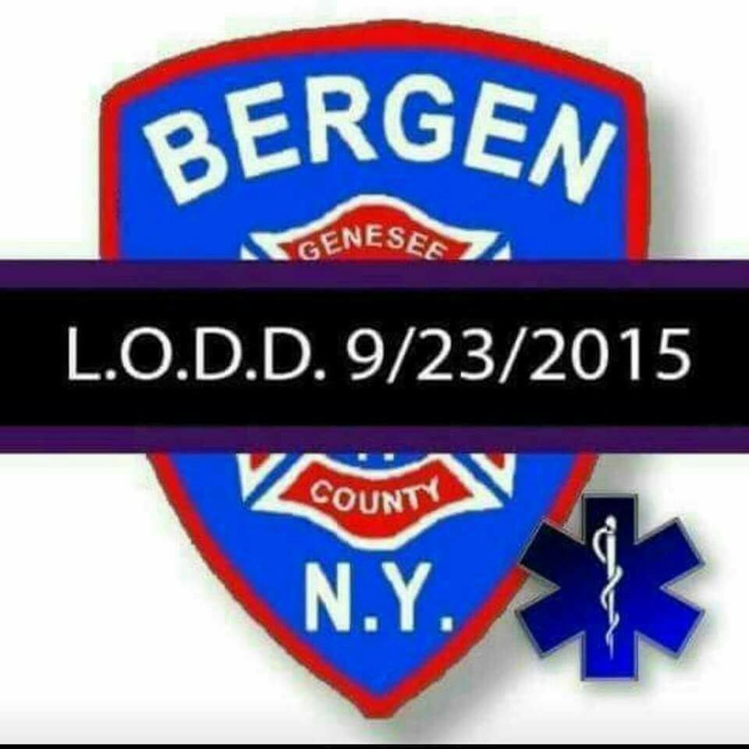


NYS Department of Taxation and Finance – Property Tax Myths and Misunderstandings
Myth #1 - Assessors determine property taxes
Typically tax rates are set by school boards, town boards, village boards and county legislatures, but not boy Assessors. Each
Board determines the total amount of taxes it need to raise, and then decides that number by the total taxable asses value of the jurisdiction to determine the tax rate. Your share of the tax is calculated by multiplying the tax rate by your property assessed value minus exemptions, such as STAR. Assessors are responsible for determining your property’s assess value. In order to do this, the assessor estimates your property’s market value, and then applies the municipal level of assessment to that market value. In many communities, the level of assessment is 100%, so a home with a market value of $90,000 has an assessment of $90,000. In a town with a level of assessment of 50%, the assessed value of the same home is $45,000. The assessor also performs other functions, such as processing exemption applications and keeping track of the local real estate market, but the assessor doe not determine your tax rate.

Myth #2 – Taxes are high because of assessments

It’s important to distinguish between taxes and assessments. If you feel your taxes are too high, you should take that up with the town board, school, board, or other government authority that is determining tax levies and setting tax rates. If you feel your assessment is too high, there are administrative and judicial processes where you can seek to have your assessment lowered. Assessments should be based on market value, and if you feel your assessment is too high, your first step in confirming that is to determine your property’s market value. The best way to do this is to look at the sale prices of similar properties in similar neighborhoods. If you feel that your assessment is too high, we recommend that you informally discuss your concerns with your assessor. More information on grievance process is available from your assessor’s office and online: www.orps.state.ny.us

Myth #3 – NYS collects too much money through property taxes

While the government receives no money from the real property tax, this stable revenue source is vitally important to the delivery of services to the state’s citizens. Local governments and school districts collect the property tax, which is their largest source of revenue. That’s one of the main reasons that property taxes and assessments are administered locally (rather than by state) in New York.

Myth #4 – Equalization rates can correct unfair assessments

Equalization rates are determined by the State Office of Real Property Tax Services and represent the overall ratio of a municipality’s total assessed value to the municipality’s total market value. Because equalization rates are municipal wide measures, they are not intended to correct unfair individual assessments in a city or town. The assessor has the primary role in ensuring the fairness of individual assessments, subject to the right owners to seek administrative and judicial review of assessments. While equalization rates have many uses, they are most commonly known for their use in apportioning property taxes among municipal segments of school districts and counties. In order for a school district or county to fairly distribute its property tax levy (the total amount of taxes to be collected), the levy needs to be divided in proportion to the total market value of each municipality segment. This allows for aa equitable distribution of taxes based upon the market value of each municipality or segment. The apportionment process, the equalization rate is used to estimate the total market value of an entire municipality.

Happy Holidays! During your holiday rush of activities don’t forget to enjoy the many holiday books and movies available at your Library! We have quick cooking books for meals on the go! Make a family tradition by baking cookies from our many cookbooks! Stop by when the children are on vacation for boredom buster books and craft books to inspire their imaginations. Don’t forget your audio books and movies for the long car rides to Grandma’s house!! Check us out on the web at www.byron-bergenpubliclibrary.org and check out our on-line catalog.
Book discussion for December will be on Thursday the 8th at 7:00pm. We are reading One Dress Nine Women by Jane L. Rosen. January we will meet the 12th with the book Secret Wisdom of the Earth by Christopher Scotton. If you’re interested in joining the group, stop by and pick up a reserve copy or log on to the catalog at www.byron-bergenpubliclibrary.org to place your request.
Pre-school story time is at 10:30am on Fridays until December 16th!!! If you are 3-5 years old or are home schooled, join us for a story, related craft and a snack!! January 11th starts our Winter Fun theme for story time. Registration is recommended.

The Holiday Library hours will be:
Tuesday Dec. 22nd10am-12pm and 2pm-8pm
Wednesday Dec. 23rd- 10am-12pm and 2pm-8pm
Thursday Dec. 24th – 10am – 4pm
Friday Dec.25thand Saturday 26th - Closed
Tuesday Dec. 29th 10am-12pm and 2pm-8pm
Wednesday Dec. 30th10am-12pm and 2pm-8pm
Thursday Dec. 31st -10am-4pm
Friday Jan.1^{st and} Saturday Jan. 2nd- Closed.

Christmas break at your Library!
*December 22nd at 6:30-Movie Night on the Big Screen with BFG! Join the fun of watching the movie with all your friends and family. Popcorn and a drink to enjoy!
*December 27th at 6pm— The Library is hosting an Xbox Kinect Bowling Tournament.
All ages- Fun for the whole family! Come enjoy some pizza and pop too!
Keep up to date with Library Happenings by liking us on Facebook! We are on Twitter too @byrbg check us out to follow us there! There are more than just books at your Library.
Did Santa bring you an e-reader this year? Are you not sure how to use it? Stop in January 4th between 3pm-6pm to learn how to get digital books and materials free from the Library with a valid library card! The Library provides free book, audio book, comic book, music and movie downloads available from OverDrive and Hoopla at our website www.byron-bergenpubliclibrary.org.
January 14th is Movie day @ the Library with “Middle School: the Worst Years of My Life” showing at 10:30am! Bring a friend or two and enjoy a movie and some refreshments!
(Continued)



A babysitting workshop on Monday January 30th from 10am to 3pm at the Library. This workshop is recommended for children 11 years old and up. The cost is $45 with book included. Registration and payment is due by February 17th. Please call 494-1120 for more information.
Have you read the newest bestsellers? Stop by the Library to get your copy to enjoy or reserve your copy on-line of the newest James Patterson, J.D. Robb, and Mary Higgins Clark books. New Audio CD’s and Playaways are available too. New children’s books arrive weekly! New DVD’s monthly!
Order books – down load audio books, e-books and order the newest movies at the Nioga Library system from the comfort of your home!! There are databases; Librarian 24/7, TumbleBook Library, NOVEL list, and many more data base are available to you!! Just go to www.byron-bergenpubliclibrary.org and you’re on your way!
The Library has Roadrunner Internet service available. The Library has copy /fax service for a small cost. Interlibrary loans from any library in the NIOGA Library system at our catalog www.byron-bergenpubliclibrary.org
If you can’t find it, please ask! Stop in soon! For more information on our services or programs, please call the library at 494-1120.
Happy Reading and Happy Holidays-Nancy Bailey Library Manager

Community Christmas Activities

Annual Village Tree Lighting will be held Friday Dec 2th
Carolers leave Hickory Park at 6:30 pm to escort Mr. and Mrs. Claus to Ward Park.
Ward Park festivities include meeting the Clauses, tree lighting, hot cocoa and cookies, elementary band, decorated trees by community organizations, etc.
Bus provided to ride back to Hickory Park
For further information contact the village office 494-1513

Saturday, December 3rd at 6:00 PM
Bergen Community Christmas Concert
Bergen First Presbyterian Church
38 Lake Ave, Bergen, NY

Join us for an evening of Christmas music performed by members of the community. Young and old are welcome to attend. Special Family Friendly seating available this year, bring all your little ones! Cookies and cocoa to follow. Questions about attending or performing? Contact Jocelyn Rebisz, 494-6031.

Saturday, December 10th
Santa’s Workshop
9:00 am – 2:00 pm Gillam-Grant Community Center
Mrs. Claus Kitchen, Entertainment, Cookie Decorating,
Christmas BINGO, Face Painting, Reindeer Games, Raffles,
Christmas Crafts, Lego Winter Scene Display, Christmas Music by
Rebel’s Posse Unplugged.






Town Highway by Mike Johnson
Please be reminded that during a “normal” snow event, it will take plow trucks 2 ½ to 3 hours to complete one pass on all roads. As such, it is very possible that everyone will encounter less that pleasant driving conditions at times. Late evenings and early mornings, with very light traffic volumes, will received lower levels of service. Ever y attempt will be made to maintain open and passable roadways, both for normal and emergency traffic. At times, lanes may narrow and accumulate snow. The Town is responsible for snow and ice removal on all Town and County roadways in Bergen as well as State routes. This winter, as in the past, we will strive to provide the same level of the safest possible roadways at all times, within reason and budget constraints.
Also remember to use caution on snow covered roads. Here are a few safety tips: Slow Down, Make safe lane changes, pump your brakes on slick roads, and lastly don’t tailgate, especially the plow truck. If you can’t see him in his side mirror there is a good chance he can’t see you! And for on First Aid rule: Carbon Monoxide is called “the silent Killer” if you go off the road keep your exhaust clear of snow.
Two additional reminders: Mailboxes, if damaged by our plows will be repaired or replaced, within Town Board adopted limits, as soon as weather, time permits. PLEASE, when installing or repairing your mailbox, remember that our trucks require a minimum 17 ½ feet from center of the roadway. Also, take into account the excessive force of the exhausted snow as it strikes your mailbox assembly.
Please don’t hesitate to call me at 494-1362 if I may be of service. Highway Department hours are 7:00 am – 3:30 pm Monday thru Friday. However, you may leave a message 24 hours a day on our answering machine, and I will return your call as soon as possible. In closing, the entire highway department would like to wish everyone a healthy and happy holiday season, and a safe winter.

Village Historian News by Raymond McConnell
Ralph D. Gillette 1891-1972 Ralph was a life-long Bergenite. His father, George, was prominent in
railroading and farming. He also loved politics. Ralph began his work in the insurance business in
1919 and the company was known as Gillette Insurance Agency. It was located on Buffalo Street where Mike's Gym is now located. Ralph and his wife Minna lived in the family home at 48 Rochester Street. They always maintained the exterior of their home perfectly.

I remember Ralph as a very happy man. Many times he said , "Rayme, I knew you before you were born." He entered my father's grocery store (Harts), around the corner from his office, most afternoons to take a few items home for supper. Near Christmas my father had a supply of small trees in the store for those who wished a tree of about 3 feet tall. They were living trees with a water reservoir at the base. Ralph walked into the store and saw the trees. He said, "Rayme, pick a nice tree out for me to take home." So I did, and he went home very happily to share the tree with his wife. They had no children and he was sure the tree would add to their holiday decorations.
He provided the best for his wife. Each month it was my job to collect a penny bank from houses on Rochester Street from our Presbyterian Church members. I would appear at their front door and Minna would ask me to step inside while she collected the bank. I enjoyed seeing the newly redecorated living room and dining room. She had worked with a decorator from Sibley's and the results were magnificent, at least from this 12 year old kid's perspective. I had never seen such a lovely decorated home with Waterford chandelier, sterling displayed on the buffet in the dining room, and elegant upholstered furniture in the living room with a Royal Doulton "Balloon Lady," ceramic on a period
(Continued)

Notes From the Village Historian - Raymond MacConnell

Ralph D. Gillette 1891-1972
Ralph was a life-long Bergenite. His father, George, was prominent in railroading and farming. He also loved politics. Ralph began his work in the insurance business in 1919 and the company was known as Gillette Insurance Agency. It was located on Buffalo Street where Mike's Gym is now located. Ralph and his wife Minna lived in the family home at 48 Rochester Street. They always maintained the exterior of their home perfectly.
I remember Ralph as a very happy man. Many times he said , "Rayme, I knew you before you were born." He entered my father's grocery store (Harts), around the corner from his office, most afternoons to take a few items home for supper. Near Christmas my father had a supply of small trees in the store for those who wished a tree of about 3 feet tall. They were living trees with a water reservoir at the base. Ralph walked into the store and saw the trees. He said, "Rayme, pick a nice tree out for me to take home." So I did, and he went home very happily to share the tree with his wife. They had no children and he was sure the tree would add to their holiday decorations.
He provided the best for his wife. Each month it was my job to collect a penny bank from houses on Rochester Street from our Presbyterian church members. I would appear at their front door and Minna would ask me to step inside while she collected the bank. I enjoyed seeing the newly redecorated living room and dining room. She had worked with a decorator from Sibley's and the results were magnificent, at least from this 12 year old kid's perspective. I had never seen such a lovely decorated home with Waterford chandelier, sterling displayed on the buffet in the dining room, and elegant upholstered furniture in the living room with a Royal Doulton "Balloon Lady," ceramic on a period card table in the corner In church, they always sat in the same pew, near the front, and people always noted Minna's new hat, coat, or purse. She was a style setter, and that was the way she liked it!
After his wife's death in 1967 the spark was gone from Ralph. He declined rapidly and died in a Rochester nursing home in 1972. He left the community many gifts which carried on after his passing.



card table in the corner in church, they always sat in the same pew, near the front, and people always noted Minna's new hat, coat, or purse. She was a style setter, and that was the way she liked it!
After his wife's death in 1967 the spark was gone from Ralph. He declined rapidly and died in a Rochester nursing home in 1972. He left the community many gifts which carried on after his passing.

Town Clerk News by Michele M. Smith

Town & County Taxes
If you pay your own taxes, you will receive your tax bill shortly after January 1, 2017. If you should receive a tax bill that an escrow company or someone else is supposed to pay, please call me right away. Don’t put it aside and assume that it will be paid. Also, if you have paid off your mortgage and did not receive a tax bill, you should call me. No matter what the situation is, you are responsible for your taxes and penalties, if it is not paid. If you are leaving town for the winter please leave your “winter” address with me so late fees can be avoided. Credit cards (Visa, MasterCard & Discover) are accepted for payment with a convenience fee.
Tax payments cannot be received before January 1, 2017 per the County Treasurers office, all payments will be stamped after that date. Taxes are due penalty free by January 31st, all taxes have to be paid to me by March 31st. After March 31st, the unpaid taxes are returned to the County Treasurer. If you are going to pay them to the County Treasurer by mail, you will need to call his office in Batavia at 344-2550, ext. 2211 as there will be additional penalties.

Dog License News:
I hate to “hound” you, but if your dog’s license renewal is due or past due, please take care of it so we don’t have to send you a reminder notice or eventually a court appearance ticket. All dogs, four months of age need to be licensed even those in apartments. Proof of a rabies vaccination and proof of neutering or spaying must be presented at the time of licensing. If you receive an appearance ticket, you will have to pay a fee of $25.00 plus also pay for your dog’s renewal. If there is a problem getting an appointment for a rabies vaccination, etc., please call me. I have an answering machine so you can call anytime day or night.
Office Closing Office Hours
December 24, 2016 – Christmas Eve Monday, Tuesday, Wednesday and Friday
December 26, 2017 - Christmas observed 8:00 am – noon & 1:00 – 4:00
January 16, 2017 – Martin Luther King Jr. Day Saturday 9:00 am - noon
February 20, 2017 – Presidents Day Closed on Thursdays




Transfer station Holiday Hours
Christmas Eve - December 24th 9:00 am – Noon
New Years Eve - December 31st normal hours 9:00 am – 3:00 pm

HAPPY HOLIDAYS FROM THE TOWN OF BERGEN
TOWN of BERGEN
10 HUNTER STREET
BERGEN, NY 14416
bergenny.org





