TOWN OF BERGEN NEWSLETTER
MARCH, APRIL, MAY 2016

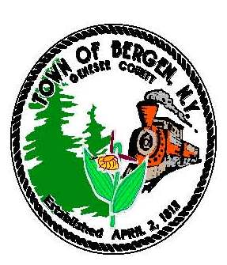

Town News … From the Desk of Town Supervisor Donald Cunningham
Spring… Coming Soon?
Unlike a year ago, we’ve been very fortunate to experience such a mild winter thus far. The minimal snowfall offers safer travel for motorists and brings many benefits to the highway budget through a reduction in material usage, fuel consumption, and labor hours. March can still deliver some significant winter weather events but at this point we can consider ourselves ahead of the game and before long spring will move us into the grass mowing season. As usual, during periods of snowy travel please respect the highway crews trying to service roads. We appreciate their efforts in making our commutes safer!
Plans For 2016
The Library building recently received window upgrades and plans for paved parking are being developed so that site work can take place in the spring/summer of this year. These projects became feasible through a grant reward to the BB Public Library along with matching portion of town funds. The investment will service Library patrons and visitors to the Harford Barn Museum and Historians Office very well. As stated in the previous newsletter the plans for an HVAC upgrade is also underway for the Library building. We’ve spent the last several years “chipping” away at building related needs and will continue to try and stay ahead of deteriorating conditions and inefficiencies associated with the older structures serving the public.
A couple of committees have been formed by the Bergen Fire Department to develop long range plans for fire equipment and facilities. These committees will have members from the department as well as representation from both the town and village boards. I commend the executive board of the department for taking a long term strategic approach to assess the future of the organization. This focus is vital to our community beyond fire protection. With the town hall and court facilities occupied under a lease with the fire department this effort presents a perfect opportunity to have long range planning discussions for town facility needs as well and I look forward to working with the department.
The Parks Committee will continue to work on a Master Plan and present improvements for Robbins Brook Park, Drews Nature Center, and the linear trail. Currently the committee is putting together plans for improved signage at the Robbins Brook location and discussions for a pavilion at that location are taking place as well.
Comprehensive Plan
The Comprehensive Plan Steering Committee is reviewing a draft plan and preparing it for presentation at the joint meeting of the Town and Village Boards on March 22nd. Upon satisfactorily refining the draft, a public information meeting will be scheduled. We continually thank everyone that has worked on this project, participated in the workshops, and endured some long meetings!
America’s Best Communities initiative
It was a disappointing surprise to receive the news that LeRoy and Bergen did not advance to the next round in the America’s Best Communities competition. A great effort was put forth by representatives of both communities, the county, and the GCEDC, to put together a plan that gave us great expectations and hope. I’m thankful to my committee peers for the effort and collaboration put forth by everyone.
Some Info on Sales Tax
I frequently use the newsletter to suggest spending in Genesee County. The reason is that Genesee County shares sales tax revenues with municipalities to provide budgetary funding and help control property taxes. When you purchase in Genesee County, a portion of the sales tax comes back to Bergen. For most townships this is a significant amount of funding for annual budgets and without it financial management and tax control would become difficult. The current sales tax agreement works well and is up for review this year. We are hopeful that the context of the agreement will remain “as is” and I will be one of the Genesee Association of Municipalities representatives working with the review committee on the renewal.
“In accordance with Federal Law and U.S.D.A policy, this institution is prohibited from discriminating on the basis of race, color, national origin, sex, age, or disability. (Not all prohibited bases apply to all programs). To file a complaint of discrimination, write USDA, Director, Office of Civil Rights, 1400 Independence Ave., S.W., Washington, D.C. 20250-or call (800)795-3272 (Voice) or (202)720-6382 (TDD)”

From the Desk of County Legislator Robert Bausch
In early January the County Legislature held its organizational meeting with one new legislator.
John Deleo replaced Frank Ferrando to represent District 7, the east end of the City of Batavia.
In addition, Pam LaGrou, from the Town of Alabama, was appointed Legislative Clerk to replace
Sarah Kingdon, who transferred to the County Attorney’s Office.

There will be two additional changes in county leadership positions in the coming year. County Court Judge Robert Noonan retired on December 31, 2015. The governor may choose to appoint a replacement to serve until the November election; to date, no appointment has been made. In the interim, the 8th Judicial District has appointed Judge Michael Pietruszak from Erie County to serve until an appointment is made or the November election. Sheriff Gary Maha has announced that he will not seek reelection this fall and will retire on December 31, 2016. Looking ahead to the November election, to date only Charles Zambito has announced his candidacy for the County Court Judge position. Presently, he is the county attorney and he sat in my seat as your county legislator prior to his current position. Christopher Parker, a deputy in the sheriff department, and William Sheron, the undersheriff, have announced they will be running for the sheriff position.
The legislature’s agenda for the next two years is full. As discussed in the past, the nursing home has been sold, but the county is waiting for state approval. Hopefully, the process will be completed by October. The county water agency purchases a significant amount of water from Monroe County and the contract requires updating. The county sales tax agreement with the City of Batavia and the towns and villages expires next year. Currently, the county 4% sales tax is shared with the county retaining 50%, the city receiving 16% and the towns and villages receiving 34%. Sharing county sales tax with other municipalities is a unique arrangement. Lastly, all bridges in the county that exceed 5 feet in length, including some on state highways, are the county’s responsibility. A study is underway to determine the status of the 384 bridges, many of which are past their normal life, to develop and implement a replacement schedule.
As always, if you have a concern, please contact me at your convenience.

Historian News by Thomas Tiefel

Welcome to 2016! A new year always brings new beginnings. With that said, I am looking forward to
what will hope to be another prosperous year for the Harford Museum. I would like to thank Town
Supervisor, Don Cunningham and the Town Board for my 2016 re-appointment as Town Historian. I will
continue to do my very best in preserving the past for the future with Bergen's history. As the new year
gets underway, I am pleased to announce the appointment of our history department's new genealogist and
archivist, Gina Schelemanow. Gina is a GCC sophomore that is majoring in history. Gina is a resident of
Bergen and is also employed at Liberty Pumps. It has been a difficult task trying to find that "right fit" to
fill the shoes of past archivist Dick Partridge. While those shoes may seem impossible to fill, Gina is up for the challenge and has wasted no time in getting things at the Historian’s office whipped into shape. She also has brought some great ideas to the table and is doing an exceptional job in taking care of people in need of research. I have no doubt that Dick would be proud! Stop in and see her to show her some of that great hospitality that has put our town in the running for "America's Best Communities.

Some of you may have noticed the new neon "open" sign in the window of the Historian's office. We have officially started open office hours as of January 1st. We are doing this in an effort to better serve people who wish to personally inquire about research. Office hours are Tuesday & Thursday evenings 4pm-7pm with Gina, and Wednesday & Friday mornings 10am-1pm with myself.

Remember to “find us on Facebook!” You can like us at the Harford Museum Face Book page. Check us out and take a trip down memory lane! Many new pictures are being added weekly that give a glimpse into Bergen's past.

As always, the historian’s office is located at 15 S. Lake Ave in the village of Bergen. If you would like to contact me for any reason, feel free to call 585-494-0080 or call Gina Schelemanow for any genealogy research at 585-331-9570 and we will be happy to assist you!

“In accordance with Federal Law and U.S.D.A policy, this institution is prohibited from discriminating on the basis of race, color, national origin, sex, age, or disability. (Not all prohibited bases apply to all programs). To file a complaint of discrimination, write USDA, Director, Office of Civil Rights, 1400 Independence Ave., S.W., Washington, D.C. 20250-or call (800)795-3272 (Voice) or (202)720-6382 (TDD)”

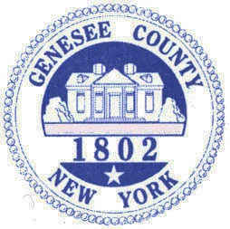

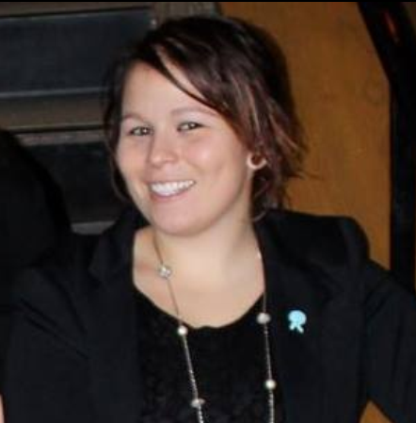
Bergen Fire Department by PJ Cummings
“Soon after a fire is seen and cry’d out, the place is crowded by active men of different ages, professions and title who, as of one mind and rank, apply themselves with all vigilance and resolution, according to their abilities, to the hard work of conquering the increasing fire.”

For over 150 years, these words written by Ben Franklin have lived on in the hearts of people that live right here in your own community. Back when they were written the Town of Bergen had yet to be established, but they were carried here over time and in 1861 a group of volunteers formed what we know today as the Bergen Volunteer Fire Department. We have proudly provided continuous service since that day.
What’s sad though is every year that goes by, these words get pushed farther back into history. Not just here, but everywhere in small town America. We can blame social media, blame technology, blame budgets and training, or even blame an entire generation of younger people who stereotypically “don’t want to go above and beyond”. We can blame whatever it is that we want, but at the end of the day it comes down to ones willingness to do whatever it takes to preserve Liberty and Freedom. No, you don’t have to be a soldier and go to war to do so, nor do you have to fight a fire. Helping people within your own community means you’re helping to preserve someone’s liberty, freedom, and pursuit of happiness.
For us this means responding to emergencies within our own community. There is so much that needs to be done and we literally require people with all kinds of talents, from all walks of life, and have something for almost everyone to do. Our survival as an organization depends on it and the commitment may fall on you. For as little as 5 hours a week, YOU can make a difference. We’re not asking you to fight a war against another nation, but we are asking you to help us fight the natural elements and be prepared for whatever (one day) comes our way.
The decline of volunteers falls on us as a fire department as well. It’s our job to educate you about what we need and more importantly about the realities of what we do as an organization. We’ve done a terrible job in the public education over the last 15 - 20years and we need to correct it. We need to make the Bergen Fire Department an example for what it takes to be a thriving organization, not only for the rest of New York State, but for the rest of the Country. It can be done…
No one wants higher taxes right. What’s one thing we can do to ensure we don’t see drastic increases? Keep the volunteer service alive and strong.Imagine what it’s going to cost if we have to (one day) start hiring full time paid firefighters. We understand that not everyone has the time to commit or might suffer from a physical disability that prevents them from active service. It certainly isn’t for everyone. Let me show you a quick sketch of what most of our members lives look like and see if there are any familiarities…
There are generally 126 total hours committed for the week for the average member for the normal
things in life. Some weeks we don’t get any calls and some weeks we get several, but it averages to
about 2-4 hours per week. Regardless of how much time we commit there are roughly 42hours
remaining each week for football, hobbies, or whatever else we enjoy doing in our spare time. After
you take your initial training, the fire department is not really much of a time commitment or a burden.
We know “lack of time” is a popular excuse and that there are circumstances where people travel or
work two jobs making their time schedule much different, but for most of you this time commitment
schedule probably looks very familiar. What you may not know is that contrary to popular belief the fire department is not all about hard work. The hard work portion is a very small portion of what we do. You’ll have a lot of fun; you’ll meet new people around the area, discover new talents, learn new skills, become leaders, and literally become part of our family. Obviously, whether you’re a member or not, we have your back when you call 911, but from experience it’s more reassuring when you personally know the people coming to help you.
I spent 11 years as an active member in the Bergen Fire Department from 2001 – 2012. I left in 2012 and spent the next two years traveling the Country visiting firefighters from Oregon to Texas, from Florida to Nebraska, and beyond. I can tell you right now that there is no greater fire department that exists. Bias opinion, maybe, but when I say I’d risk my life for anyone within its walls, I mean it. ANYONE! Mainly, it’s because they would risk their life for me and that’s a pretty awesome feeling. That’s one major reason I decided to join the Department again late last year. This is not the only reason and I’d be glad to share all of the reasons, but I need to wrap this up.
The experience of traveling and meeting with other departments has resulted in many personal ideas related to increasing the number of volunteers we have. Sometimes I’ve been snickered at when I’ve proposed my ideas in these other communities, but what everyone else outside the Bergen area might not know is how great the people that live here really are. I say in full confidence that we can increase our numbers each year because I personally know many of you - the people that make up the Bergen community - and I know firsthand how amazing the pride is here. I grew up here and like most of you, haven’t left because I love this little community and the people in it.
(Continued)

“In accordance with Federal Law and U.S.D.A policy, this institution is prohibited from discriminating on the basis of race, color, national origin, sex, age, or disability. (Not all prohibited bases apply to all programs). To file a complaint of discrimination, write USDA, Director, Office of Civil Rights, 1400 Independence Ave., S.W., Washington, D.C. 20250-or call (800)795-3272 (Voice) or (202)720-6382 (TDD)”

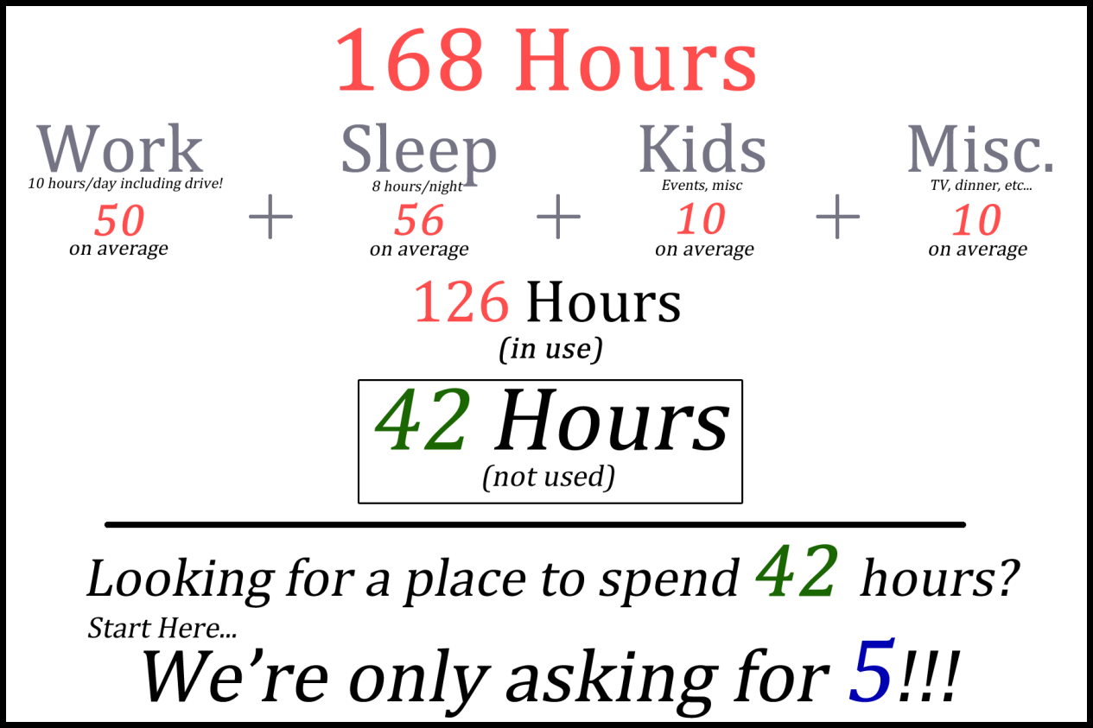
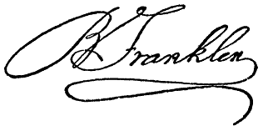

Throughout the spring and summer, we’re going to be working hard visiting and connecting with each and every one of you within the community. While our main mission is recruitment, our secondary mission is public education. We want you to become very familiar with us (as people), our organization, and what we’re up too. We’ll be out in the community more than ever and we encourage everyone to say “hi” and ask questions. Of course you’re always welcome to stop by and visit us on any Monday night from 7 to 9pm.
On behalf of the Bergen Fire Department, we thank you for reading this and thank you for your continued support.

Library News by Nancy Bailey

Stay connected with your Library by checking us out at www.byron-bergenpubliclibrary.org
and “Like” us on Facebook! Find us on Twitter too! Lots of great programs coming up!!

We have New York tax forms available here! You also can go to the website at www.nystax.gov and go to forms to print from home. If you need Federal tax forms, they are available at www.irs.gov or at the larger Libraries and Post Offices in Batavia and Brockport. Hoopla is here and available at your Library! What is Hoopla? A place to get all your digital movies, TV shows, e-books, audio books, comics, and music! All you need a valid Library card and you are on your way! Check us out on the web at www.byron-bergenpubliclibrary.org!

Tech Time at the Library! Call and sign up any Wednesday during regular Library hours to receive help to set up your e-reader, tablet or phone to get use Library digital platforms. Please come with your passwords and Library card and all your questions to be answered.
Library has preschool story time at 10:30am on Fridays. Join Miss Veronica for some stories, a related craft and a snack too! Registration is recommended by calling or stopping by the Library.
Book discussion group will meet March 3rd, April 14th, May 12th, and June 9th. Join this and explore new venues and topics. We have lively conversation about the book and refreshments to enjoy too! Stop by or call the Library to reserve your copy of our current book.
“Keep me in Stiches”—Knit and Crochet group- Meeting every 2nd Tuesday at 10am. Join us with your own supplies and get help with an experienced knitter and crocheter—Miss Amy! All levels of experience are welcome! No registration required.
What would happen if everyone read the same book??? Well, if you read our A Tale for Three Counties book you will find out!! A Tale for Three Counties book for 2016 will be Black River by M.S Hulse. The author will visit in our area March 10th at Genesee Community College at 1 pm and the Richmond Memorial Library in Batavia at 7pm. Check us our online at www.taleforthreecounties.org or “Like” us on FaceBook. Log on to www.byron-bergenpubliclibrary.org and reserve your copy now.
Join us March 5th at 10:30am for a special program on the History of Chocolate. This fun Saturday event is open for all ages. So come enjoy the Genesee County Museum Moveable Museum programs about chocolate and get a taste of history too! No Registration needed. This program is made possible with funds from the Decentralization program, a regrant program of the New York State Council on the Arts with support of Governor Andrew Cuomo and the New York State Legislature and administered by the Genesee-Orleans Regional Arts Council (a.k.a. GO ART!)

Saturday Morning Cartoons at the Library on March 12th at 10:30 am. Join us for popcorn and enjoy the movie “The Peanuts Movie” on the big screen! Everyone invited!! Registration appreciated!
Color Yourself Calm- March 15th – April 19th& May 17th Come and de-stress with this special adult only color program. Experience the latest trend in relaxation- coloring! Studies show coloring can have a calming effect on the adult mind and helps promote overall wellness. All supplies provided-Along with hot beverage and refreshments. No registration required.
Spring Break Happenings!! Yes we are open!!
Tuesday March 22nd is PJ Story time! Come join us in your PJ’s for a fun story, craft and snack too. Miss Makayla will be reading stories about spring so bring your favorite stuffed animal too. Registration is not required but appreciated by calling the Library.
Thursday March 24th – Movie Day – “Alvin and the Chipmunks: the Road Chip” will be showing at 2:30pm. Enjoy popcorn and a drink! Sign up is appreciated.
Friday March 25th – Preschool story time but all welcome at 10:30am! Join us for a special Easter story time, craft and treat! Registration is appreciated. (continued)

“In accordance with Federal Law and U.S.D.A policy, this institution is prohibited from discriminating on the basis of race, color, national origin, sex, age, or disability. (Not all prohibited bases apply to all programs). To file a complaint of discrimination, write USDA, Director, Office of Civil Rights, 1400 Independence Ave., S.W., Washington, D.C. 20250-or call (800)795-3272 (Voice) or (202)720-6382 (TDD)”

“In accordance with Federal Law and U.S.D.A policy, this institution is prohibited from discriminating on the basis of race, color, national origin, sex, age, or disability. (Not all prohibited bases apply to all programs). To file a complaint of discrimination, write USDA, Director, Office of Civil Rights, 1400 Independence Ave., S.W., Washington, D.C. 20250-or call (800)795-3272 (Voice) or (202)720-6382 (TDD)”


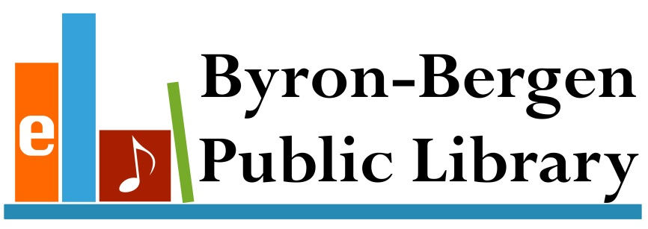
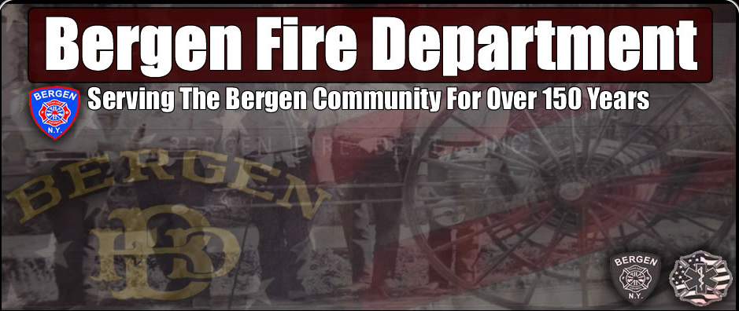

Save the date of March 30th for our annual pre-school concert! Join our smaller patrons at the Bergen First Presbyterian Church at 9:30am for music and fun with Susie Rozler and her “Mama Earth’s Kitchen Show Band”! With audience participation and humor, her show brings not only music to our younger patrons but they will learn about gardening, bird-watching and so much more! A great way to get the children excited about spring! No Registration required! Just come join the fun! This free program is made possible with funds from the Decentralization program, a regrant program of the New York State Council on the Arts with support of Governor Andrew Cuomo and the New York State Legislature and administered by the Genesee-Orleans Regional Arts Council (a.k.a. GO ART!)
National Library week is April 10th-16th – Stop in and take out a book or two and have a chance to win a prize!! Everyone invited to participate!
April 12th – Spring Story time at 6:30. Come celebrate Library week and enjoy a story about spring and a fun craft too. No registratio
Saturday Morning Movie! April 23rd – Enjoy a fun movie for the whole family showing at 10:30am – check out the web at www.Byron-BergenPublicLibrary.org for more information.
May 5th – Join us and the Bergen Historical Society for a Genesee County Museum program “The Language of Flowers” at 7pm. Learn about the most enchanting customs of the 19th century – communicating through flowers instead of words. Find out what the different flowers mean using specimens from your backyard. This free program is made possible with funds from the Decentralization program, a regrant program of the New York State Council on the Arts with support of Governor Andrew Cuomo and the New York State Legislature and administered by the Genesee-Orleans Regional Arts Council (a.k.a. GO ART!)
Saturday Morning Movie on May 14th at 10:30- Save the date. Movie to be determined so check the website for more information or stop into the Library.
Come enjoy some great music for the Byron Memorial Day events with Hill Brothers in concert on May 25th at 11:30am--after the parade at the Byron Fire Hall on Rt.262. A fun-filled afternoon of sing-alongs, humor, and participatory songs for the whole family to enjoy!
The Library will be hosting the Kelley’s Hero’s Marching Band at the Bergen Park Festival on June 13th in the parade and right after the parade too with a field show not to be missed! Stop by visit the book sale too! This free program is made possible with funds from the Decentralization program, a regrant program of the New York State Council on the Arts with support of Governor Andrew Cuomo and the New York State Legislature and administered by the Genesee-Orleans Regional Arts Council (a.k.a. GO ART!)
Would you like to volunteer during the summer at the Library? For children 11yrs and older, the Library is looking for help with the summer reading program. Stop by before June 18th to sign up! Chance to win prizes, help with programs, and place to meet new people! Come join by yourself or with a friend!!
The Library has Roadrunner Internet service available. The Library has copy /fax service for a small cost. Interlibrary loans from any Library in the NIOGA Library system at our catalog www.byronbergenpubliclibrary.org. If you can’t find it, please ask! Stop in soon! For more information on our services or programs, please call the Library at 494-1120.
~Happy Reading

Town Clerk News by Michele Smith
Dog License: Please make sure your dogs are licensed and their rabies information is up to date.
ANTI-RABIES CLINICS: April 21st – Pembroke Highway Garage 1145 Main Rd. (Rt. 5) Pembroke
2016 Town & County Tax Payment - Last day to pay Town & County taxes is Thursday, March 31st with 2% penalty, the office is closed on Thursdays but payment will be accepted Friday, April 1st or can be left in the drop box. Any taxes not paid by that date will be turned over to Genesee County Treasurer.
Office Closing Office Hours
March 25th & 26th – Easter Monday, Tuesday, Wednesday and Friday
May 28th & 30th – Memorial Day 8:00 am – Noon & 1:00 – 4:00
Saturday 9:00 am - Noon
Closed on Thursday

“In accordance with Federal Law and U.S.D.A policy, this institution is prohibited from discriminating on the basis of race, color, national origin, sex, age, or disability. (Not all prohibited bases apply to all programs). To file a complaint of discrimination, write USDA, Director, Office of Civil Rights, 1400 Independence Ave., S.W., Washington, D.C. 20250-or call (800)795-3272 (Voice) or (202)720-6382 (TDD)”



Easter Egg Hunt Saturday, March 19th at 1:00 PM

The Bergen Business & Civic Association sponsors
this annual event at the Hickory Park in the Village of Bergen.

“In accordance with Federal Law and U.S.D.A policy, this institution is prohibited from discriminating on the basis of race, color, national origin, sex, age, or disability. (Not all prohibited bases apply to all programs). To file a complaint of discrimination, write USDA, Director, Office of Civil Rights, 1400 Independence Ave., S.W., Washington, D.C. 20250-or call (800)795-3272 (Voice) or (202)720-6382 (TDD)”





