TOWN OF BERGEN NEWSLETTER
MARCH, APRIL, MAY 2017

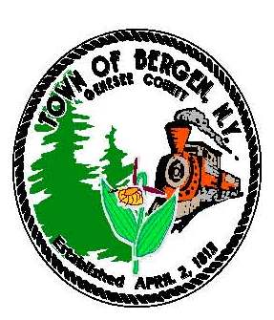

Editor: Michele Smith
Town News … From the Desk of Town Supervisor Donald Cunningham
Looking forward to spring...
With February temperatures in the upper 60's I, like many, get the itch for spring to arrive. It's been another mild winter and while it's easy to rejoice in the lack of piling snow, the limited snowfall extends the concern for a low water table. After the dry summer of last year, many residents and farmers in the area were relying on this winter replenishing the water table. Without significant snow, or spring rains, this remains a serious concern for many Bergen residents. We know March can still be a significant month for winter activity, and though my desire for spring rises with the temperature, I would welcome some significant precipitation in any form to refill depleted wells.
To date the Highway Department has battled mostly nuisance snow & ice events, and done an excellent job. As usual, during periods of snowy travel please respect their efforts.
Looking ahead in 2017
The town has a few projects going on to include continued work in keeping our buildings in good shape. The Buildings & Grounds committee has arranged a review of the Historians office and the Harford Barn Museum for needs to these structures. We’ll try to make plans to correct any deficiencies this year.
Discussions are also being conducted for the Library building to determine what can be done to improve accessibility and space utilization.
The town has secured a grant for improvements at Robins Brook Park and the Drews Nature Center. Early plans include a pavilion, trails, and site amenities at Robins Brook and we’d like to improve access to Drews Nature Center for public walk in, while securing it from damaging atv access. One of the biggest concerns at Drews is the phragmities infestation. The town is trying to coordinate an effort with the Bergen Swamp Society to control this infiltration and improve pond conditions. This is not an easy task and will take much research, time, and effort to bring these waters back to preferred conditions.
The Town Historian provided his annual report which showed a slight decline in attendance at the museum last year. We speculate that this was due in part to the parking lot construction taking place during the park festival. We are hopeful attendance will resurge this year. The Harford Barn Museum is a little gem and worth the visit. Please plan on attending sometime this year and check the regular posts on Facebook.
I have to again mention sales tax. It’s the most important revenue segment of the town budget and without the sales tax revenue sharing as we know it, there would have to be increases to town property taxes or cuts to services that are currently provided. Should a structured decline in sales tax revenue come as a result of the county changing the sharing formula, it would be logical for budget reductions to begin with the services we provide to the county. This would primarily affect the Highway Department and the road work provided to the county. I remain hopefully optimistic for a good outcome in the negotiations, but with time running out, I’m compelled to prepare residents for significant changes in the 2018 budget. For now I’ll continue to encourage residents to support the local economy and sales tax sharing formula by purchasing goods and services within Genesee County. Stay tuned on this topic.
Reminder - Daylight Savings change coming on March 12th. Don’t forget to change your clocks.
“In accordance with Federal Law and U.S.D.A policy, this institution is prohibited from discriminating on the basis of race, color, national origin, sex, age, or disability. (Not all prohibited bases apply to all programs). To file a complaint of discrimination, write USDA, Director, Office of Civil Rights, 1400 Independence Ave., S.W., Washington, D.C. 20250-or call (800)795-3272 (Voice) or (202)720-6382 (TDD)”

From the Desk of County Legislator Robert Bausch

First, there is good news to share: On February 2nd the county nursing home sale was finally completed.
The process took much longer than could reasonably be expected. It was set to close on December 31st. Then
at the last minute, the state put a new requirement on the purchaser. The issue was more relevant to downstate and had little bearing on upstate localities but it still needed to be addressed and delayed the closing an additional month.

The new nursing home owner assumed operational responsibilities on January 1st. The county had already transferred the employees and vendor contracts to the new owner as of January 1st. Once the closing was delayed due to the late state notification it would have been a real mess to transfer the employees and contracts back to the county only to transfer them back to the new owner a month later. The transition to the new owner appears to have been efficiently handled with just a few problems that were immediately addressed. The new owner's plan is to seek state approval to convert the domiciliary care wing, which has 80 beds and seldom reaches 40% occupancy, to an assisted living facility. This level of care has been needed in the county for many years but the state would not authorize a public nursing home to provide that level of care.
The next step in the long process for the county will be to financially close the nursing home books. After all expenses and outstanding loans are paid, the amount of money available for other projects will be determined. As stated in previous newsletters, the majority of the proceeds will be allocated for county roads and bridges. The estimated cost of bridge reconstruction exceeds $20,000,000 which will be greater than proceeds from the nursing home sale.
County revenues continue to struggle. As reported in the press, the county overrode the state property tax cap of 0.4% because new or expanded state mandated services alone exceed the cap amount. Sales tax revenues continue to be flat as a result of a number of factors (most of which are good for consumers but not for sales tax receipts): lower gas prices, continued expansion of internet sales, low inflation, and an economy that continues to be sluggish.
One last thought. Much is said about the 2% cap on property taxes but it is a very misleading discussion. As noted above, Genesee County’s tax cap was 0.4% for 2017, nowhere near the 2% that the governor states as the cap. Meanwhile, the governor has been touting in his state of the state addresses how the state is living under the self imposed 2% cap. But as is so often the case with Albany, there is a significant slight of hand to arrive at their number. If the state used the same formula as the countries, cities, towns and villages are required to use, the state budget increase would be 4.6% and growing as this is written.

Historian News by Thomas Tiefel
I will start by wishing everyone a happy and prosperous New Year! As 2017 gets underway, I have reflected on the accomplishments made to preserve our town's history. I must say 2016 was a zenith year overall and I'm looking forward to its continuation into 2017.

Museum Update: The new exhibit, “Bergen Life During World War II” drew much attention. This particular exhibit proved to be quite a challenge as we only had a limited quantity of original artifacts to work with and limited display space. After extensive research along with some creativity, fellow Archivist, Gina Schelemanow and I pulled it off and we believe it will be a fitting representation of one of our town's most challenging times. One of the main highlights of this exhibit is the rationing books issued to local residents. These artifacts really put things into perspective when it came down to everyone sacrificing and contributing to the war effort.

Historian’s Office Update: As usual, the work will continue through the winter months inside to make the existing records easier to access. Additional archival space is being created for better preservation purposes as well as additional space for our ever growing needs. We are currently holding office hours by appointment as well as open office hours during the week Remember to “find us on Facebook!” You can like us at the Harford Museum Face Book page. Check us out and take a trip down memory lane! Many new pictures are being added weekly, and a new album called “History in the Headlines” showing old newspaper articles give a glimpse into Bergen's past. Work continues on a new kiosk for genealogy and database research that will be available to the public. As always, the historian’s office is located at 15 S. Lake Ave in the village of Bergen. If you would like to contact us for any reason, feel free to call 585-494-0080 and I will be happy to assist you!

“In accordance with Federal Law and U.S.D.A policy, this institution is prohibited from discriminating on the basis of race, color, national origin, sex, age, or disability. (Not all prohibited bases apply to all programs). To file a complaint of discrimination, write USDA, Director, Office of Civil Rights, 1400 Independence Ave., S.W., Washington, D.C. 20250-or call (800)795-3272 (Voice) or (202)720-6382 (TDD)”

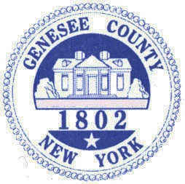

Bergen Fire Department
Preamble
The Bergen Fire Department would like to recognize the efforts of Melodie Kolmetz, one of our own dedicated members who volunteered her time to teach an Emergency Medical Technician (EMT) class held right at the Bergen Fire Department. It is estimated she spent in excess of 500 hours between preparation, class time itself, grading exams, and paperwork. Through her efforts, along with those members that assisted, the Bergen community has 30 EMTs available to help you in your time of need. Melodie truly represents what it means to be a community member and a Bergen Fire Department member, and we are thankful to call her our colleague and friend.
The following is an article by Melodie:
“The Bergen Fire Department dedicated our new ambulance on April 22, 2016 in the name of Barry Miller, but there were only 13 Emergency Medical Technicians (EMTs) available to staff it and most of them work full-time outside of the Bergen community. The community still needed EMTs to get the ambulance rolling down the road on calls.
We were fortunate to form a partnership with the LeRoy Ambulance Service Course Sponsorship and an EMT course was planned at the Bergen Fire Department. Right after Labor Day (2016), 46 students from Bergen and the surrounding communities began a 5-month long journey of learning. They were a mixture of brand new students and seasoned professionals due for recertification with a mix of ages ranging from 17 to 65.
Over the course of the next 5 months, one thing became apparent; the group became a close family. The experienced folks came to extra classes just to help the new students learn. Everyone worked together without regard to age, gender, or experience level. The teamwork and inter-agency cooperation was amazing.
On Thursday evening, January 19th, these students took their New York State Emergency Medical Technician certification exam. An amazing thing happened that evening, when the Bergen Fire Department gained an additional 15 EMTs and 5 more renewed their certifications through continuing medical education. There are currently 67 active members of the Bergen Fire Department and 30 of them are now EMTs.
In class, there were a husband and wife team, a mother daughter team, a father son team, and a father daughter team. There are now two families with 3 EMTs in the family and five families with 2 EMTs in the household. Some of these people have only lived in Bergen a short time. Some grew up here, and some are second and third generation legacy members of the Fire Department. The most important part is that their community is also their family. These students gave up easily 200 hours of their time to provide a much-needed service to their community, all in the name of Barry Miller.
The work isn’t done. There is still training to be done so that these new EMTs can go on calls. They will all keep pushing on to provide emergency medical care for the community. They know that Barry has been with them all the way and they will continue to carry on his legacy. The Bergen Fire Department is all one big family, including firefighters, EMTs, Fire Policemen, Explorers, and Auxiliary members. In a small community like Bergen, your neighbor is your family too. We are so proud of these individuals who have stepped up to provide emergency medical care to our community.” Melodie Kolmetz

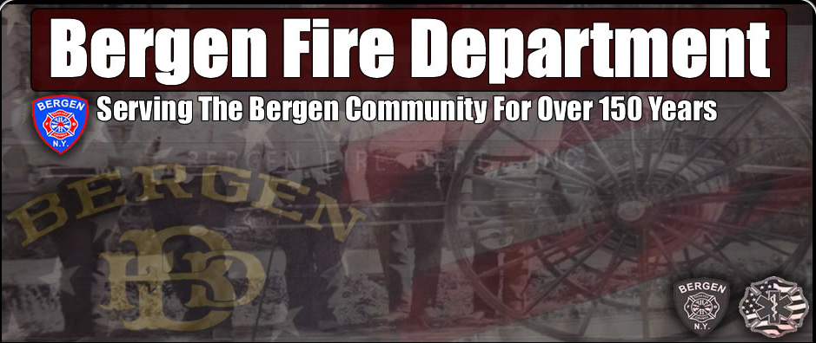
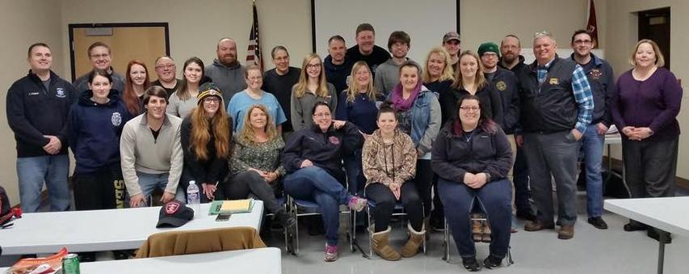

Library News by Nancy Bailey

Stay connected with your Library by checking us out at www.byron-bergenpubliclibrary.org or friend us on Facebook and follow us on Twitter! We have lots of great programs coming up! We also have volunteer opportunities so call or stop in for more information.
We have New York tax forms available here! You also can go to the website at www.nystax.gov and go to forms to print from home. If you need Federal tax forms, they are available at www.irs.gov or at the larger Libraries in Batavia and Brockport.
Library has toddle/preschool story time at 10:30am on Fridays until April 7th for its winter session and will begin its spring session on April 21st. We enjoy a different themed story each week with a related craft and a snack! Registration is recommended by calling or stopping by the Library.
Book discussion group meets on 2nd Thursday of each month. March 9th is our next meeting. Come join this fun group and see what your neighbors are reading!!! We enjoy lively conversation about the book and refreshments too! Stop by the Library to reserve your copy of our current book.
Join us for a St. Patrick’s Day for story time Tuesday March 14th at 6:30 pm with Miss Makayla. Wear something green and come enjoy a story, craft and a yummy treat! Registration is not necessary but appreciated
Movie on the Big Screen! At 2:30pm on March 17th featuring “Moana”! Enjoy popcorn and drink too! Join us on your day off from school.
Our Annual Pre –K outreach to our younger patrons and young at heart patrons will be March 22nd at 9:30 with Doug Rougeux –“The Bubble Man” with is “BubbleMania” show at the Bergen Evangelical Presbyterian Church! Doug will wow our young patrons with his bubbling and juggling talents as well as entertaining them with the science of bubbles using humor just plain fun!
Spring Break Happenings!! National Library Week too!
National Library week is April14th – 20th Stop in and take out a book or two and have a chance to win a prize!! Everyone invited to participate!
Monday April 10th – Babysitting workshop from 10am-3pm. Cost is $25/student and includes book. You must be at least 11 years old. Special pricing for workshop so sign up soon! Class size is limited. Payment is needed by April 5th.
Tuesday April 11th - at 2:30pm a special showing of “Sing”-- Come watch on the Big Screen and enjoy popcorn with your friends. Sign- up for this program is appreciated.
Friday April 5th from 10:30am -1pm Make and Take Craft day—just stop in anytime during the allotted hours and make a fun craft to take home and enjoy! No registration required.
Would you like to volunteer during the summer at the Library? For children 11yrs and older, the Library is looking for your help with the summer reading program. Stop by before June 17th to sign up! Chance to win prizes, help with programs, and place to meet new people! Come join by yourself or with a friend!! The summer reading theme this year is “Build a Better World!”
Enjoy eBooks and Audio books Anytime, Anywhere
Enjoy popular titles from the comfort of home
Byron-Bergen Public Library is proud to offer you best-selling and classic eBooks and digital audiobooks available 24/7 from the library’s digital collection, https://nioga.overdrive.com/ (Continued)

(continued)

“In accordance with Federal Law and U.S.D.A policy, this institution is prohibited from discriminating on the basis of race, color, national origin, sex, age, or disability. (Not all prohibited bases apply to all programs). To file a complaint of discrimination, write USDA, Director, Office of Civil Rights, 1400 Independence Ave., S.W., Washington, D.C. 20250-or call (800)795-3272 (Voice) or (202)720-6382 (TDD)”




You can browse the collection, borrow with your library card, and enjoy on your computer, tablet, smartphone or eReader. Many borrowed eBooks, audio books and more can be enjoyed immediately in your web browser or can be downloaded to the free OverDrive app for mobile devices. Digital titles can also be enjoyed on tablets and eReader devices such as the iPad®, NOOK®, and Kindle®. No matter how you plan to enjoy, titles will automatically expire at the end of the lending period. There are no late fees! With hundreds of popular titles to choose from, this new collection is guaranteed to have something for everyone. You can enjoy best-sellers and classic literature, stories for kids and teens, and much more anytime, anywhere.
The latest best sellers like Never, Never by James Patterson, Echoes in Death by J D Robb, and Racing the Devil by Charles Todd are just a few we have available to you at the Library to get your copy reserved on-line at www.byron-bergenpubliclibrary.org or stop in and our Library staff will be happy to help. New children’s books arrive weekly! New DVD’s monthly! Check out Playaways too! If we don’t have it we usually can request it free of charge from our Nioga Library System.
Stop in and get a Library card that will open up the whole NIOGA system for ordering books from the comfort of your home! There are databases; Librarian 24/7, Tumbling Talking Books, NOVEL list, downloadable books, e-books, Hoopla –downloadable music and much more are available to you!! Just go to www.byronbergenpubliclibrary.org and you’re on your way!
The Library has Roadrunner Internet service available. The Library has copy /fax service for a small cost. Interlibrary loans from any Library in the NIOGA Library system at our catalog www.byronbergenpubliclibrary.org. If you can’t find it, please ask! Stop in soon! For more information on our services or programs, please call the Library at 494-1120.
Village Historian News by Raymond MacConnell
The Village of Bergen is situated in the eastern part of the town. The village in the early days was where Route 262 (Townline Road) meets Route 19. It was first called Buell's Corners, then Bergen Corners. When a settlement developed near the new railroad, the settlement on the hill was sometimes called High Bergen and the new settlement was called Low Bergen, or Cork after the Irishmen who built the railroad or Wardville after Martin Ward and family who bought the land by the railroad and laid out the village. The area to the South was a busy four corners, with stores and taverns, houses, a school and the Congregational Church. Buffalo Road was the main road from Rochester to Buffalo. The Village of Bergen was incorporated on April 3, 1877. The village's first mayor or president was W. Monroe Sage.
This information was taken from the booklet "175th Anniversary, Town of Bergen, 1813-198" by Tally Almquist, Wanda MacVean and Sharon Pocock.

Town Clerk News by Michele Smith
Dog License: Please make sure your dogs are licensed and their rabies information is up to date.
ANTI-RABIES CLINICS: May 18th – Pembroke Highway Garage 1145 Main Rd. (Rt. 5) Pembroke
2017 Town & County Tax Payment - Last day to pay Town & County taxes is Friday, March 31st with 2% penalty, any taxes not paid by that date will be turned over to Genesee County Treasurer, payments can be left in the drop box after hours. .
Office Closing Office Hours
April 14th & 15th – Easter Monday, Tuesday, Wednesday and Friday
May 27th & 29th – Memorial Day 8:00 am – Noon & 1:00 – 4:00
Saturday 9:00 am - Noon
Closed on Thursday

“In accordance with Federal Law and U.S.D.A policy, this institution is prohibited from discriminating on the basis of race, color, national origin, sex, age, or disability. (Not all prohibited bases apply to all programs). To file a complaint of discrimination, write USDA, Director, Office of Civil Rights, 1400 Independence Ave., S.W., Washington, D.C. 20250-or call (800)795-3272 (Voice) or (202)720-6382 (TDD)”




Easter Egg Hunt Saturday, April 8th at 1:00 PM

The Bergen Business & Civic Association sponsors
This annual event at the Hickory Park in
the Village of Bergen.

“In accordance with Federal Law and U.S.D.A policy, this institution is prohibited from discriminating on the basis of race, color, national origin, sex, age, or disability. (Not all prohibited bases apply to all programs). To file a complaint of discrimination, write USDA, Director, Office of Civil Rights, 1400 Independence Ave., S.W., Washington, D.C. 20250-or call (800)795-3272 (Voice) or (202)720-6382 (TDD)”




