TOWN OF BERGEN NEWSLETTER
MARCH, APRIL, MAY 2018

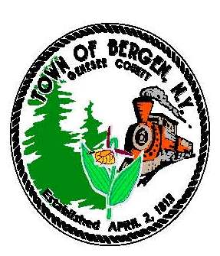

Editor: Michele Smith
Town News … From the Desk of Town Supervisor Ernest Haywood
It has been a very busy start to the New Year at the Town as we continue to work on the following:
Agreement with Genesee County for residents in Water District II and Peachy Road
The Genesee County Legislature has requested that the Town enter into an agreement to allow the county to charge a surcharge on water usage. The surcharge would go toward the cost of maintaining and expanding the water distribution system. In response to this request, the Town Board invited all affected residents to an informational meeting on 2/13/17. Robert Bausch, County Legislator shared the reason for the surcharge and answered questions. At this time the Town has tabled any action on the agreement and has requested more detailed information from the county.
Planned upgrades to the Robins Brook Park and to Drew’s Nature Center
The town was awarded a grant to assist with the funding to provide upgrades at both the Robins Brook Park and Drew’s Nature Center. We have completed a preliminary Master Plan for the parks and shared it with interested parties at the 2/27/18 board meeting. The proposed upgrades to Robins Brook Park include new fencing, parking lot improvements, a new pavilion, benches, signage and a hiking trail. Proposed improvements at the Drew’s Nature Center will include a new sign for the entrance and upgrades to the parking. We anticipate starting renovations this fall and completing them by the fall of 2019.
Transfer Station
With the proposed upgrades to the Robins Brook Park and the rising cost of operating the transfer station, the town board continues to discussions on the transfer station. At this time no decisions have been reached. As we continue to study the costs and options let me the town board will provide opportunities for the residents to have input.
Additional Water District
Based upon expressed interest from residents, the town board has been working with our Engineer on the possibility of expanding water town wide. We are hosting a public meeting to discuss this on 3/27/17 at 7 pm at the Byron-Bergen Central School Auditorium. A notice of this meeting is including in this newsletter.
Having been the Supervisor, since January, I have had the opportunity to meet several residents and have come to appreciate the dedicated service of my fellow board members. I also wanted to thank the dedicated elected public officials and staff of the town who work each and every day for the benefit of Bergen.
If you have any questions please don’t hesitate to contact me at 494-1121 ext. 22

“In accordance with Federal Law and U.S.D.A policy, this institution is prohibited from discriminating on the basis of race, color, national origin, sex, age, or disability. (Not all prohibited bases apply to all programs). To file a complaint of discrimination, write USDA, Director, Office of Civil Rights, 1400 Independence Ave., S.W., Washington, D.C. 20250-or call (800)795-3272 (Voice) or (202)720-6382 (TDD)”

From the Desk of County Legislator Robert Bausch

Following the November elections, the County Legislature reorganized in January and welcomed
three new Legislators: John Hilchey from District 1 (Towns of Oakfield & Alabama); Gordy Dibble
from District 3 (Towns of Pembroke and Darien); and Gary Maha from District 9 (west end of the City of Batavia). The former chair of the Legislature, Ray Cianfrini, did not seek reelection. My fellow legislators elected me as the new chair for a two-year term.

The new legislature will be addressing some significant issues remaining from the previous legislature. The most pressing is water, specifically increasing the water supply from the Monroe County Water Agency (MCWA). As this is being written various environmental studies are being completed and preparation is under way for the needed bonding. The total cost is estimated at $25 million. The county is also in the process of identifying grants, both state and federal, that may be available to assist with the cost. Bottom line is that the county is out of water and all the towns are requesting additional capacity. In addition the county water plant in Batavia which currently serves approximately 45% of the county population is aging and in need of replacement.
On February 24th, the legislature received the initial report on the status and need for a new jail. This has been, and will continue to be, a very slow and deliberate process. In January I toured the current facility with the Jail Superintendent, Bill Zipfel, and fellow legislator and former sheriff, Gary Maha. The physical structure is severely lacking and staff working conditions are poor / inadequate. The newest area is 40 years old and the oldest and largest area is over 100 years old. The State Department of Corrections continues to grant the county a variance that allows the jail to house 10 more male inmates than its designed capacity but there is no reason to expect this wavier to continue indefinitely.

Genesee County continues to not be immune from the opioid crisis or any of the related drug issues. Professionals in law enforcement, mental health and medical community in general are continuing to report significant and increasing drug activity. Unfortunately the death toll continues to rise with Genesee County reporting 2 to 3 deaths per month. In addition, a significant number of deaths, for privacy and other reasons, are not reported as drug related that are drug related.
Some good news: Sales tax receipts increased for the first time in the 4th Qt of 2017 in over a year. The increase was driven by a stronger economy and higher gas prices which account for 20 to 25% of the county’s sales tax revenue. Scott Gage, Director of the Job Development Bureau, reported that for the week ending February 10th his office had 1046 job postings for available positions in the county.

Town of Bergen Parks Master Plan informational meeting for Robins Brook Park and Drews Nature Center is being held at the Bergen Town Hall Tuesday, February 27th at 7:00 pm. To view the proposed Parks Master Plan go to the Town of Bergen website at www.bergenny.org under Town News & Legal Notices. All interested parties are invited to provide comment either in person at the information meeting or via e-mail at supervisor@bergenny.org

Historian News by Thomas Tiefel

“In accordance with Federal Law and U.S.D.A policy, this institution is prohibited from discriminating on the basis of race, color, national origin, sex, age, or disability. (Not all prohibited bases apply to all programs). To file a complaint of discrimination, write USDA, Director, Office of Civil Rights, 1400 Independence Ave., S.W., Washington, D.C. 20250-or call (800)795-3272 (Voice) or (202)720-6382 (TDD)”

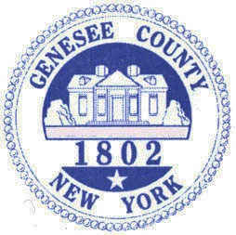

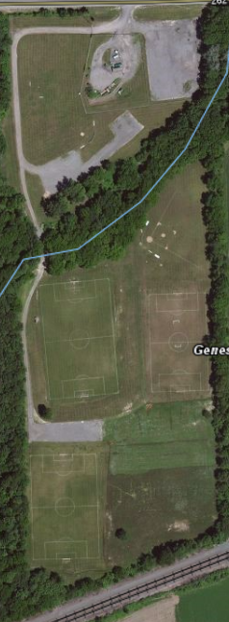
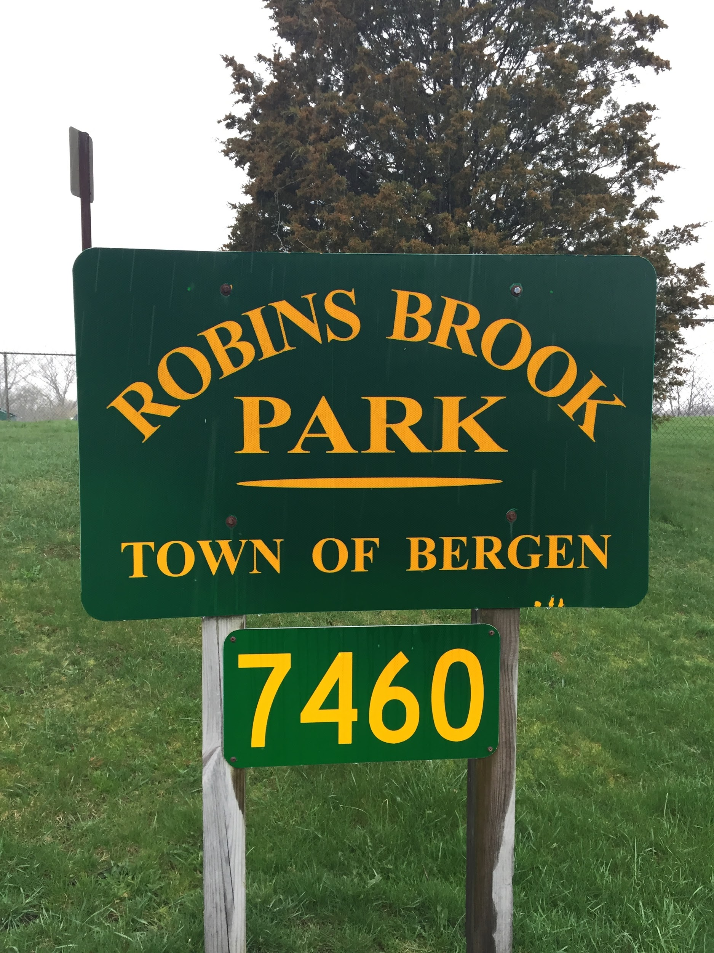


Library News by Nancy Bailey

Stay connected with your Library by checking us out at www.byron-bergenpubliclibrary.org and “Like” us on Facebook! Find us on Twitter too! Lots of great programs coming up!!
We have New York tax forms available here! You also can go to the website at www.nystax.gov and go to forms to print from home. If you need Federal tax forms, they are available at www.irs.gov or at the larger Libraries and Post Offices in Batavia and Brockport.
Hoopla is here and available at your Library! What is Hoopla? A place to get all your digital movies, TV shows, e-books, audio books, comics, and music! All you need a valid Library card and you are on your way! Check us out on the web at www.byron-bergenpubliclibrary.org!
Tech Time at the Library! Call and sign up any Wednesday during regular Library hours to receive help to set up your e-reader, tablet or phone to get use Library digital platforms. Please come with your passwords and Library card and all your questions to be answered.
Health Fair on March 3rd from 10-12! Join us to find out different ways to stay healthy! Healthy Refreshments will be served! Young Living Oils with Andrea Golino, It Works! with Chris Ariyaratnam, Bergen Chiropractic with Dr. Amy, Peer Educator with Jill Smith. Stop in and see all Bergen has to offer! For a fun educational day! Something for everyone! Call 494-1120 for more information.
Library has preschool story time at 10:30am on Fridays. Join Miss Brilyn for some stories, a related craft and a snack too! Registration is recommended by calling or stopping by the Library.
Book discussion group will meet March 8th, April 12th, May 10th, and June 14th at 7 pm. Join this and explore new venues and topics. We have lively conversation about the book and refreshments to enjoy too! Stop by or call the Library to reserve your copy of our current book.
Save the date of March 14th for our annual pre-school concert! Join our smaller patrons at the Bergen Evangelical Presbyterian Church at 9:30am for music and fun with Checkers and his “On your Mark-Get Set -Read”! A unique magic and juggling show full of fun and learning! A great way to get the children excited about reading! No Registration required! Just come join the fun!
Join us on St. Patrick’s Day for a Make and Take Craft day on Saturday March 17th from 10:30 to 12:30pm with Miss Makayla. Wear something green! Enjoy a green treat!
Pajama Story time Tuesday March 27th at 6:30pm! Come join us in your PJ’s for a fun story, craft and snack too. Miss Makayla will be reading stories about spring so bring your favorite stuffed animal too. Registration is not required.
Spring Break Happenings!! Yes we are open!!
Tuesday April 3rd at 6:30 – “Noah’s Ark-Build a Bear” workshop coming to the library! Join us for a story and a choice of animal- frog, lamb, chick, or bunny to stuff! Cost will be $2/per person. Space is limited so sign up soon!
Wednesday April 4th at 2:30 –Star Wars-The Last Jedi Movie will be showing on the Big Screen! This movie is rated PG so grab a friend and we will provide the popcorn! (Continued)

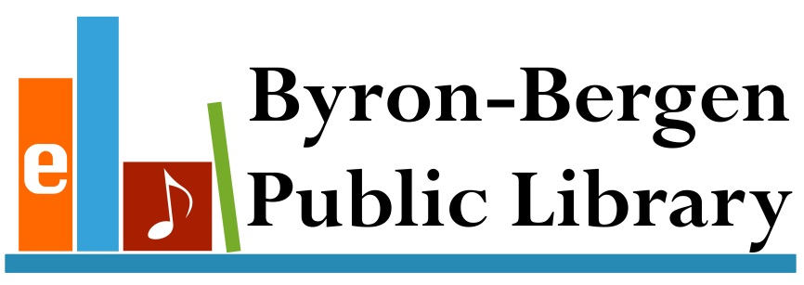

Thursday April 5th – Babysitting workshop from 10am-3pm. Cost is $25/student and includes book. You must be at least 11 years old. Special pricing for workshop so sign up soon! Class size is limited. Payment is needed by Mach 30th.
Friday April 6 – Coloring Fun! From 10:30 to 1:30- Come color with us! Experience the latest trend in relaxation- coloring! Studies show coloring can have a calming effect on the adult mind and helps promote overall wellness. All supplies provided-Along with refreshments. All ages welcome
National Library week is April 10th-14th – Stop in and take out a book or two and have a chance to win a prize!! Everyone invited to participate!
Game day at the Library on Wednesday April 18th at 5pm! Bring the family and join us as we explore different board games, card games, and Xbox games! Pizza and drink provided! No registration needed!
Saturday Morning Movie! April 21st – Enjoy a fun movie for the whole family showing at 10:30am – check out the web at www.Byron-BergenPublicLibrary.org for more information.
Pajama Story time Tuesday April 24th at 6:30pm! Come join us in your PJ’s for a fun story, craft and snack too. Miss Makayla will be reading stories about spring so bring your favorite stuffed animal too. Registration is not required.
Thursday May 3rd at 7pm – Join the Library and the Bergen Historical Society for a fun presentation on hats and headdresses from around the world! Stacey W. Miller from Hat Horizons will share her insight on all the variations of hats and headdresses that are a tribute to the diversity of the world’s cultures. No registration required! Refreshments provided.
Saturday Morning Movie on May 19th at 10:30- Save the date. Movie to be determined so check the website for more information or stop into the Library.
Come enjoy some great music for the Byron Memorial Day events with Hill Brothers in concert on May 28th at 11:30am--after the parade at the Byron Fire Hall on Rt.262. A fun-filled afternoon of sing-alongs, humor, and participatory songs for the whole family to enjoy!
The Library will be hosting the Kelley’s Hero’s Marching Band at the Bergen Park Festival on June 9th in the parade and right after the parade too with a field show not to be missed! Stop by visit the book sale too!
Would you like to volunteer during the summer at the Library? For children 11yrs and older, the Library is looking for help with the summer reading program. Stop by before June 19th to sign up! Chance to win prizes, help with programs, and place to meet new people! Come join by yourself or with a friend!!
Enjoy eBooks and audio books Anytime, Anywhere
Enjoy popular titles from the comfort of home
Byron-Bergen Public Library is proud to offer you best-selling and classic eBooks and digital audiobooks available 24/7 from the library’s digital collection, https://nioga.overdrive.com/
The Library has Roadrunner Internet service available. The Library has copy /fax service for a small cost. Interlibrary loans from any Library in the NIOGA Library system at our catalog www.byronbergenpubliclibrary.org. If you can’t find it, please ask! Stop in soon! For more information on our services or programs, please call the Library at 494-1120.

“In accordance with Federal Law and U.S.D.A policy, this institution is prohibited from discriminating on the basis of race, color, national origin, sex, age, or disability. (Not all prohibited bases apply to all programs). To file a complaint of discrimination, write USDA, Director, Office of Civil Rights, 1400 Independence Ave., S.W., Washington, D.C. 20250-or call (800)795-3272 (Voice) or (202)720-6382 (TDD)”



Please support the Veterans Memorial Proposed drawing of Memorial
It has been 100 yrs since World War I ended and a dedicated group of
Veterans formed the American Legion. The Sackett-Merrill-White
American Legion #575 will be honoring the veterans of the Town and
Village of Bergen who served in WWII, Korean, Vietnam and Gulf War/
War on Terrorism by placing a new monument in Hickory Park. This
monument will join the existing monument which honors all WWII
Veterans from our area. A group of ladies in the Town and Village
known as the Triangle Club bought and placed the Veterans Monument in
Hickory Park in the Village of Bergen.

Our local American Legion has been able to purchase the stone for the monument (it has been quarried from the same
area as the stone of the Vietnam Memorial in Washington D.C.) and will have the stone inscribed. We are asking that the community come together in support of the installation and landscaping of the new memorial planned for Hickory Park; a symbol of honor to our veterans for their service. The monument will honor the men and women that have served as well as those that are now serving. Please consider donating to the Memorial Fund. You can mail your tax deductible donation to the Sackett-Merrill-White Post 575 to P.O. Box 207 Bergen, NY and note that it is for the memorial fund. If you have any questions please contact Thomas F. Williamson Commander of the Bergen Legion at 494-1627.

Easter Egg Hunt Saturday, March 24th at 1:00 PM
The Bergen Business & Civic Association sponsors
This annual event at the Hickory Park in
the Village of Bergen.

Town Clerk News by Michele Smith

Dog License: Please make sure your dogs are licensed and their rabies information is up to date.
ANTI-RABIES CLINICS: May 17th – Pembroke Highway Garage 1145 Main Rd. (Rt. 5) Pembroke
2018 Town & County Tax Payment - Last day to pay Town & County taxes is Friday, March 31st with 2% penalty, any taxes not paid by that date will be turned over to Genesee County Treasurer, any payments can be left in the drop box after hours. .
Office Closings Office Hours
March 30th & 31st – Easter Monday, Tuesday, Wednesday and Friday
May 26th & 28th – Memorial Day 8:00 am – Noon & 1:00 – 4:00
Saturday 9:00 am - Noon
Closed on Thursday

“In accordance with Federal Law and U.S.D.A policy, this institution is prohibited from discriminating on the basis of race, color, national origin, sex, age, or disability. (Not all prohibited bases apply to all programs). To file a complaint of discrimination, write USDA, Director, Office of Civil Rights, 1400 Independence Ave., S.W., Washington, D.C. 20250-or call (800)795-3272 (Voice) or (202)720-6382 (TDD)”






Informational Meeting Notice
Town of Bergen Future Areas of Service
For Public Water
Based upon interest expressed by numerous Town residents over the past several years, the Town of Bergen has authorized our Town Engineer, Chatfield Engineers, to evaluate the feasibility of providing public water to the remaining areas of the Town of Bergen that currently do not have public water available.
The Town of Bergen will be hosting an Informational Meeting to present the findings of the investigation, to seek public input and answer questions. The informational meeting will be held on Tuesday March 27, 2018, 7:00 pm at the Byron-Bergen High School Auditorium.

“In accordance with Federal Law and U.S.D.A policy, this institution is prohibited from discriminating on the basis of race, color, national origin, sex, age, or disability. (Not all prohibited bases apply to all programs). To file a complaint of discrimination, write USDA, Director, Office of Civil Rights, 1400 Independence Ave., S.W., Washington, D.C. 20250-or call (800)795-3272 (Voice) or (202)720-6382 (TDD)”




