TOWN OF BERGEN NEWSLETTER
December 2018, January and February 2019

Michele M. Smith, Editor

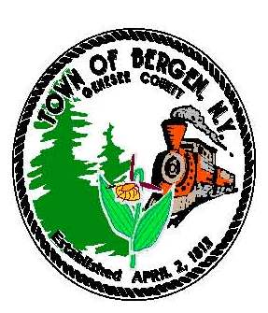

TOWN NEWS … FROM THE DESK OF TOWN SUPERVISOR Ernest Haywood
The fall season flew by and winter arrived too fast. The town staff and Board have been busy with the preparation of the 2019 town budget and work on several projects to improve our town. On behalf of the board and the staff Happy Holidays and the best in the New Year!
POTENTIAL WATER IMPROVEMENT BENEFIT AREA:
The engineer is finalizing the preliminary engineering report for the provision of water to all areas of the town that currently do not have it. We are in the process of completing our application to the USDA-Rural Development to determine the amount of grant and low interest loan funding we will be eligible for and if the project will be done in phases or all as one project. Our goal is to submit the application by the end of December. Once we know what funding is available, we will hold a public meeting to share the costs with residents who currently don’t have public water and to seek input from the residents.

2019 TOWN BUDGET
Thank you to the town board and the staff for their diligence in completing the 2019 town budget. The approved budget calls for a 2% reduction in Town taxes and the budget was within the limits of the Tax Cap. The Fire District budget experienced a 2% overall increased due primarily to new state mandates for insurance.

RENOVATIONS TO THE LIBRARY BUILDING
A new furnace and air conditioning unit was installed at the library and paid for through grant money obtained by the library. We continue to work on the necessary paperwork to obtain a contract from the state for the grant funding to proceed with additional renovations to the library building. The renovations will include new bathrooms, upgrades to the fire alarm system, and other renovations to improve accessibility. At this time we anticipate starting these renovations in the fall of 2019.

COUNTY PROPOSES TO TAKE BACK SALES TAX
As the county looks for ways to fund a new mandated jail, they have put forth a resolution to take back the sales tax they share with towns and villages in Genesee County as of the end of 2019. The town currently depends upon the sales tax revenue to offset our costs. If we lose the sales tax revenue our town taxes would have to be raised significantly. I have strongly advocated that such an agreement will have a significant negative impact on the Town of Bergen. Along with three other town supervisors, we have suggested alternative proposals, which would lessen the financial impact to our county legislators. To date the county has chosen not to consider these and other options presented to them. Please join me and my fellow elected officials from the town of Bergen, in letting Robert Bausch our county legislator know the devastating fiscal implications to the Town if the county takes back sales tax. He can be reached at 494-2114 or via e-mail rjbausch@yahoo.com

(Continued)
“In accordance with Federal Law and U.S.D.A policy, this institution is prohibited from discriminating on the basis of race, color, national origin, sex, age, or disability. (Not all prohibited bases apply to all programs). To file a complaint of discrimination, write USDA, Director, Office of Civil Rights, 1400 Independence Ave., S.W., Washington, D.C. 20250-or call (800)795-3272 (Voice) or (202)720-6382 (TDD)”

“In accordance with Federal Law and U.S.D.A policy, this institution is prohibited from discriminating on the basis of race, color, national origin, sex, age, or disability. (Not all prohibited bases apply to all programs). To file a complaint of discrimination, write USDA, Director, Office of Civil Rights, 1400 Independence Ave., S.W., Washington, D.C. 20250-or call (800)795-3272 (Voice) or (202)720-6382 (TDD)”

Improvements to Robins Brook Park and to the Drew’s Nature Center
If you have driven by Robin’s Brook Park you have seen the extensive work Mike Johnson, Superintendent of Highways, and his crew have completed over the past several months. The work will continue next year with a goal to complete all proposed upgrades by the end of 2019. The improvements include upgrades such as a pavilion, walking trails, a new ball field and relocation of parking at Robins Brook Park. At the Drew’s Nature Center renovations continue and will include new signage and upgrades to the parking area and entrance. In October, Jared Fregoe, a scout from Bergen Troop 31, built and installed two signs for the Nature Center for his Eagle Scout project. The town recognized Jared with a proclamation at the installation ceremony.

Again Happy Holidays and the best in the New Year. I once again thank you for the opportunity to serve you and ask that if you any questions or comments you contact me at 494-1121- ext. 22.

From the Desk of County Legislator Robert Bausch

The 2019 county budget is complete and should be passed at the November 28th legislative meeting,
assuming no unforeseen issues. The tax rate will decrease $0.03 per thousand. This is the result of
increased assessed value in the county from new commercial projects that are now being fully assessed
and the old county nursing home which is now privately owned. The budget is under the state mandated tax cap which is important because if the county overrides the tax cap $1,000,000 to $2,000,000 NYS mandated services reimbursement is in jeopardy.

The new budget is funding some critical shortcomings in the county. After much study, the legislature determined that there was a need for the reinstatement of an assistant county engineer. This individual will provide the professional expertise necessary to support the demands of the water projects, bridge programs, and numerous other initiatives. The IT Department was unable to meet the requirements for various county and state programs so an additional position was approved. Both positions received prior approval in late summer and individuals have been recruited. The District Attorney’s office is facing many challenges so an additional Assistant DA position was budgeted. Lastly, there is a strong desire to continue upgrading the county parks and ensuring that maintenance is performed timely, so additional staffing was approved.
The Jail project continues to move forward. The County advertised for architectural proposals and received four. The jail work group interviewed two firms. Both made strong presentations and were asked to provide additional information, including a pricing structure. When the jail project started 18 months ago, the projected timeline was 5 years to completion. Being thorough and cost conscious, that is realistic.
Phase 2 of the water project is progressing. Bid documents are being prepared, SEQR has been approved, the closing on 4 parcels in Monroe County is almost complete, and financing is progressing. This project should be completed within two years. Phase 3, which is very important to the Byron-Bergen area, initial design is starting.
The current sales tax agreement between Genesee County and the City of Batavia expired earlier this year and an extension is expected to be granted by the State Controller through December 31, 2019. A new agreement with the city is complete but will require special NYS legislation because it will be for 40 years. A revenue sharing program with the towns and villages has been approved by the legislature for 2020 with the anticipation that a similar program will be the basis for future revenue sharing. Unfortunately, these changes were required to provide funding for the new jail.
(Continued)
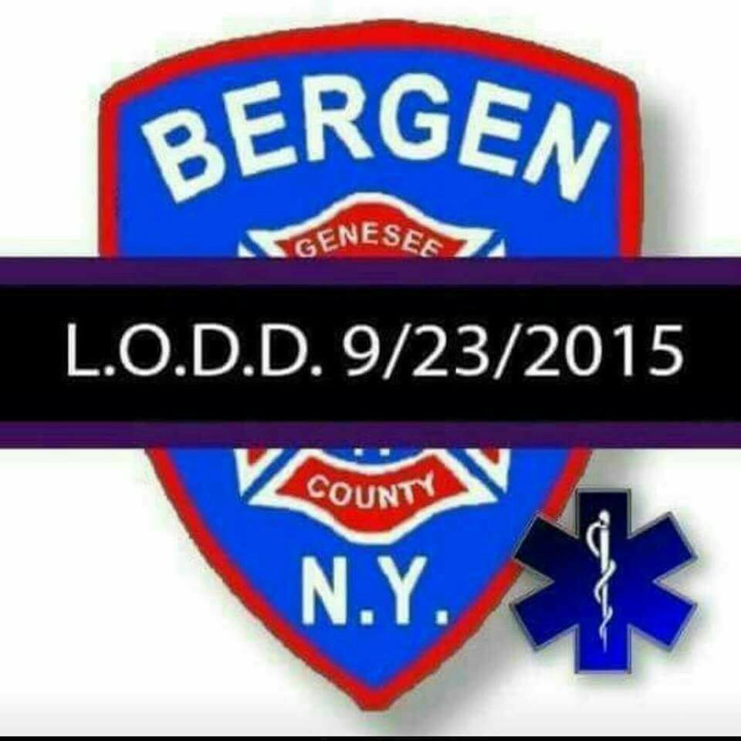

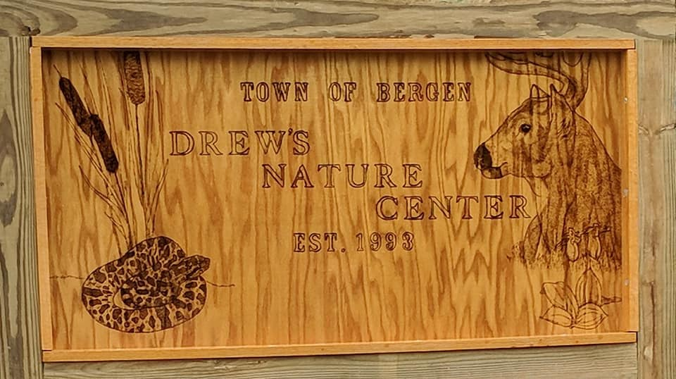
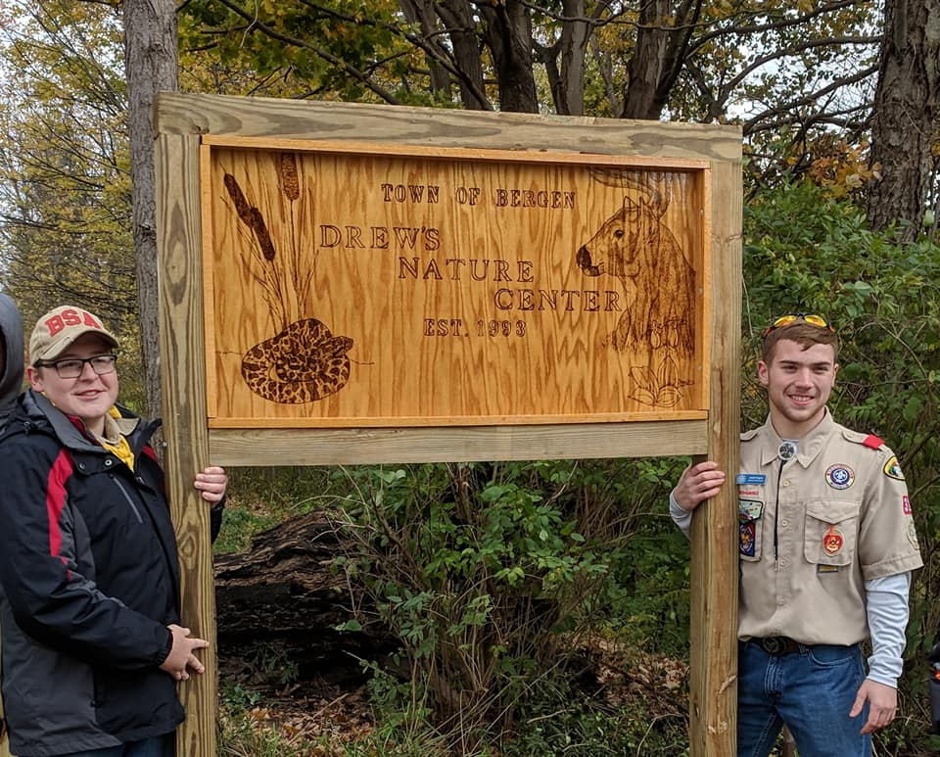
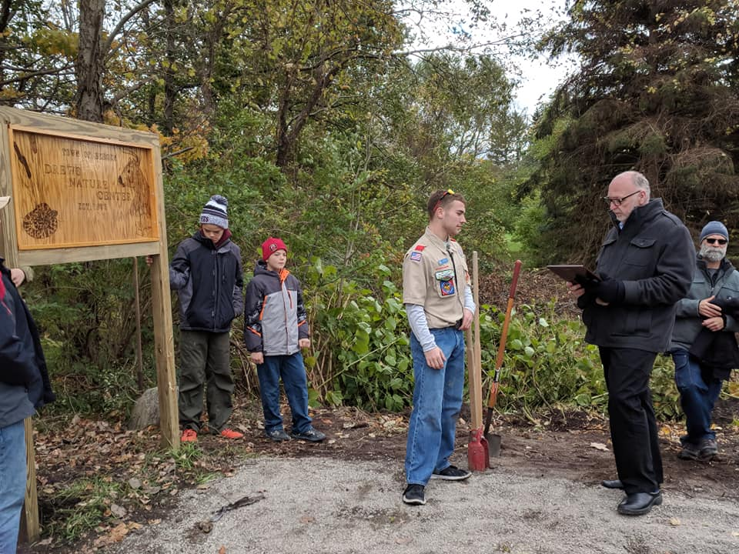
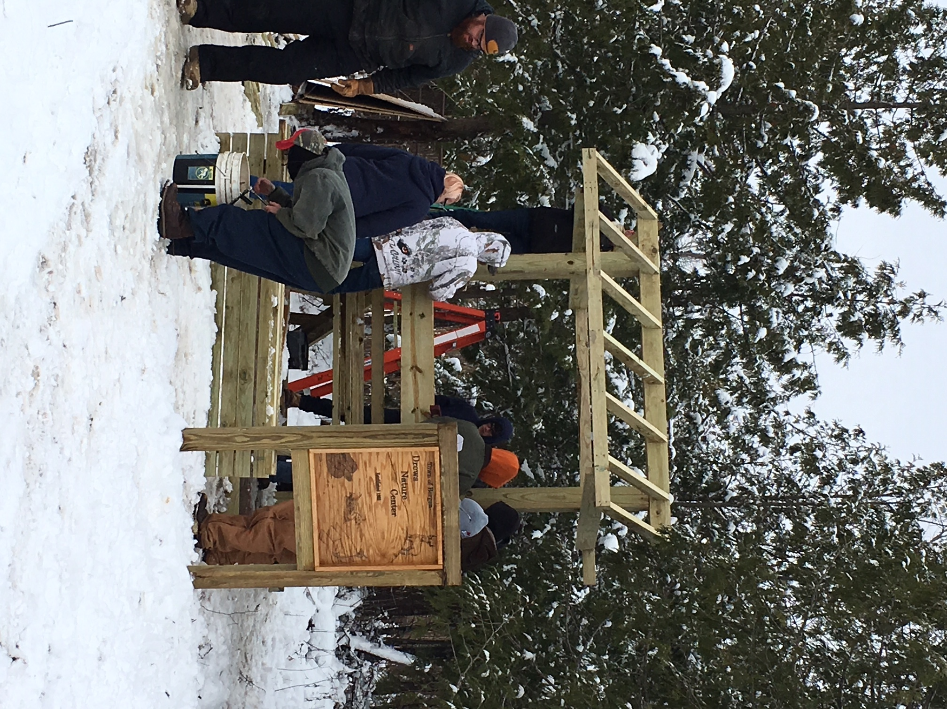

I would like to thank everyone who took the time to consider and vote on the proposal to change the term of county legislators from two to four years. I was a strong supporter and very much appreciate its passage.
In closing, I would like to wish everyone a happy holiday season.

Town Historian News by Tom Tiefel

It’s with great sadness that we had to say goodbye recently to a colleague and dear friend, Theresa Alexander-Pengelly. For those who didn’t know her, Theresa was President of the Bergen Historical Society and had been a member for many years. I first got to know Theresa when I moved to Bergen nearly 25 years ago . Smart, funny, witty, she took the time to befriend an outsider who knew very few people and whose knowledge in Bergen’s history was minimal at best. She encouraged me to join the Historical Society and I had soon realized that Theresa was one you could call a true friend. As the years passed, we often worked side by side coordinating events, volunteering, and discussing the monthly business during Historical Society meetings. Anytime I had to stop by Theresa’s home to either pick up or drop something off “quickly”, the definition of “quickly” was open to interpretation. A chair and some cookies were almost always waiting. I will cherish those visits and times we spent talking about the past, the present, and the future. Our community has lost one of its greatest members and we will miss her dearly.

Holidays are a time of thanks and a time to reflect on the year that draws to a close. With that said, I wish to thank not only our Town Board, but each and every one of you that helped make another year for the Hartford Livery Museum a success. From your donations, to our Facebook page, to those of you that volunteered, Gina Schelemanow and myself are blessed to work in such a generous and supportive community. Happy Holidays and Best Wishes into 2019!

Village Historian News by Raymond McConnell
PICTURES OF DAYS GONE BYE!
If you have seen some of the old photos of Bergen, you would have seen on the reverse side in very small print the name of E.R. Mann, photographer. Eaton Richmond Mann lived with his mother on Church Street, where his studio also was located, until about 1911. I believe he left Bergen about 1911 just after his mother's death. He then lived in Buffalo. He is buried in Mount Rest Cemetery with his mother. No date of death is on his stone, so that is in question. Richmond was born in 1874. His father was killed early on by a train. He took many pictures of high school teams, family group photos, and street scenes of Bergen.
He was an avid bike rider and could be seen with his camera on his back. He would travel many miles on his bike. The Buffalo News reported many of his long bike trips in the newspaper. He also was a composer of music and played the piano and often played for village parties. The sheet music included:"My Tallahassee Lassie," "On The Alert," and the "Dewey Two-Step." The many post cards were sent to Germany to be printed, and most bear the mark, Printed in Germany.





Happy Holidays!! During your holiday rush of activities don’t forget to enjoy the many holiday books and movies available at your Library! We have cookbooks for meals on the go as well as baking cookbooks for the perfect Christmas cookie! Stop by when the children are on vacation for boredom buster books and craft books to inspire their imaginations. Don’t forget your audio books for the long car rides to Grandma’s house! Search our website at www.byron-bergenpubliclibrary.org and check out Library happenings as well as our on-line catalog or join us on Facebook and Twitter too!

The Holiday Library hours will be:
Tuesday December 25th -Closed
Merry Christmas!
Wednesday Dec. 26th 10am-12pm and 2pm-8pm
Thursday Dec. 27th -10am-12pm and 2pm-8pm
Friday Dec. 28th – 10am- 6pm
Saturday Dec. 29th 10am – 1pm
Tuesday January 1^{st-} Closed
Happy New Year!

Holiday Happenings-
Girls night out- December 6th at 7pm- Join us as we make an ornament- using English paper piecing- that you can keep or give a gift. Great way to make holiday memories and learn something new! Refreshments and fun! Registration is appreciated but not necessary.
Movie Day on Friday December 21st Stop anytime from 10:30 am. We will be enjoying a classic movie for the whole family to enjoy- Emmett Otter’s Jug-Band Christmas. Enjoy sharing this classic with your favorite child- featuring Jim Hanson’s Muppets- run time 60 minutes. Call the Library for more information. No Registration required.
Game Night at the Library will be Wednesday Dec. 26th – Come join us for games of all kinds-board games-card games and pizza and a treat! All the fun starts at 5pm! Registration is appreciated.
Craft/Maker Space fun at the Library – Thursday Dec. 27th from 3-6 pm- Stop to create and explore at the different stations we will have set up! No Registration required.
Did you get a new Gadget for Christmas? Do you need help getting Library books, movies and music on you gadget? Set up an appointment any Wednesday during regular Library hours to get the help you need. There are more free materials for our patrons that have E-readers, smart phones, laptops and tablets using your Library card. Call 494-1120 or stopping in.
Pre-school/Toddler story time will run Fridays at 10:30am starting on January 11th. Join us for a story, craft and a treat with Miss Brilyn! This is recommended for ages 2-5 but younger children are welcome with their parents/guardian. Registration is appreciated.
Book Club meets the 2nd Thursday of every month at 7pm! Join us as we explore new and different books and meet new people! No registration required- call the Library for more information and to order the next book we are reading.



Safety Day at the Library Friday January 25th– Home Alone Workshop from 9-11am-Cost $15.
Babysitter’s Workshop from 11:30 to 4:30 pm. The cost is $25 with book included. Just Yell FIRE! Workshop for girls ages 11-13 from 4:30- 6:30 pm. Sign up for Babysitter and Just Yell FIRE! and receive a discount of $40 for both. Registration and payment is due by January 18th. Please call 494-1120 for more information.
Winter Fun Story time January 22nd at 6:30 pm. Join us for a story or two – wintery craft and a snack – no registration necessary. Fun for all ages!
February Break Happenings! Look upcoming activities during winter break– check us out on the web at www.Byron-BergenPublicLibrary.org.
Did you know that the Library has free digital magazines? Check it out on our website at www.byron-bergenpubliclibrary.org . All you need is a valid Library card. Click on RBdigital – sign in with your Library Card and you are on your way!

Getting a new E-Reader for Christmas or have one now…..Check out our catalog for downloadable e-books free with a valid Nioga Library card. We have Digital movies- music- eBooks- and audio books through HOOPLA and OverDrive/Libby apps! All you have to do is stop at our website www.byron-bergenpubliclibrary.org to sign up with your Library Card!

If you don’t find what you are looking for at the Library, we can order it for you from the NIOGA Library System. The website is www.byron-bergenpubliclibrary.org and click on catalog to see if our system has the book you are looking for. You then can order online, call the Library at 494-1120 or stop in with your request.
The Library has copy /fax service for a small cost, Roadrunner Internet on three computers, Wi-Fi and interlibrary loans from any Library in the NIOGA Library system. Check us out on the web at www.byron-bergenpubliclibrary.org or stop in and we will assist you! You can also friend us on Facebook and follow is on Twitter to keep up with the latest events. For more information on our services or programs, please call the Library at 494-1120.
Happy Holiday Reading -
Nancy Bailey
Library Manager

**********************************************************************************************
From the Byron-Bergen Public Library Board of Trustees:
There will be an opening on the Board of Trustees coming January 2019. If you ever wanted to volunteer for the Library and want to make a difference in your community – send a letter to Byron-Bergen Public Library stating your interest to P.O. Box 430, Bergen NY 14416.
The Library Board meets the 2nd Monday of the month. Need to be a resident of Byron or Bergen. Call the Library at 585-494-1120 with any questions.








Town Highway by Mike Johnson
Please be reminded that during a “normal” snow event, it will take plow trucks 2 ½ to 3 hours to complete one pass on all roads. As such, it is very possible that everyone will encounter less that pleasant driving conditions at times. Late evenings and early mornings, with very light traffic volumes, will received lower levels of service. Ever y attempt will be made to maintain open and passable roadways, both for normal and emergency traffic. At times, lanes may narrow and accumulate snow. The Town is responsible for snow and ice removal on all Town and County roadways in Bergen as well as State routes. This winter, as in the past, we will strive to provide the same level of the safest possible roadways at all times, within reason and budget constraints.
Also remember to use caution on snow covered roads. Here are a few safety tips: Slow Down, Make safe lane changes, pump your brakes on slick roads, and lastly don’t tailgate, especially the plow truck. If you can’t see him in his side mirror there is a good chance he can’t see you! And for on First Aid rule: Carbon Monoxide is called “the silent Killer” if you go off the road keep your exhaust clear of snow.
Two additional reminders: Mailboxes, if damaged by our plows will be repaired or replaced, within Town Board adopted limits, as soon as weather, time permits. PLEASE, when installing or repairing your mailbox, remember that our trucks require a minimum 17 ½ feet from center of the roadway. Also, take into account the excessive force of the exhausted snow as it strikes your mailbox assembly.
Please don’t hesitate to call me at 494-1362 if I may be of service. Highway Department hours are 7:00 am – 3:30 pm Monday thru Friday. However, you may leave a message 24 hours a day on our answering machine, and I will return your call as soon as possible. In closing, the entire highway department would like to wish everyone a healthy and happy holiday season, and a safe winter.
Community Christmas Activities
Annual Village Tree Lighting will be held Monday Dec 3rd
Carolers leave Hickory Park at 6:15 pm to escort Mr. and Mrs. Claus to Ward Park.
Ward Park festivities include meeting the Clauses, tree lighting, hot cocoa and cookies, elementary band, decorated trees by community organizations, etc. Bus provided to ride back to Hickory Park
For further information contact the village office 494-1513

Bergen Community Christmas Concert
Saturday, December 8th
6:00 PM
Bergen Evangelical Presbyterian Church Christmas Eve Service at 5:00 PM
38 S. Lake Ave

Join us for an evening of Christmas music performed by members of the community. Young and old are welcome to attend. Special Family Friendly seating available this, bring all your little ones! There will be Cookies, milk, and cocoa to follow.
New this year: Need a ride? Please call 494-1251. Calling all musicians- please share your talent with our community!
Questions about attending or performing? Contact Jocelyn Rebisz, 494-6031.

Saturday, December 8th
Santa’s Workshop
9:00 am – 1:00 pm Gillam-Grant Community Center

Breakfast, Mrs. Claus Kitchen open all day, Entertainment, Cookie Decorating,
Christmas BINGO, Face Painting, Coloring Contest, Toy Raffles, Santa’s Secret
Kids Store, Christmas Crafts, Santa Visits.




Town Clerk News by Michele M. Smith

Town & County Taxes
If you pay your own taxes, you will receive your tax bill shortly after January 1, 2019. If you should receive a tax bill that an escrow company or someone else is supposed to pay, please call me right away. Don’t put it aside and assume that it will be paid. Also, if you have paid off your mortgage and did not receive a tax bill, you should call me. No matter what the situation is, you are responsible for your taxes and penalties, if it is not paid. If you are leaving town for the winter please leave your “winter” address with me so late fees can be avoided. Credit cards (Visa, MasterCard, Discover and American Express) are accepted for payment with a convenience fee.
Tax payments cannot be received before January 1, 2019 per the County Treasurers office, all payments will be stamped after that date. Taxes are due penalty free by January 31st, all taxes have to be paid to me by March 31st. After March 31st, the unpaid taxes are returned to the County Treasurer. If you are going to pay them to the County Treasurer by mail, you will need to call his office in Batavia at 344-2550, ext. 2211 as there will be additional penalties.

Dog License News:
I hate to “hound” you, but if your dog’s license renewal is due or past due, please take care of it so we don’t have to send you a reminder notice or eventually a court appearance ticket. All dogs, four months of age need to be licensed even those in apartments. Proof of a rabies vaccination and proof of neutering or spaying must be presented at the time of licensing. If you receive an appearance ticket, you will have to pay a fee of $25.00 plus also pay for your dog’s renewal. If there is a problem getting an appointment for a rabies vaccination, etc., please call me. I have an answering machine so you can call anytime day or night.

Office Closing Office Hours
December 24rd & 25th – Christmas Holiday Monday, Tuesday, Wednesday and Friday
December 31st & January 1, 2019 – New Years 8:00 am – noon & 1:00 – 4:00
January 21, 2019 – Martin Luther King Jr. Day Saturday 9:00 am - noon
February 18, 2019 – Presidents Day Closed on Thursdays

ATTENTION SNOW BIRDS
If you are leaving town for the winter please leave your winter address with the Town Clerk/Tax Collector to mail your Town & County Tax Bill to avoid any late fees. All Tax Bills are mailed on December 31st and are due by January 31st without penalty.
Michele Smith, Town Clerk/Tax Collector
494-1121 Ext. 21




Transfer station Holiday Hours
Normal Hours during the Christmas Holidays Saturdays 9:00 am – 3:00 pm

HAPPY HOLIDAYS FROM THE TOWN OF BERGEN
TOWN of BERGEN
10 HUNTER STREET
BERGEN, NY 14416
bergenny.org




“This institution is an equal opportunity provider and employer. If you wish to file a Civil Rights program complaint of discrimination, complete the USDA Program Discrimination Complaint Form, found online at http://www.ascr.usda.gov.complaint_filing_cust.html or at any USDA office, or call (866)632-9992 to request the form. You may also write a letter containing all of the information requested in the form. Send your completed complaint form or letter to us by mail at U.S.D.A., Director, Office of Adjudication, 1400 Independence Ave., S.W. Washington, D.C. 20250-9410, by fax (202)690-7442 or email at program.intake@usda.gov”

