TOWN OF BERGEN NEWSLETTER
MARCH, APRIL, MAY 2019

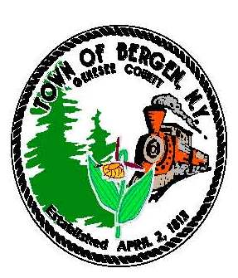

Editor: Michele Smith
Town News … From the Desk of Town Supervisor Ernest Haywood
The Town of Bergen is busy on several fronts this winter. Most importantly is the fight to retain NYS AIM funding and a fair share of sales taxes collected by Genesee County. The Governor's proposed budget eliminates AIM funding to most towns and villages (but keeps intact the funding to cities). Bergen stands to lose $11,020 annually if this revenue sharing is eliminated. That's equivalent to the contractual cost of operating the town court or the personnel costs of operating the transfer station.
The prospect of losing, in future years, a portion of the current sales tax is also of concern. In our 2019 budget, sales tax revenue funds 24% of expenditures. I have been working with fellow supervisors to advocate that the county provide exact details on their plans to reduce sales tax and to put in writing their plans to share revenue in years to come.
I have written and/or met with our State and County Representatives regarding these vital funding sources. I have also met with my counterparts from other local towns and villages who will be similarly impacted. Together we will continue to advocate for our local taxpayers.
At our February 12 Town Board meeting, we proposed legislation to place a nine-month moratorium on the construction of Commercial Solar Energy Systems and Solar Farms. A public hearing on the moratorium was to be held on February 26 and although the deadline for this newsletter was prior to the hearing, I am confident that the Board will have adopted the moratorium.
The reason for the moratorium is simple: currently the Town of Bergen has no regulations on the books regarding commercial solar farms. Many of our neighboring towns have recently adopted regulations or are in the process of doing so. Because Bergen has so much open farm land, we may prove to be an attractive location for solar farms. We want to be sure that when a project is proposed that we have reasonable regulations in place. The moratorium simply gives us the time to develop those regulations. We have gathered sample legislation from other municipalities and I believe we will be able to adopt our own well before the moratorium expires.
Another major undertaking has been the submission of a Water Funding Application to Rural Development that would essentially provide water to all of the remaining un-watered areas of the Town. The estimated cost of the project is $8.9 million dollars to install approximately 163,720 linear feet of water line. The project will provide public water to those who have problems with the quality and quantity of their private wells and will also enhance fire protection.
It will be several months before the Town knows if the funding application is successful. Funding would come in the form of grants (monies the Town would not have to pay back) and low interest loans. If the project is funded through Rural Development, there will be several public meetings so that residents will know what to expect regarding the financing and construction of the water line.

“In accordance with Federal Law and U.S.D.A policy, this institution is prohibited from discriminating on the basis of race, color, national origin, sex, age, or disability. (Not all prohibited bases apply to all programs). To file a complaint of discrimination, write USDA, Director, Office of Civil Rights, 1400 Independence Ave., S.W., Washington, D.C. 20250-or call (800)795-3272 (Voice) or (202)720-6382 (TDD)”

From the Desk of County Legislator Robert Bausch

When the NYS Legislature is in session, the assembly and senate approve new programs or mandates and the
governor signs them with the anticipation that local taxpayers will pick up the cost. To close the state three
billion dollar and growing 2019-2020 budget gap, the governor requested approval to withhold from the counties internet sales taxes that the state collects and then should remit to the counties. Currently, 90% of the NYS counties’ property tax revenues pay for state services, now the governor is proposing taking sales tax revenue as well. Genesee County did not budget any extra revenue in anticipation of additional internet sales tax revenue so the impact should be minimal. But this action will set an unfortunate precedent. The current session of the state legislature has already cost the counties significant amounts with the change in election laws being an unfunded mandate with no process in place to meet the law.
The jail project continues to move forward. A recommendation to award the architectural and engineering contract was presented to the Public Service and Ways & Means Committees and was approved. The contract will be on the legislature next agenda.
Phase 2 of the water project is progressing. Land acquisitions are complete and the bidding process should begin within the next two months. The initial conceptual design for Phase 3 has started.
Genesee County and the City of Batavia passed resolutions requesting the state for special legislation authorizing a forty year sales tax agreement. This would allow the financing for the new jail and the water projects to move forward.
On recommendation of the District Attorney and all the local police agencies, the legislature is considering a local “pawn shop law”. The proposed law is very specific and similar to laws in neighboring counties. There has been some discussion as to its effect on garage sales, antique dealers and others. The proposed law will be crafted so these businesses will be exempt. The only existing business that will be affected is already complying with similar laws in other counties.
As has been well published, a two to four thousand acre solar farm is proposed in the Byron area. The approval process for this project will be very lengthy. The county will have a very limited role in that process.
Lastly, as announced last month, I am not seeking reelection. It has been an honor to serve the residents of Elba, Byron and Bergen on the county legislature.

Historian News by Thomas Tiefel

As winter ever so slowly draws to a close, work continues on the Harford Livery Museum. Some current exhibits will undergo slight changes to better accommodate our “younger history enthusiasts” and work is underway for some new and exciting exhibits. I’m excited to say that we’ve noticed a dramatic increase in research and genealogy requests in recent months. People from all over the country have emailed and called us regarding information on their ancestors. We believe this is partly due to our exposure on social media.. This has kept us busy over the winter months and we have passed on our usual “busy work” to our awesome volunteers. It’s very a rewarding feeling to walk into our office and hit the ground running so to speak. Our volunteers have been doing a tremendous job at filing and various other tasks. On that note, I would like to especially thank Myrna List for providing our office with an endless supply of newspaper clippings pertaining to Bergen. Our future generations will gladly appreciate it!

Remember to “find us on Facebook!” You can like us at the Harford Museum Face Book page. Check us out and take a trip down memory lane! Many new pictures are being added weekly that give a glimpse into Bergen's past. We are rapidly approaching the 1,000 members mark!

As always, the historian’s office is located at 15 S. Lake Ave in the village of Bergen. If you would like to contact me for any reason, feel free to call 585-494-0080 and we will be happy to assist you!

In accordance with Federal Law and U.S.D.A policy, this institution is prohibited from discriminating on the basis of race, color, national origin, sex, age, or disability. (Not all prohibited bases apply to all programs). To file a complaint of discrimination, write USDA, Director, Office of Civil Rights, 1400 Independence Ave., S.W., Washington, D.C. 20250-or call (800)795-3272 (Voice) or (202)720-6382 (TDD)”

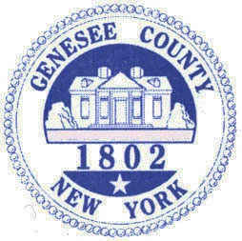

Library News by Nancy Bailey

Did you know?
- The Library is Bigger than it Looks-The Byron-Bergen's interlibrary loan service gives you access to collections at other libraries! Being part of the Nioga Library system gives you opportunities to interloan books from Niagara, Orleans, and Genesee County Libraries. Just check out our online catalog with your valid Library card unlock millions of books, audio books, music CD’s, and DVD’s available to you! Can't wait for delivery to the Library? Take your card to other libraries in the system and check it out yourself!
- The Library has several free options for online and downloadable books you can read on your computer, smart phone, dedicated eBook reader, or tablet. Just go to the Byron-bergenpubliclibrary.org website and click on OverDrive/Libby or Hoopla to find out more!
- That you have access to over 80 downloadable magazines that you can read on your computer, smart phone, dedicated e-Book reader, or tablet? Check us out on the RB Digital button at the Library website. You can catch up on past months of your favorite magazine too!
- The Library is more than just books – there are movies and music, programs for all ages, book sales, and much more. Check us out at www.Byron-BergenPublicLibrary.org or “Friend” us on Facebook and follow us on Twitter.
We have New York tax forms available here! You also can go to the website at www.nystax.gov and go to forms to print from home. If you need Federal tax forms, they are available at www.irs.gov
Library has Pre-K/Toddler story time for children at 10:30am on Fridays until April 12th for the winter session and will begin the spring session on April 26th. We enjoy a different themed story each week with a related craft and a snack! Registration is recommended by calling or stopping by the Library.
Book discussion group meets on the 2nd Thursday of each month at 7pm.March 14thwe are reading Dear Mrs. Bird by AJ Pearce come join this fun group and see what your neighbors are reading!!! We enjoy lively conversation about the book and refreshments too! Call or stop by the Library to reserve your copy of our current book.
Join us for St. Patrick’s Day story time Monday March 12th at 6:30 pm with Miss Makayla. Wear something green and come enjoy a story, craft and a yummy treat! Registration is not necessary but appreciated.
Move Day March 15th at 1pm – come watch Fantastic Beasts: The Crimes of Grindelwald-From the imagination of Wizarding World creator J.K. Rowling -- rated PG-13 and runs 134 minutes. Refreshments provided!
Sew-Quilting Club is starting up at the Library on Thursday March 28th at 10am! We hope to meet at least once a month to share ideas and help with questions. Come with your creations and enjoy some one on one time with like-minded patrons. Refreshments provided. (Continued)

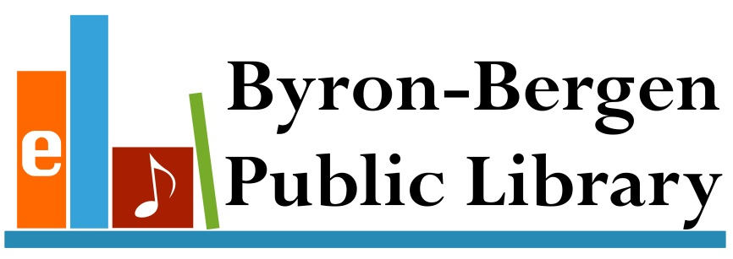

Save the date of April 3rdfor our annual pre-school concert! Join our smaller patrons at the Bergen Evangelical Presbyterian Churchat 9:30am for music and fun with Farmer Tom! With audience participation and humor, the “Celebration of Reading” show is one you won’t want to miss! No Registration required! Just come join the fun!
National Library week is April 7th – 13th--Stop in and take out 3 or more books and have a chance to win a prize!! Everyone invited to participate!

Spring Break Happenings!! April 15th – April 20th
Babysitting workshop will be held on Monday April 15th from 10 to 3 pm. This workshop is open to anyone 11yrs old and up. Cost $25- includes a book to take home to reference. Registration and payment (cash only) is needed by Tuesday April 9th - Space is limited so sign up soon!
Wildlife Rockstars Animals will join us on Tuesday April 16th at 7pm. Come enjoy an up close and personal animal encounter with birds, reptiles and much more. No registration necessary.
Movie Day Wednesday April 17th at 2:30pm – Join us for the movie Dogs Way Home- Rated PG-192 mins long. Refreshments too!
Spring/Easter Make & Take Craft – April 18th from 3pm- 6pm- Come anytime between 3pm and 6pm to create a fun colorful craft. No Registration necessary.
Join the Library and the Bergen Historical Society as we welcome Melinda Grube as Elizabeth Cady Stanton on Thursday May 2nd at 7pm. See history come alive in this historical interpretation. -Refreshments s to follow.
Spring Break Happenings!! April 15th – April 20th
Babysitting workshop will be held on Monday April 15th from 10 to 3 pm. This workshop is open to anyone 11yrs old and up. Cost $25- includes a book to take home to reference. Registration and payment (cash only) is needed by Tuesday April 9th - Space is limited so sign up soon!
Wildlife Rockstars Animals will join us on Tuesday April 16th at 7pm. Come enjoy an up close and personal animal encounter with birds, reptiles and much more. No registration necessary.
Movie Day Wednesday April 17th at 2:30pm – Join us for the movie Dogs Way Home- Rated PG-192 minutess long. Refreshments too!
Spring/Easter Make & Take Craft – April 18th from 3pm- 6pm- Come anytime between 3pm and 6pm to create a fun colorful craft. No Registration necessary.
Join the Library and the Bergen Historical Society as we welcome Melinda Grube as Elizabeth Cady Stanton on Thursday May 2nd at 7pm. See history come alive in this historical interpretation. -Refreshments s to follow.

“In accordance with Federal Law and U.S.D.A policy, this institution is prohibited from discriminating on the basis of race, color, national origin, sex, age, or disability. (Not all prohibited bases apply to all programs). To file a complaint of discrimination, write USDA, Director, Office of Civil Rights, 1400 Independence Ave., S.W., Washington, D.C. 20250-or call (800)795-3272 (Voice) or (202)720-6382 (TDD)”



Bergen Fire Dept. by Eric Wies, President

The mission statement of the Bergen Fire Department is “to protect the lives and property of the citizens and visitors of the area protected by the Bergen Fire Department by providing the highest possible level of service through fire suppression, emergency medical services, fire prevention, public education, and mitigation of the effects of natural and man-made disasters, consistent with resources available.”

Living up to that statement seems to be more difficult every year, with membership challenges, financial concerns, and advancements in techno’/
/?logy and building materials. This requires us to evolve and adapt to meet these concerns through training, equipment purchases, and hard work. This was evident earlier this year when we started a fund drive to replace our Jaws of Life with a battery powered unit capable of dealing with the advancements in automotive safety design. The men and woman of your Bergen Fire Department are extremely grateful to those community members and business who have donated to the Jaws of Life fundraiser. Your efforts have gone a long way towards providing these lifesaving tools for our community.

We still have a little way to go in meeting our financial goal. If you not done so yet and have the ability, please consider sending your tax-deductible check to: Bergen Fire Department, PO Box 428, Bergen, NY 14416 while adding “Jaws of Life” to the memo line. This was also evident in 2018, when the decision was made to consolidate our trucks with the purchase of a new tanker, replacing our rescue and 28-year old tanker with a single truck. This decision was driven by declining membership and long-term financial concerns. However, rest assured the new Tanker 29 was designed to meet the needs of the community and uphold the Mission Statement.

So, what will 2019 bring? Maybe it starts with having you stop by on a Monday night for a tour of the facility and trucks, followed by a discussion on how you could help the community you live and work in. Yes, it can be difficult at times, but the thought of saving a life, preserving someone lifelong collection of memories by extinguishing a house fire, or simply just “being their” at someone’s most difficult time cannot be put into words. We hope to see you soon.

Please visit out Facebook page at https://www.facebook.com/Bergenfiredepartment/.

Town Clerk News by Michele Smith
Dog License: Please make sure your dogs are licensed and their rabies information is up to date.
ANTI-RABIES CLINICS: May 2nd – Pembroke Highway Garage 1145 Main Rd. (Rt. 5) Pembroke
2019 Town & County Tax Payment - Last day to pay Town & County taxes is Saturday, March 30th with 2% penalty, any taxes not paid by that date will be turned over to Genesee County Treasurer, any payments can be left in the drop box after hours. .
Office Closings Office Hours
April 19th & 20th – Easter Monday, Tuesday, Wednesday and Friday
May 25th & 27th – Memorial Day 8:00 am – Noon & 1:00 – 4:00
Saturday 9:00 am - Noon
Closed on Thursday



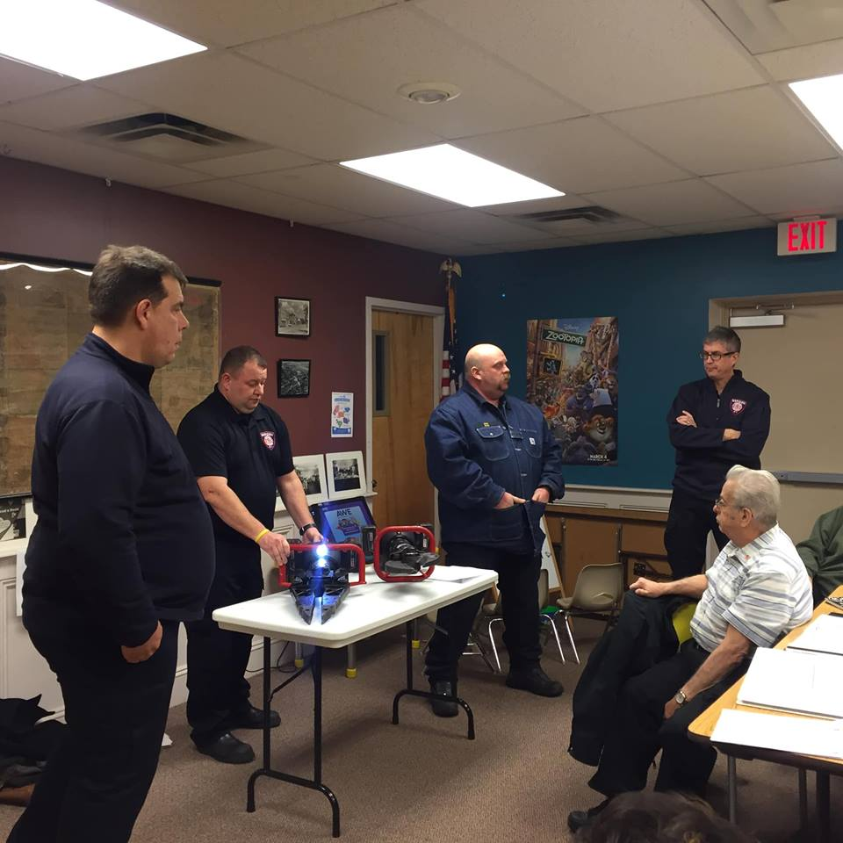

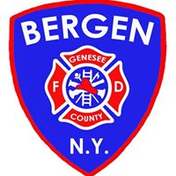

“In accordance with Federal Law and U.S.D.A policy, this institution is prohibited from discriminating on the basis of race, color, national origin, sex, age, or disability. (Not all prohibited bases apply to all programs). To file a complaint of discrimination, write USDA, Director, Office of Civil Rights, 1400 Independence Ave., S.W., Washington, D.C. 20250-or call (800)795-3272 (Voice) or (202)720-6382 (TDD)”

In accordance with Federal Law and U.S.D.A policy, this institution is prohibited from discriminating on the basis of race, color, national origin, sex, age, or disability. (Not all prohibited bases apply to all programs). To file a complaint of discrimination, write USDA, Director, Office of Civil Rights, 1400 Independence Ave., S.W., Washington, D.C. 20250-or call (800)795-3272 (Voice) or (202)720-6382 (TDD)”

Easter Egg Hunt Saturday, April 13th at 1:00 PM
The Bergen Business & Civic Association sponsors
This annual event at the Hickory Park in
The Village of Bergen.




