TOWN OF BERGEN NEWSLETTER
JUNE, JULY, AUGUST 2019
Editor: Michele Smith
Editor

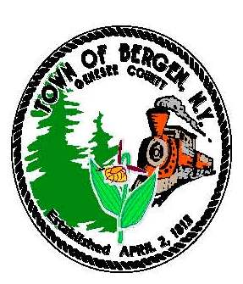



Town News … From the Desk of Town Supervisor Ernie Haywood
This newsletter was published just after our May 28 informational meeting regarding the expansion of public water. Those of you who own property in the proposed new district should have received a letter in the mail regarding the meeting, and I hope you were able to attend. In order to continue forward on the water district formation process, a majority of the property owners must sign the petition. If you were not able to attend the meeting and sign the petition on May 28, we will be having resident volunteers pass the petitions door-to-door. Call 494-1121 x 22 for more information.
I hope to have our engineer’s water presentation available on our website following the meeting for those of you who could not attend and for those who wish to review the information again. Keeping our residents fully informed is an important part of the district formation process.
Residents should soon notice activity at Robins Brook Park as we begin construction of the pavilion. Thompson Builds, Inc. was awarded the contract and is close to beginning work. Thompson estimates a two-week construction period. Our highway department completed much of the site work and parking improvements last year. The project has been in funded in large part by a $125,000 State and Municipal Facilities Program Grant (SAM).
We are also working diligently on our library/town building renovations. Two grants (SAM and a NYS Construction Grant) are funding the majority of the work. Unfortunately, the SAM grant has been tied up in Albany. I have contacted our state representatives and those in the Senate majority office for help in getting the funds released.
The SAM grant funding will pay for handicapped accessibility to the building and restrooms. The improvements will benefit visitors to both the library and the town offices. The NYS Construction Grant will fund a new circulation desk, new flooring and the expansion of the multi-purpose meeting room.
Finally, we are continuing to work on our new Solar Farm Code. We enacted a nine-month moratorium on the construction of Solar Farms while we draft the new code. There is a great deal of interest from solar companies in locating in Bergen and surrounding towns, and it is important that we have regulations in place before they locate here. We expect to have a draft law ready late in the fall, at which time we will hold a public hearing to gather your input.
As always if you have question please reach call me at 494-1121 x 22.

This institution is an equal opportunity provider, and employer. If you wish to file a Civil Rights program complaint of discrimination, complete the USDA Program Discrimination Complaint Form, found online at http://www.ascr.usda.gov/complaint_filing_cust.html, or at any UDSA office, or call (866)-632-9922 to request the form. You may also write a letter containing all of the information requested in the form . Send your completed complaint form or letter to us by mail at U.S. Department of Agriculture,, Director, Office of Adjudication, 1400 Independence Avenue, S.W., Washington, D.C. 2050-9410 or by fax (202)690-7742 or e-mail program.intake@usda.gov



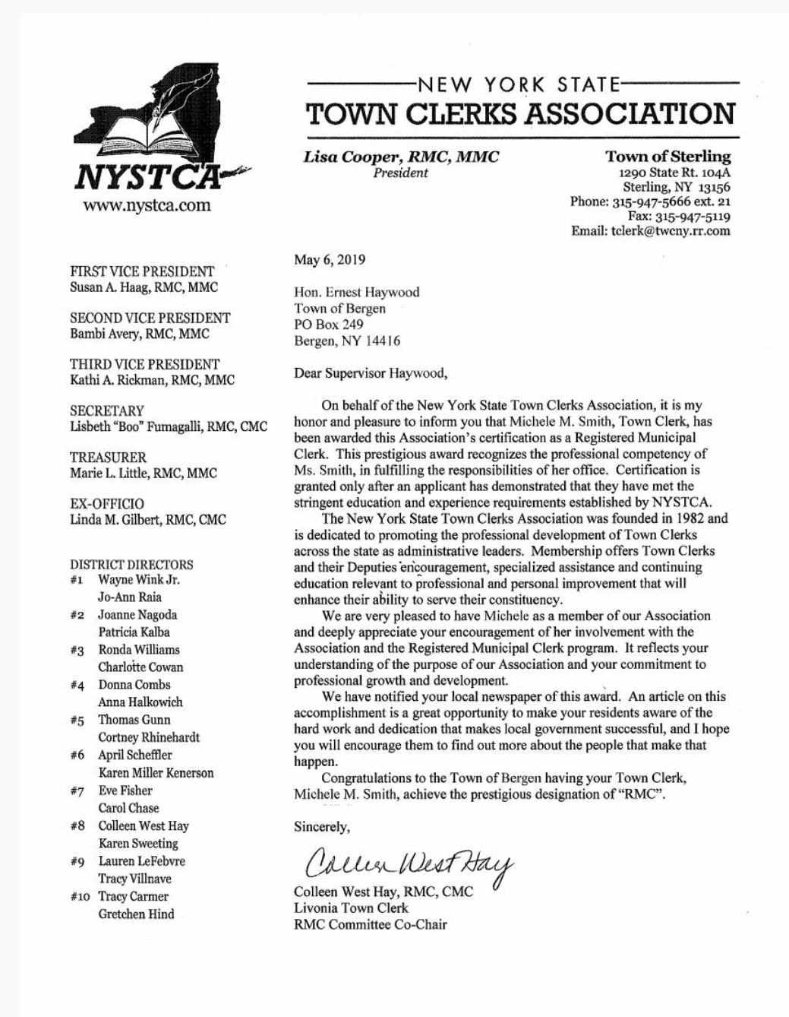

“Congratulations to Town Clerk, Michele Smith for obtaining the designation of Registered Municipal Clerk for professionalism in fulfilling the responsibilities of her office. Well done!” – Bergen Town Board

Assessor’s Office News by Rhonda Saulsbury

The Town of Bergen has contracted with an experienced professional party to take pictures of ALL improved parcels in the Town of Bergen for the Assessor’s Office, and Genesee County Office of Real Property. This is necessary for maintaining updated property records.
The picture taking process will start as of June 1, 2019. The whole project will take a month or so, and will normally happen on Monday, Wednesday and Friday afternoons, and possibly on Saturdays and Sundays.
The vehicle being used is a tan Buick Encore, with a yellow flashing light on top of the driver's side roof, with proper identification available. The Genesee County Sheriff’s Office has also been notified, with property owner’s safety in mind.
Thank you in advance for your cooperation with this project & if you have any questions please call 494-1484.

Town Clerk News by Michele Smith

Hunting Licenses will be going on sale August 12th, DMP’s are on a lottery first come first serve basis as in the past $10 for 2. Fishing Licenses now run a year from the date of purchase and are available for $25.

Dog License News: I hate to “hound” you, but if your dog’s license renewal is due or past due, please take care of it
so we don’t have to send you a reminder notice or eventually a court appearance ticket. If new to the area please transfer your dog with the Town of Bergen. If there is a problem getting an appointment for a rabies vaccination, etc., please call me 494-1121 x 21; if after hours leave a message on my voicemail anytime day or night.

ANTI-RABIES CLINICS: Dog, Cat and Ferret Vaccinations are free to Genesee County residents. A $5.00 voluntary donation per dog, cat or ferret, is requested to offset expenses. Non-County residents must pay a mandatory $5.00 fee for each dog, cat and ferret immunized. Each animal must be accompanied by someone who can control it.
August 15th – Genesee County Fairgrounds 5031 E. Main St., Batavia 4:00 – 7:00 pm

Office Closing Office Hours
Saturday, June 8th – Park Festival Monday, Tuesday, Wednesday and Friday
Friday, July 5th – Independence Day Holiday 8:00 am – Noon & 1:00 – 4:00
Saturday, August 31st & Monday, September 2nd – Labor Day Weekend Saturday 9:00 am - Noon
Closed on Thursday





THE 30th ANNUAL BERGEN PARK FESTIVAL

SATURDAY, JUNE 8, 2019
EVENTS SCHEDULE

All Proceeds to benefit our Parks
11:00 am 6th Annual Car Cruise In - Enjoy the cars until 3:00pm
Craft Vendors Group Foosball
Book Sale---Byron-Bergen Public Library Rock Climbing Wall
Food Vendors – all day and evening Bounce House Pony Rides Laser Tag – Sponsored by the Byron-Bergen Public Library

12:00 - Parade down Lake Ave.
(Please contact Michele Smith parade Chair to participate 494-1121 ext. 21)
Celebrating the 30th Anniversary of the Bergen Park Festiva!
Following parade - Kelly’s Heroes band Sponsored by the Byron-Bergen Public Library 12:30 pm Please join us in celebrating our 30th Anniversary by sharing in cupcakes
under the main tent following the parade

12:30 – 2:30 pm Pony Rides
2:00 – 2:30 pm Master Lim’s Taekwondo Academy Demonstration
3:00 pm BERGEN’s Got Talent (front Pavilion)
Sponsored by Triple-O Mechanical
DJ – Chris Scibani

-tt
4:00 - 5:30 PM Chicken BBQ – served near the back pavilion

$10.00 – Pre-sale tickets are available at the Town Hall & Village offices

Sackett-
Come enjoy your chicken dinner listening to:
4:00 – 6:00 pm


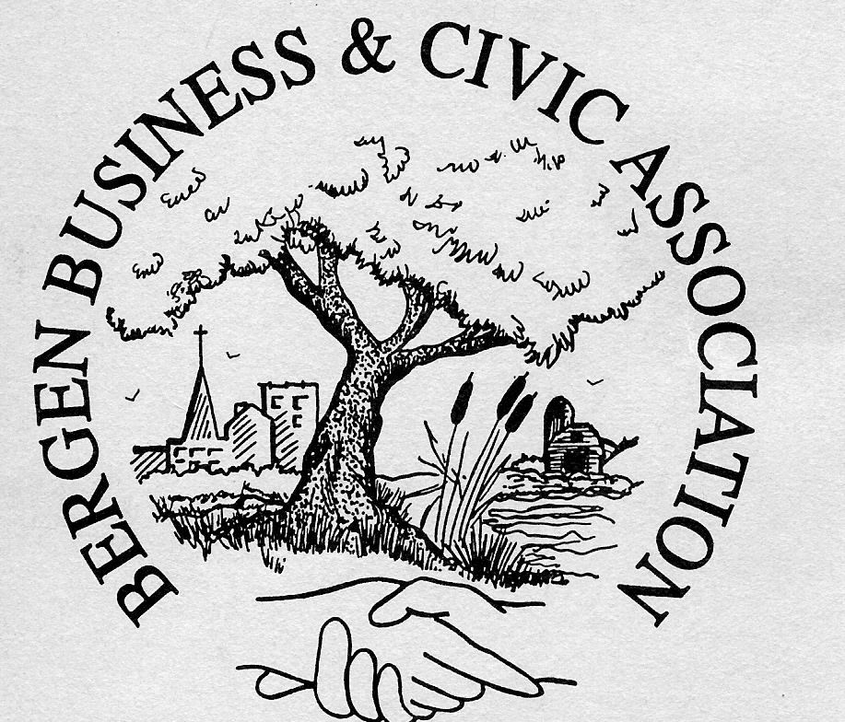

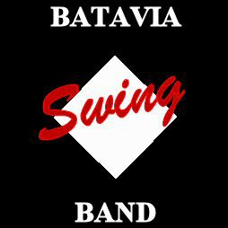

6:30- 10:00 pm That Party Band

This day is sponsored by the Bergen Business & Civic Association
Fun entertainment for the whole Family!

FIREWORKS AT 10:00 pm

Our sincerest thank you to all of the volunteers that make it so special!


The Bergen Park Festival continues as an event to bring our community together with any profits going back to Village & Town Parks
Please do your animals and the other guests a favor, and leave your pets home. Thank you.
Schedule is subject to change.


Make sure to check out the Main Tent! Purchase Chicken Barbeques tickets, a new 2019-2020 Bergen/Byron Directory and buy a Wrist band for the kids to enjoy the Bounce House, Rock Climbing Wall, Laser Tag and Foosball game unlimited number of times!!!!!!!

Who is the BBCA? We are a group of businesses and people that like to help our community in any way that we can. Want to become a member?
Join us and let us know at BBCA1311@gmail.com

Library hours:
Sunday and Monday – Closed
Tuesday 10-12 and 2-8
Wednesday 10-12 and 2-8
Thursday 10-12 and 2-8
Friday 10-6
Saturday 10-1
Closed: Saturday June 8th for Bergen Park Festival
Closed July 4th and 5th for Independence Day!
Closed Saturdays July and August

Open up new worlds- read new authors, try a new recipe book, or get lost in a movie! Check us out on the web at www.byron-bergenpubliclibrary.org. There are databases, Librarian 24/7, TumbleBook Library-e-books for Kids, NOVEL list-readers advisory, RBDigital- digital magazines, Libby/Overdrive –e-books and downloadable audio books and Hoopla for eBooks, audio books, video and music are available to you with a valid Library card! The Library also has a coupon exchange available to patrons! The Library has Wi-Fi available as well as three patron computers with printing for a small fee.
Library book sale will be at the Bergen Park Festival on June 8th. There are audio books, movies, children’s books and many bestselling authors. The Library will be closed on June 8th so stop by the tent at the Park Fest!
The Library is hosting the Kelley’s Hero’s Marching Band at the Bergen Park Festival on June 8th in the parade and right after the parade too with a field show not to be missed! Come join us for Laser Tag too this year! Bergen Park Festival is fun for the whole family.
The Library is looking for responsible kids age 11 years old and older to help volunteer during the summer reading program. Stop by and pick up an application now before the end of the school year! You can win prizes for volunteering and get a first look at all the new books and DVDs!!! Beat the heat in our air conditioned Library and sign up with a friend to join the fun!
Summer is coming!! So is the summer reading program- “Universe of Stories” The kick-off will be Tuesday June 25th at 2:00pm with Cris Johnson’s ”Spaced Out” Magic Show! Come join us for a fun magical afternoon and sign up for the summer reading program!
Why should you join the reading program? The summer reading programs are set up for children 3 years old and up to read and win prizes! Having your child read throughout the summer will help keep up their reading skills for school in the fall. Reading to your preschool child will help them master the skills of language at an early age.
If you are not able to make the Kick-off event- stop in any time after June 25th to sign up! Throughout the summer we will be having special story times, science fun, crafts, animal visits, and movie days. For a complete schedule of events check us out on the web at www.byron-bergenpubliclibrary.org and friend us on Facebook or stop by to pick up a schedule. Lots of fun activities you won’t want to miss!
The Library has preschool story time at 10:30am starting Friday July 12th to August 9th. We will be exploring sound, color, and animals! Join the fun this summer with your young children! There’s magic in every book! A
Babysitting workshop will be offered on July 18th from 10-3. If you are interested, please call the Library to sign up. Cost is $25. You must be at least 11 years old to be certified. (continued)


Happy Reading-- Nancy Bailey



Join us at the Byron Heritage Fest on July 27that 1:00 the Library will be hosting the band, Kelley’s Hero’s Marching Band in the parade! Come join us at the parade!
Come check out our newest books the web at www.byron-bergenpubliclibrary.org to reserve your copy! We also have a great selection of adult and children’s audio books that are great to listen to while you are driving to your vacation destination!
The Library has copy /fax service for a small cost, Spectrum High Speed Internet, Wi-Fi and interlibrary loans from any Library in the NIOGA Library system. If you can’t find it at our Library, please ask or check us out on the web at byron-bergenpubliclibrary.org! Stop in soon! For more information on our services or programs, please call the Library at 494-1120.

***********************************************************************************************From the Desk of County Legislator Robert Bausch
As discussed in the February newsletter, during the January – June time period each year, county leaders are
anxiously awaiting word from Albany regarding new policies and practices and whether the counties will be
negatively impacted. Unfortunately, so far this year there has been very little positive alongside a significant number of actions that will be detrimental county resources and residents.

Bail reform is an excellent example. Under the legislation that was passed, bail will not be required, except for the most serious crimes and for individuals with previous arrests. This was proposed on the basis of economic fairness because lower income individuals are often jailed when they cannot make bail while individuals with greater resources are able to make bail. Recently, I attended a lengthy meeting with the county judge, district attorney’s staff, public defender’s staff, sheriff, senior staff from the sheriff’s office and various other individuals which this legislation impacts. Unfortunately, there was little agreement on how this legislation will be implemented, but there was agreement that the state did not consider its local impact or victims’ rights, especially important in domestic violence cases.
A critical component of county operations is the 911 call center. Over the past 6 years, the county has invested significant funds in new towers, software, and various operational components of the 911 operation. The towns, villages, fire departments, and emergency medical services have also made significant investments. Currently, the county is preparing plans for an additional tower in the south central part of the county to service areas where reception is problematic and nationally a Next Generation 911 software package is being developed. The cost of these improvements should be paid from the 911 surcharge on individual phone bills and a federal government matching program. However, New York State diverts 90% of the 911 fees to the general fund. As a result, the FCC has informed NYS that they are not eligible for matching federal funds, putting an added burden on NYS taxpayers.
Two important projects that the county undertook the past year are coming to successful conclusions. County buildings were all evaluated for energy conservation and, where required, upgrades to the electrical and mechanical systems were implemented. All county facilities received a security audit, from a public and staff perspective. Where lapses were identified, upgrades were made and that work is completed.
The county’s two major projects continue to move forward: new jail and increasing water capacity. The architect /engineering firm for the jail project has been hired as well as a construction management firm. The scope of the project is now being defined. On May 16th, the county held its first public information meeting on the jail project which was well attended. You can follow progress on this project on the county’s website. The Phase 2 water project will be starting construction shortly. The preliminary design work on Phase 3 has started. Also, the water resource agency recommended an emergency water plan to the legislature and it was approved. Hopefully, it will not require implementation.

Historian News by Thomas Tiefel


From the Byron-Bergen Public Library Board of Trustees-
The Byron-Bergen Public Library is pleased to announce that its annual fundraising event, Barley & Books, will be held Saturday, September 28th. During the past eight years, this event has raised over to $60,000 for much-needed updates to the Library’s facilities and technology, as well as provide additional programming for our community.



Summer Transfer Station Hours
Wednesdays 5:00 – 7:00 pm July 10th – August 28th
Saturdays 9:00 am – 3:00 pm

REPUBLICAN PRIMARY FOR TOWN CLERK
TUESDAY, JUNE 25TH
BERGEN TOWN HALL
POLLS OPEN NOON – 9:00 PM

TOWN OF BERGEN
10 HUNTER STREET
BERGEN, NY 14416
bergenny.org

OCCUPANT BERGEN, NY 14416

This institution is an equal opportunity provider, and employer. If you wish to file a Civil Rights program complaint of discrimination, complete the USDA Program Discrimination Complaint Form, found online at http://www.ascr.usda.gov/complaint_filing_cust.html, or at any UDSA office, or call (866)-632-9922 to request the form. You may also write a letter containing all of the information requested in the form . Send your completed complaint form or letter to us by mail at U.S. Department of Agriculture,, Director, Office of Adjudication, 1400 Independence Avenue, S.W., Washington, D.C. 2050-9410 or by fax (202)690-7742 or e-mail program.intake@usda.gov

This institution is an equal opportunity provider, and employer. If you wish to file a Civil Rights program complaint of discrimination, complete the USDA Program Discrimination Complaint Form, found online at http://www.ascr.usda.gov/complaint_filing_cust.html, or at any UDSA office, or call (866)-632-9922 to request the form. You may also write a letter containing all of the information requested in the form . Send your completed complaint form or letter to us by mail at U.S. Department of Agriculture,, Director, Office of Adjudication, 1400 Independence Avenue, S.W., Washington, D.C. 2050-9410 or by fax (202)690-7742 or e-mail program.intake@usda.gov

