TOWN OF BERGEN NEWSLETTER
December 2019, January and February 2020

Michele M. Smith, Editor

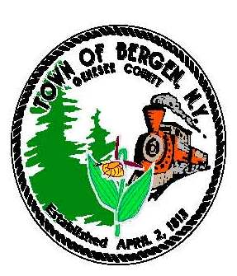

TOWN NEWS … FROM THE DESK OF TOWN SUPERVISOR Ernest Haywood
I am pleased to announce that the Town of Bergen and the Byron-Bergen Public Library have awarded a contract to Whitney East for the renovation of the library. Six companies bid on the work, which is an excellent response, resulting in a very competitive low bid.
The work will begin in December and will include: renovation of restrooms and kitchenette; new carpeting; new electric and fire alarm system; accessible doors; new entryway; new circulation desk; new lighting; renovation of offices, multi-purpose and storage rooms.
The project is funded a SAM grant through Senator Ranzenhofer, a NIOGA grant and the Library itself.
The project is extensive and will require the move of library materials and staff. We will need the public’s patience as we work through the logistics of the phasing of the work and the accessibility of library materials and programs during the project. Huge kudos in advance to Library Manager Nancy Bailey and her staff for this major undertaking.
For property owners in our proposed new Water District, the formation documents have been filed with the New York State Comptroller. While we wait for approval, we continue to work on consultant agreements, engineering and financing. A project progress meeting was held on November 6 and all of checklist items are moving forward.
We adopted the 2020 Town of Bergen Budget on October 22. There is a slight tax increase, about $5 a year on the average household. We included the cost of a new highway truck in the budget and were cautious with predicting revenue flows. You may notice that the Fire Department budget decreased slightly.
We will hold a public hearing on November 26 regarding the adoption of Local Law #5, Notice of Defects in town roads, sidewalks and culverts. The local law was recommended by our insurance company and will better indemnify the Town in the case of unreported defects.
We have two projects in progress that should be completed by the end of the year: the replacement of flooring at the Town Hall and the adoption of an Employee Handbook.
Several projects have been undertaken and completed in 2019: we bid out and awarded a new refuse contract; adopted a Solar Energy Law; adopted a Fund Balance Policy and completed the Park Project.
Congratulations to Bergen Town Clerk Michele Smith, Highway Superintendent Mike Johnson, Town Councilpersons Mark Anderson and Belinda Grant and Justice Joseph Nenni on their re-election. Thank you to all candidates and most importantly, voters, who participated in our democratic process.
Wishing you and yours the best during this Holiday Season.

(Continued)
“In accordance with Federal Law and U.S.D.A policy, this institution is prohibited from discriminating on the basis of race, color, national origin, sex, age, or disability. (Not all prohibited bases apply to all programs). To file a complaint of discrimination, write USDA, Director, Office of Civil Rights, 1400 Independence Ave., S.W., Washington, D.C. 20250-or call (800)795-3272 (Voice) or (202)720-6382 (TDD)”

“In accordance with Federal Law and U.S.D.A policy, this institution is prohibited from discriminating on the basis of race, color, national origin, sex, age, or disability. (Not all prohibited bases apply to all programs). To file a complaint of discrimination, write USDA, Director, Office of Civil Rights, 1400 Independence Ave., S.W., Washington, D.C. 20250-or call (800)795-3272 (Voice) or (202)720-6382 (TDD)”



From the Desk of County Legislator Robert Bausch

The county legislature has been busy this fall. In late October the Governor signed the new Genesee
County / City of Batavia 40 year sales tax legislation approving a new sales tax agreement. This allowed
the county to move forward on a number of projects.

In early October I wrote to the Commission on Correction (COC) and stated the jail project could not go forward until a source of funding was secured. The COC had been very understanding over the years but stated that Genesee County’s jail, with areas over 100 years old, was inadequate and no legislator disagreed. With their support and the efforts of Senator Ranzenhofer, Assembly Hawley and many others on both sides of the political aisle the Governor signed the legislation which secured the required funding. The most recent design is for a 185 bed facility at a cost of $60,000,000, the most expensive capital project ever untaken by Genesee County. The costs are projected to be covered by the new sales tax agreement with no increase in property taxes.
With the new sales tax agreement, the county can continue with Phase 2 & 3 of the county wide water project. An important aspect of the agreement was that the city water plant, which supplies approximately one third of county’s water needs, will be decommissioned and replaced by Monroe and Erie County water. This will result in both significant savings and the elimination of a number of health concerns.
Last, but certainly not least, as one of only five counties in the state responsible for all local bridges over five feet on county roads plus on town roads and village and city streets, long term funding for needed bridge replacement has now been secured. The significance of this agreement and benefit to all residents of Genesee of County cannot be overstated. Starting in late summer contracts were released for Phase 2 of the water project. Site work has begun in Chili, Churchville and LeRoy on North Rd. and Valance Rd. The anticipation is that water will be flowing by June, 2020 making the continual expansion of the water systems in Byron and Bergen possible.
The other major activity for the legislature this fall has been the 2020 budget which has been approved and requires a $0.07 per thousand tax rate increase. Unfortunately the tax increase will only cover about half the cost of implementing New York State’s new bail reform and discovery laws. Those two NYS laws will have significant impact on NYS residents from a financial as well as a safety perspective.
This is my last newsletter as my term ends in December. I wish to thank the Towns of Byron and Bergen for making this space available to me. I also want to thank everyone for the support you have shown me over the past ten years as I have served as your legislator. My replacement, Christian Yunker, will be an excellent legislator and I look forward to having him serve our legislative district. Wishing you a Merry Christmas and Prosperous and Happy New Year!!!!!

From the desk of incoming County Legislator Christian Yunker

I’d like to take the opportunity to introduce myself as I plan to fill the role of Genesee County Legislator in District 2 this upcoming year. I’m very excited for the opportunity to work with all of you. Robert Bausch has done an exceptional job as your representative on the Legislature and serving as Chairman. I have very large shoes to fill! Robert has been gracious enough to include me in correspondence and meetings throughout the Summer and Fall to keep me in the loop on some of the significant current issues happening in the County. The most pressing and impactful issues we are currently facing are the Jail project and the upcoming challenges of the 2020 budget. With the ongoing pressures of State mandates, general increasing costs, and preparation of the Jail funding, to name a few, we continue to face challenges and opportunities in the County. Robert, and the other Legislators, have done a great job working with the local municipalities and the State to secure a funding source for the Jail with the recently signed 40-year sales tax agreement. As 2020 approaches, my hope is to be as informed as possible. I will work hard to hit the ground running as best I can. I’m looking forward to meeting many of you and listening to your feedback or concerns. Feel free to contact me anytime. My email is Christian.yunker@gmail.com.

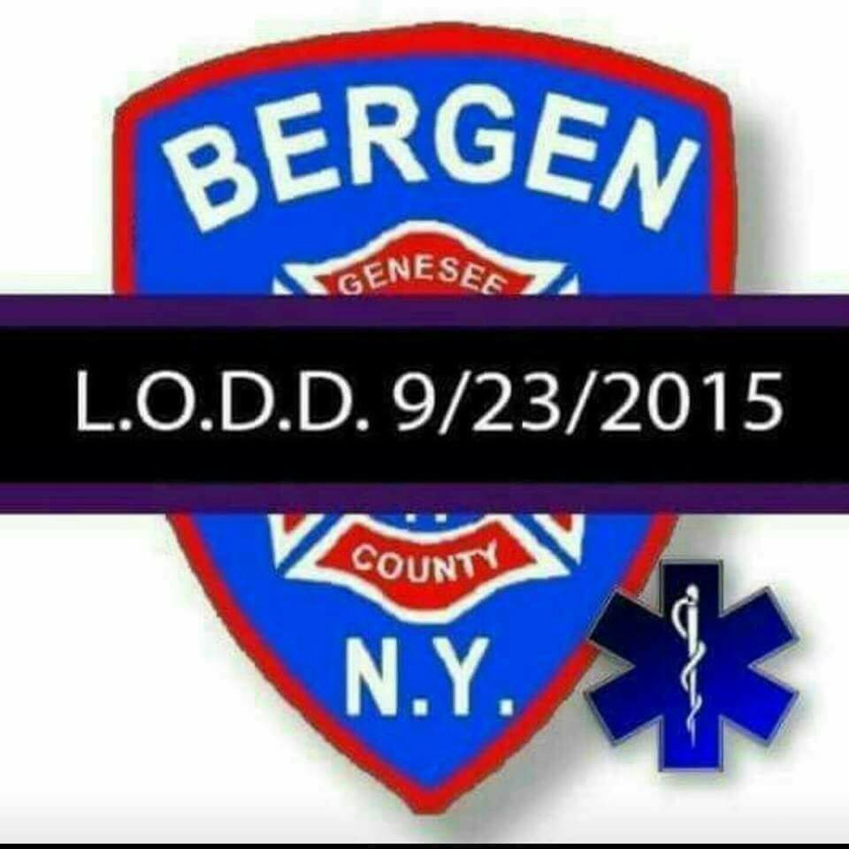


Town Historian News by Tom Tiefel
We want to wish everyone a happy and safe holiday season. 2019 has been a fantastic year for the Harford Museum and Historian’s Office. We had a tremendous volunteer staff helping out with our daily duties with over 250 service hours given. It definitely kept us on our toes and we appreciate their time and enthusiasm. I do wish to give family and friends my condolences to the passing of fellow historian, Ray MacConnell. Ray was a lifelong village resident who had an unmatched passion for our community’s history and dedicated most of his life to preserving our town’s past. He proudly served on the board of the Bergen Historical Society for over 30 years holding various positions and served for nearly a decade as Village Historian. His passing will undoubtedly be felt throughout our community.
Thanksgiving, Christmas, and New Years is a busy time for many of us. It’s a month and a half of hustle and bustle , picking out that right turkey or ham, that special gift ...or 10, and some of us will be driving great distances to visit family. This season is also a time of reflection. I ask that everyone take the time to reflect on holidays passed. Think back to a time when you couldn’t wait to get that toy you asked “Santa” for. Or, maybe you still have those old ornaments packed away somewhere long forgotten from your childhood. Take the time and share these treasures with our younger generations. Our history starts at home. Tell the stories or pass down that one special ornament. It’s the little things that keep our history alive. Happy Holidays!
As always, the historian’s office is located at 15 S. Lake Ave in the village of Bergen. If you would like to contact us for any reason, feel free to call 585-494-0080 and we will be happy to assist you! Also, find us on Facebook at Harford Livery Museum.

SACKETT – MERRILL- WHITE AMERICAN LEGION – POST 575
CASH RAFFLE PRIZES
SATURDAY, DECEMBER 7, 2019
SPAGHETTI DINNER 4:00 – 6:00 pm
DJ 6:00 – 9:00 pm
50/50 Raffle & Basket Raffles
For more information or to purchase tickets, please contact Lew Cunningham 494-2524






Happy Holidays!!
We are happy to announce the closing of the Library for renovations! Unfortunately- we will need to close on Nov. 27th until March 2020.
Closest Libraries to us are-
Richmond Memorial Library- Batavia- 19 Ross St.
Monday through Thursday: 9 AM – 9 PM
Friday & Saturday: 9 AM – 5 PM
Holiday hours- Closed Christmas Eve and Christmas Day
Close at 5pm New Year's Eve
Woodward Memorial Library - LeRoy -7 Wolcott St.
Monday, Tuesday, Wednesday, & Thursday: 9 a.m. - 8:30 p.m.
Friday: 9 a.m. – 5 p.m.
Saturday: 10 a.m. – 4 p.m.
Holiday hours- Closed Christmas Eve and Christmas Day
Close at 3pm New Year's Eve
Your B-B card can be used at all Nioga Libraries located in Genesee, Orleans, and Niagara Counties.
Please follow us on FaceBook and Twitter for updates or check out our website at www.Byron-BergenPublicLibrary.org
Thank you for your patience while we renovate.
If you have books to return – you are welcome to return them to any Nioga Library as well.
Getting a new E-Reader for Christmas or have one now…..Check out our catalog for downloadable e-books free with a valid Nioga Library card. We have Digital movies- music- eBooks- and audio books through HOOPLA! All you have to do is stop at our website www.byron-bergenpubliclibrary.org to sign up with your Library Card!
Did you know that the Library has free digital magazines? Check it out on our website at www.byron-bergenpubliclibrary.org . All you need is a valid Library card. Click on RBdigital – sign in with your Library Card and you are on your way!
The Library is open 24/7 using our digital platforms.
We will continue Pre-K/Toddler Story time on Fridays December 6th and 13, and the month of January starting the 10th at 10:30 am at the Evangelical Presbyterian Church 38 South Lake Ave Bergen until the renovations are complete. So stop in and enjoy the fun.
Book Club 2nd Thursdays of the month will continue to meet at the Bergen Town Hall -10 Hunter St. Bergen- December 10- January 9th and February 13th at 7pm. All are welcome! Check out the web for our book selections.
Search our website at www.byron-bergenpubliclibrary.org and check out Library happenings as well as our on-line catalog or join us on Facebook and Twitter too!
Happy Holiday Reading -Nancy Bailey Library Manager



Eric Wies is Leadership Genesee Alumnus of the Year

Leadership Genesee will present awards honoring the 29 members of the Class of 2019
along with the 2019 Outstanding Alumnus Award at the annual Graduation Celebration on
Dec. 5th at Terry Hills

Eric Wies, a graduate of the LG Class of 2006, has been named the Leadership Genesee Alumnus
of the Year. The award is presented annually to an alumnus who works to fulfill the program’s
mission displaying exceptional achievements and contributions to the community and Leadership
Genesee. Wies is the immediate past chair of the Genesee County Chamber of Commerce and the
current president of the Bergen Fire Department.

“My primary volunteer effort is tied to helping people in times of emergency," Wies said. "I joined the Bergen Fire Department in 1992, where I have served as lieutenant, captain, assistant chief, and deputy chief. In 2015, I decided to focus my efforts on a business role with the Fire Department and was elected president, a role I continue today. While I have debated about scaling back my efforts so that I could focus on my career and other potential volunteer efforts, I have come to realize that I will always be a volunteer fireman.”
As a member of the Genesee County Chamber of Commerce Board of Directors, Wies found his involvement to be very rewarding. The Chamber plays an important role in business and tourism throughout Genesee County and he is happy to be part of their community presence.
“Eric has been an active participant in Leadership Genesee since he graduated in 2006 because he feels that Leadership Genesee has given so much to him that he wanted to give back to the program," said Leadership Genesee Director Peggy Marone. "He served on the LG Steering Committee from 2009 to 2014 and was chair of the Recruiting Committee for five years.
"He obtained sponsorships for our bowling and golf tournaments ensuring his team was ‘dressed’ for the event. Eric’s support and involvement in Leadership Genesee’s curriculum has helped the program grow and become a shining example of servant leadership.”
Wies said he feels that LG he has been a primary building block in his growth professionally and personally. His philosophy is there should always be time to participate in a program that helps you grow, introduces you to other leaders in the County, and gives you a sense of satisfaction in belonging to a group of people that consider themselves servant leaders.
“An employer that does not support your efforts to better yourself, does not truly understand that the time and money for the program will also result in a better person and employee," Wies said. "I grew up in Bergen, New York and thought I knew everything about the County but, boy, was I wrong.
"The program opened my eyes to agribusiness, gave me a better understanding of the health care issues in the County, and the challenges that local government must face every day."
When asked about previous awards and achievements, Wies said, “For me, the most important awards don’t come with a plaque or trophy, but they do come with a sense of accomplishment or being part of something bigger than you are.
"Helping a friend when his business burned down, helping a single mom at Christmas with presents for her kids, saving a young lady from her burning car, hearing my daughter tell me she loves me, and being part of a group of individuals that make up a team that puts community first.”
Marone said “This is exactly why Eric is an outstanding selection for this year’s Alumnus Award.”
“He is a true leader," said his nominator Michele Smith, LG Class of 2016 and Bergen Town Clerk. "I witnessed his cool and calm demeanor with the passing of Barry Miller LG ’08 in 2015. Eric was the president of the Bergen Fire Department, I observed several incidences that I don’t know how Eric made it through. I know inside he was a wreck, but as a leader for everyone else who was hurting, he was unwavering.”
Wies is a principal for Clark Patterson Lee, a multidiscipline architecture, engineering and planning firm. He lives in Bergen with his wife, Carrie, daughter, Hannah, and dog, Casper.
Although he hopes to retire one day, he and his family enjoy getting away for a cruise and more recently trips to remote locations in Vermont to fish and have high stakes games of family Monopoly. Wies is an avid golfer and enjoys spending weekends working on their house.


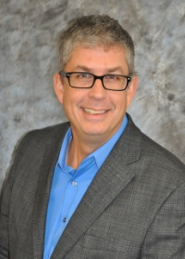

Town Highway by Mike Johnson
Please be reminded that during a “normal” snow event, it will take plow trucks 2 ½ to 3 hours to complete one pass on all roads. As such, it is very possible that everyone will encounter less than pleasant driving conditions at times. Late evenings and early mornings, with very light traffic volumes, will receive lower levels of service. Every attempt will be made to maintain open and passable roadways, both for normal and emergency traffic. At times, lanes may narrow and accumulate snow. The Town is responsible for snow and ice removal on all Town and County roadways in Bergen as well as State routes. This winter, as in the past, we will strive to provide the same level of the safest possible roadways at all times, within reason and budget constraints.
Also remember to use caution on snow covered roads. Here are a few safety tips: Slow Down, Make safe lane changes, pump your brakes on slick roads, and lastly don’t tailgate, especially the plow truck. If you can’t see him in his side mirror there is a good chance he can’t see you! For a First Aid rule: Carbon Monoxide is called “the silent Killer” if you go off the road keep your exhaust clear of snow.
Two additional reminders: Mailboxes, if damaged by our plows will be repaired or replaced, within Town Board adopted limits, as soon as weather, time permit. PLEASE, when installing or repairing your mailbox, remember that our trucks require a minimum 17 ½ feet from center of the roadway. Also, take into account the excessive force of the exhausted snow as it strikes your mailbox assembly.
Please don’t hesitate to call me at 494-1362 if I may be of service. Highway Department hours are 7:00 am – 3:30 pm Monday thru Friday. However, you may leave a message 24 hours a day on our answering machine, and I will return your call as soon as possible. In closing, the entire highway department would like to wish everyone a healthy and happy holiday season, and a safe winter.
Community Christmas Activities
Annual Village Tree Lighting will be held Monday December 2nd
Carolers leave Hickory Park at 6:15 pm to escort Mr. and Mrs. Claus to Ward Park.
Ward Park festivities include meeting the Clauses, tree lighting, hot cocoa and cookies, elementary band, decorated trees by community organizations. For further information contact the village office 494-1513

Bergen Community Christmas Concert
Saturday, December 7th
6:00 PM
Bergen Evangelical Presbyterian Church
38 S. Lake Ave

Join us for an evening of Christmas music performed by members of the community. Young and old are welcome to attend. Special Family Friendly seating available this, bring all your little ones! There will be Cookies, milk, and cocoa to follow.
New this year: Need a ride? Please call 494-1251. Calling all musicians- please share your talent with our community!
Questions about attending or performing? Contact Jocelyn Rebisz, 494-6031.

Saturday, December 14th
Santa’s Workshop
9:00 am – 1:00 pm Gillam-Grant Community Center

Breakfast, Mrs. Claus Kitchen open all day, Entertainment, Cookie Decorating,
Christmas BINGO, Face Painting, Coloring Contest, Toy Raffles, Santa’s Secret
Kids Store, Christmas Crafts, Santa Visits.




Town Clerk News by Michele M. Smith

I want to thank the residents of Bergen for the over whelming support in my re-election as
Town Clerk. I enjoy serving our community and look forward to another 4 year term.

Town & County Taxes
If you pay your own taxes, you will receive your tax bill shortly after January 1, 2020. If you should receive a tax bill that an escrow company or someone else is supposed to pay, please call me right away. Don’t put it aside and assume that it will be paid. Also, if you have paid off your mortgage and did not receive a tax bill, you should call me. No matter what the situation is, you are responsible for your taxes and penalties, if it is not paid. If you are leaving town for the winter please leave your “winter” address with me so late fees can be avoided. Credit cards (Visa, MasterCard, Discover and American Express) are accepted for payment with a convenience fee.
Tax payments cannot be received before January 1, 2020 per the County Treasurers office, all payments will be stamped after that date. Taxes are due penalty free by January 31st, all taxes have to be paid to me by March 31st. After March 31st, the unpaid taxes are returned to the County Treasurer. If you are going to pay them to the County Treasurer by mail, you will need to call his office in Batavia at 344-2550, ext. 2211 as there will be additional penalties.

Dog License News:
I hate to “hound” you, but if your dog’s license renewal is due or past due, please take care of it so we don’t have to send you a reminder notice or eventually a court appearance ticket. All dogs, four months of age need to be licensed even those in apartments. Proof of a rabies vaccination and proof of neutering or spaying must be presented at the time of licensing. If you receive an appearance ticket, you will have to pay a fee of $25.00 plus also pay for your dog’s renewal. If there is a problem getting an appointment for a rabies vaccination, etc., please call me. I have an answering machine so you can call anytime day or night.

Office Closing Office Hours
December 24rd & 25th – Christmas Holiday Monday, Tuesday, Wednesday and Friday
December 31st & January 1st – New Years 8:00 am – noon & 1:00 – 4:00
January 20, 2020 – Martin Luther King Jr. Day Saturday 9:00 am - noon
February 17, 2020 – Presidents Day Closed on Thursdays




ATTENTION SNOW BIRDS
If you are leaving town for the winter please leave your winter address with the Town Clerk/Tax Collector to mail your Town & County Tax Bill to avoid any late fees. All Tax Bills are mailed on December 31st and are due by January 31st without penalty.
Michele Smith, Town Clerk/Tax Collector
494-1121 Ext. 21

HAPPY HOLIDAYS FROM THE TOWN OF BERGEN
TOWN of BERGEN
10 HUNTER STREET
BERGEN, NY 14416
bergenny.org



“This institution is an equal opportunity provider and employer. If you wish to file a Civil Rights program complaint of discrimination, complete the USDA Program Discrimination Complaint Form, found online at http://www.ascr.usda.gov.complaint_filing_cust.html or at any USDA office, or call (866)632-9992 to request the form. You may also write a letter containing all of the information requested in the form. Send your completed complaint form or letter to us by mail at U.S.D.A., Director, Office of Adjudication, 1400 Independence Ave., S.W. Washington, D.C. 20250-9410, by fax (202)690-7442 or email at program.intake@usda.gov”

