TOWN OF BERGEN
* Established April 2, 1813 *

Phone: (585) 494-1121 * Fax: (585) 494-1372 * NYS TDD 1-800-662-1220

P.O. Box 249
10 Hunter Street
Bergen, NY 14416
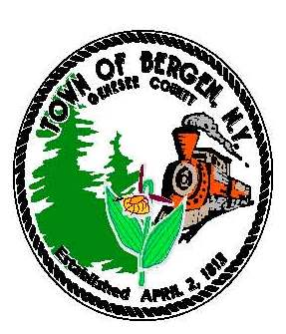
Supervisor Town Clerk/Tax Collector
Ernest Haywood Michele M. Smith
Donald Cunningham, Deputy Supervisor
Councilmen Justices
James Starowitz Joseph nenni
Mark Anderson Robert Swapceinski

Councilwomen zoning & code enforcement officer
Belinda Grant David Mason
Anne Sapienza

Superintendent of highways Assessor
mike Johnson Rhonda Saulsbury

December 14, 2019

Update on Water Benefit Improvement Area #1

Our Water Benefit Improvement Project was submitted to the NYS Comptroller’s Office at the end of October. Our Town Attorney checks on its status weekly and he believes it could receive approval by the end of January.

The Town Engineer has completed the initial field work for the entire project area and has begun to prepare the base maps. Contract specifications are being developed.

Our timeline has been adjusted to accommodate the various activities and approvals. While installation of the water main should be complete by December 2021; restoration will continue until June 2022.

I held a status meeting on December 12 with all of our consultants and I am pleased to report that each is moving forward as expeditiously as possible.

Look for another update here in January.

Ernie Haywood
Supervisor

