TOWN OF BERGEN
* Established April 2, 1813 *

Phone: (585) 494-1121 * Fax: (585) 494-1372 * NYS TDD 1-800-662-1220

P.O. Box 249
10 Hunter Street
Bergen, NY 14416
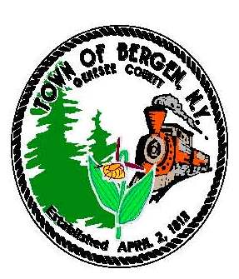
Supervisor Town Clerk/Tax Collector
Ernest Haywood Michele M. Smith
Donald Cunningham, Deputy Supervisor
Councilmen Justices
James Starowitz Joseph nenni
Mark Anderson Robert Swapceinski

Councilwomen zoning & code enforcement officer
Belinda Grant David Mason
Anne Sapienza

Superintendent of highways Assessor
mike Johnson Rhonda Saulsbury

January 25, 2020

Update on Water Benefit Improvement Area #1

A water district status meeting was held on January 23 with all of our consultants. We followed up with an update to the Town Board at a special meeting January 25.

Our Town Attorney believes that Comptroller approval of the water district formation is imminent.

The Town Engineer has completed the base mapping for the entire project and is reviewing underground utility maps. The project is going to be broken down into two projects for public bidding. The two contracts will be bid one to two weeks apart. We anticipate the bidding to occur in the fall and construction on both project to start in January. Although the exact division of the project is not final, the basic two parts will be: everything north of the old railroad tracks (North Shore) and Pocock and Swamp Roads; and everything else south of the old railroad tracks.

At this point, we are on track to issue a $2,000,000 Bond Anticipation Note in May. The tax bills that go out in January 2021 will have the first water district charges. For everyone who has their property taxes escrowed with their mortgage, it will be important to let your bank know that there will be an additional tax starting with your town and county tax bill in January 2021.

Look for another update here as soon as we have Comptroller approval.

Ernie Haywood
Supervisor

