TOWN OF BERGEN
* Established April 2, 1813 *

Phone: (585) 494-1121 * Fax: (585) 494-1372 * NYS TDD 1-800-662-1220

P.O. Box 249
10 Hunter Street
Bergen, NY 14416
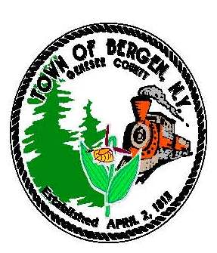

Supervisor Town Clerk/Tax Collector
Ernest Haywood Michele M. Smith

Councilmen Justices
James Starowitz Joseph nenni
Mark Anderson Robert Swapceinski

Councilwomen zoning & code enforcement officer
Belinda Grant, Deputy Supervisor David Mason
Anne Sapienza

Superintendent of highways Assessor
mike Johnson Rhonda Saulsbury

As a reminder...

The Town of Bergen offers the following partial real property tax exemptions:

- Basic Star (homes purchased before 3/1/2015)

- Enhanced Star (homes purchased before 3/1/2015)

- Senior/Aged Exemption (owner 65 or older income<24,900)

- Star Credit (homes purchased after 3/1/2015 must call the State @ 518-457-2036 to sign up)

- Veteran

- Cold War Veteran

- Combat Veteran

- Veteran Disability

- Disability/Low Income (non-Veteran, any age with disability award letter, income<24,900)

- Clergy

- 485b Commercial/Industrial Improvement

- 421f Residential Capital Improvement

- Agricultural Land

- Agricultural Building

All the above must be applied for by March 1st any given year, except the Star Credit (July1st).

Please contact the Assessor (585-343-1729 x207) for the applications & instructions or for more information.

