TOWN OF BERGEN
* Established April 2, 1813 *

Phone: (585) 494-1121 * Fax: (585) 494-1372 * NYS TDD 1-800-662-1220

P.O. Box 249
10 Hunter Street
Bergen, NY 14416
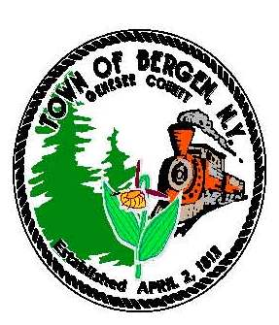

Supervisor Town Clerk/Tax Collector
Ernest Haywood Michele M. Smith

Councilmen Justices
James Starowitz Joseph nenni
Mark Anderson Robert Swapceinski

Councilwomen zoning & code enforcement officer
Belinda Grant, Deputy Supervisor Gerald Wood
Anne Sapienza

Superintendent of highways Assessor
mike Johnson Rhonda Saulsbury

The Bergen Town board is holding a special meeting for Water Improvement Benefit Area #1 on Tuesday, August 17, 2021 at 6:00 pm at 10 Hunter st., Bergen, NY 14416.

Michele M Smith,
Bergen Town Clerk

