TOWN OF BERGEN
* Established April 2, 1813 *

Phone: (585) 494-1121 * Fax: (585) 494-1372 * NYS TDD 1-800-662-1220

P.O. Box 249
10 Hunter Street
Bergen, NY 14416
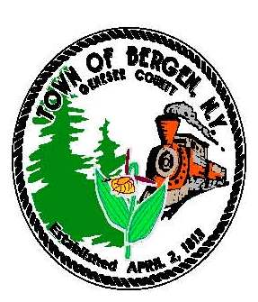

Supervisor Town Clerk/Tax Collector
Ernest Haywood Michele M. Smith

Councilmen Justices
James Starowitz Joseph nenni
Mark Anderson Robert Swapceinski

Councilwomen zoning & code enforcement officer
Belinda Grant, Deputy Supervisor Gerald Wood
Teresa Whalin

Superintendent of highways Assessor
mike Johnson Rhonda Saulsbury

Construction set to begin on water line

On February 22, the pre-construction meeting for Bergen’s new water district was held. Construction will begin on March 14. There are now action items that residents of the district must undertake:

- If you want to tie into the public water line, you must sign up with the Monroe County Water Authority. The MCWA will mail you a packet in the near future. Please read it carefully. You will have to sign documents provided by the MCWA and make a payment to them.

- We are holding water sign up meetings to facilitate the process. Because this water district is so large, the Water Authority has divided property owners into five groups based on the contractor’s tentative schedule. Please try to make this date a priority as we have scheduled residents to match with the construction schedule. The sign-up schedule is on the Town website (www.bergenny.org) and Facebook page.

This water district formation has been an exciting, yet long and challenging process. We thank you in advance for your continued patience and cooperation as we move into the construction phase of the project. If you have any questions, please call/email me at 494-1121 x22, supervisor@bergenny.org or Engineer Scott Mattison at 381-9250, scott.mattison@mrbgroup.com.

