Bergen breaks ground on $10.5 million water project
Construction on the Town of Bergen’s long-awaited public water line project kicked off at a groundbreaking ceremony March 11, 2022 at Robbins Brook Park. Three million dollars’ worth of pipe has been delivered to various sites along the project’s path. Nearly five years in the development, the new water line will provide access to public water to more than 500 properties in the Town.
The two contractors, Fineline Pipe and Morsch Piping, have begun laying pipe and are scheduled to be finished by the end of 2022. Sign-up sessions, conducted by the Monroe County Water Authority, are underway. The project is made possible by a $3.6 million grant and $6.9 million low-interest loan from USDA Rural Development.
“It has taken five years of hard work and patience to get to this point,” said Supervisor Ernie Haywood. “We are grateful to all who have helped us overcome several obstacles including a federal government shutdown, a pandemic and material cost increases. By the end of the year we will have achieved our ultimate goal of supplying public water to every Bergen property owner who wants it.”

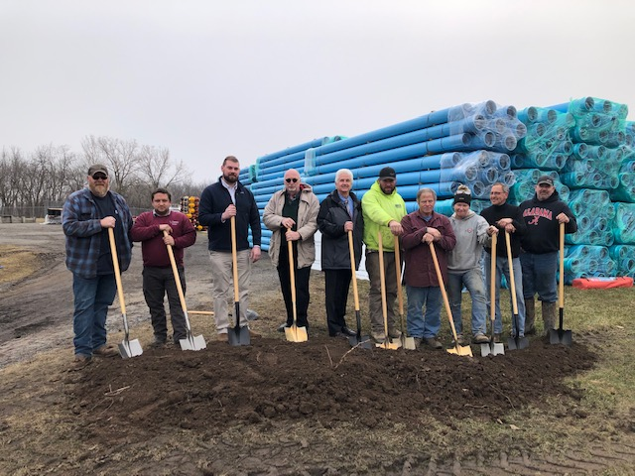

From left to right are Deputy Highway Superintendent Joel Pocock, Councilman Jimmy Starowitz, Engineer Scott Mattison, Supervisor Ernie Haywood, Engineer Paul Chatfield and the owners and crew members from Fineline Pipe and Morsch Piping.

