TOWN OF BERGEN
* Established April 2, 1813 *

Phone: (585) 494-1121 * Fax: (585) 494-1372 * NYS TDD 1-800-662-1220

P.O. Box 249
10 Hunter Street
Bergen, NY 14416
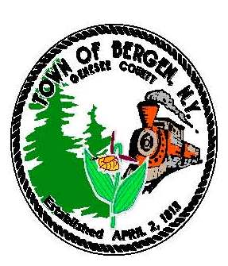

Supervisor Town Clerk/Tax Collector
Ernest Haywood Michele M. Smith

Councilmen Justices
James Starowitz Joseph nenni
Mark Anderson Robert Swapceinski

Councilwomen zoning & code enforcement officer
Belinda Grant, Deputy Supervisor Gerald Wood
Teresa Whalin

Superintendent of highways Assessor
mike Johnson Rhonda Saulsbury

TOWN OF BERGEN - PROPOSED ROBINS BROOK PARK IMPROVEMENTS- April, 2022
Description of the proposed improvements at the Robin’s Brook Park.
The Town of Bergen proposes to install 2 bocce courts (12' X 60' each) along with benches, lighting, trash receptacles, and a bike rack, and at Robbins Brook Park. In addition, the Town proposes to construct a restroom facility (24' X32') with picnic tables and sidewalk adjacent to the bocce court and current parking lot. The site of the proposed work is at the entrance to the bocce court and parking lot area. Public water is available for the restrooms and the area is highly visible for safety and convenience.
The town of Bergen owns the 28-acre parcel of land where the Robins Brook Park is located. It was originally constructed in the late 1980s when the landfill on the property was officially closed. From the late 1980 until this past year a portion of the property was used as a transfer station. The transfer station was officially closed in 2021. The area formally used as the transfer station is where the town is proposing to construct the restrooms and bocce courts. The Town has completed some improvements over the years, including installation of ball fields and a pavilion. The Park is currently used by hundreds of youths through youth recreation programs operated by the Gilliam-Grant Community Center.
Currently the park, has no amenities for senior citizens and no public restrooms. The pandemic has revealed the need for more outdoor activity space and activities close to home and the Town needs to provide sanitary public bathrooms with washing stations. The installation of bocce courts and public accessible restrooms is consistent with the recommendations in the Town’s Master Plan for the park.
In 2018 the town, with input from the residents completed a Park Master Plan. The recommendations included “Provide and maintain sufficient parks and recreational facilities that meet the needs of all age groups for active and passive recreation.”
The town of Bergen is applying for Community Project Funding through US Congressman Christopher Jacobs, for funding to construct accessible restrooms and bocce courts at the Robins Brook Park.
Project Costs:
Total Costs: $927,220.00
Amount requested from Community Project Funding: $695,415.00
Amount being provided by the Town of Bergen: $231,805.00

Details of Costs:
Soft Costs: Design, permitting and planning $ 95,770.00
Construction $618,500.00
Site Work $104,500.00
Total $927,220.00
Timeline for Completion:
Begin Project: Spring/Summer of 2023
Complete Project: Late Fall 2023
If you have any questions, please contact Ernest Haywood, Bergen town supervisor at supervisor@bergenny.org

