TOWN OF BERGEN
* Established April 2, 1813 *

Phone: (585) 494-1121 * Fax: (585) 494-1372 * NYS TDD 1-800-662-1220

P.O. Box 249
10 Hunter Street
Bergen, NY 14416
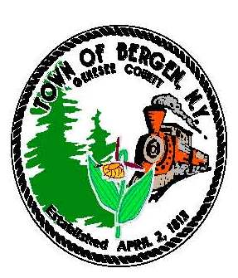

Supervisor Town Clerk/Tax Collector
Ernest Haywood Michele M. Smith

Councilmen Justices
James Starowitz Joseph nenni
Mark Anderson Robert Swapceinski

Councilwomen zoning & code enforcement officer
Belinda Grant, Deputy Supervisor Gerald Wood
Teresa Robinson

Superintendent of highways Assessor
mike Johnson Rhonda Saulsbury

NOTICE OF PUBLIC HEARING TO CONSIDER FIRE PROTECTION CONTRACT

NOTICE IS HEREBY GIVEN that a Public Hearing will be held by the Town Board of the Town of Bergen, acting as the Board of Fire Commissioners of the Bergen Fire District, Genesee County, New York on Tuesday, November 14, 2023 at 7:15 PM at the Town Hall, 10 Hunter St., Bergen, New York for the purpose of considering a contract with the Bergen Fire Department for fire protection.
- The proposed contract for one (1) year shall provide that the Fire Department
shall answer and attend upon all calls in the district.
- The contract shall continue for a period of one year.
All persons interested in the matter will be heard at such time and place.
By Order of the Town Board
Dated: October 10, 2023

Michele M. Smith
Town Clerk

