TOWN OF BERGEN
* Established April 2, 1813 *

Phone: (585) 494-1121 * Fax: (585) 494-1372 * NYS TDD 1-800-662-1220

P.O. Box 249
10 Hunter Street
Bergen, NY 14416
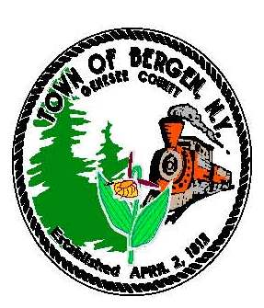

Supervisor Town Clerk/Tax Collector
Ernest Haywood Michele M. Smith

Councilmen Justices
James Starowitz Joseph nenni
Mark Anderson Robert Swapceinski

Councilwomen zoning & code enforcement officer
Belinda Grant, Deputy Supervisor Gerald Wood
Anne Sapienza

Superintendent of highways Assessor
mike Johnson Rhonda Saulsbury

NOTICE OF PUBLIC HEARING ON LOCAL LAW #1-2023

PUBLIC NOTICE is hereby given that there has been presented to the Town Board of the Town of Bergen, Genesee County, New York, on October 10, 2023, Local Law No.1 of 2023, entitled "A Local Law To Override The Tax Levy Limit Established In General Municipal Law §3-c For The Fiscal Year 2024."

Said Local Law is intended to override the limit on the amount of real property taxes that may be levied in excess of the tax levy limit as defined by General Municipal Law §3-c.

A copy of the proposed Local Law is on file with the Town Clerk.

THEREFORE, the Town Board of the Town of Bergen will hold a public hearing on the Local Law at the Bergen Town Hall Courtroom, 10 Hunter Street, Bergen, New York on Tuesday, the 14th day of November, 2023 at 7:00pm. at which time all persons interested will be heard.

By Order of the Town Board
Michele M. Smith, Town Clerk

