TOWN OF BERGEN
* Established April 2, 1813 *

Phone: (585) 494-1121 * Fax: (585) 494-1372 * NYS TDD 1-800-662-1220

P.O. Box 249
10 Hunter Street
Bergen, NY 14416
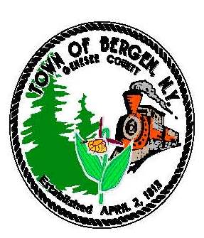

Supervisor Town Clerk/Tax Collector
Ernest Haywood Michele M. Smith

Councilmen Justices
James Starowitz Joseph nenni
Mark Anderson Robert Swapceinski

Councilwomen zoning & code enforcement officer
Belinda Grant, Deputy Supervisor Gerald Wood
Teresa Whalin

Superintendent of highways Assessor
mike Johnson Rhonda Saulsbury

WATER DISTRICT UPDATE January 10, 2022

To: Residents and Property Owners of the
Town of Bergen Water Improvement Benefit Area No. 1

Re: Water Main Installation

The Town of Bergen opened bids for Water Improvement Benefit Area No. 1 in late April and early May of 2021. Due to rapidly increasing material prices from the Covid 19 pandemic the bids received were over the original project budget. Because of this the Town of Bergen requested and was awarded additional funding for the project from USDA Rural Development. The increase in project budget forced the Town to go back to the NYS Comptroller for approval which as of December 2021 was received.

The Town of Bergen has awarded the Water Main Installation Contracts for Water Improvement Benefit Area No. 1 to Morsch Pipeline (Contract A) and Fineline Pipeline (Contract B).

Construction is expected to start around mid-March 2022, weather depending, with the Contractors anticipating being completed by mid-2023. All residents should clearly mark any underground piping, wires and conduits on their property, so that the Contractors can avoid damaging them.

The Monroe County Water Authority (MCWA) will be hosting sign up sessions for residents interested in hooking up to the water main. A mailer containing information regarding this sign-up session will be sent separately by the MCWA. It is anticipated these sessions will begin around March 2022.

The MCWA will have a cut-off date for residents to sign up with them for water service. If you sign up prior to the cut-off date the costs from the MCWA would include a $240 service connection fee to set up your account and cover the cost of the water meter and a $250 well deposit which would be refunded upon abandonment or separation of your existing water supply.

Residents will be responsible for installation of their private portion of the water service from the roadway right-of-way to the house. It may be financially beneficial for residents in the same general area to hire one private contractor to complete multiple service installations at the same time.

Full time construction inspection will be provided by the MRB Group with a Project Representative in the field available to answer any question or address any issues during construction.

If you have any questions or comments with regard to the water project, please contact:

Scott D. Mattison, P.E. of the MRB Group at (585) 381-9250 (office) or by email at Scott.Mattison@mrbgroup.com

Sincerely,

Ernie Haywood, Supervisor
Town of Bergen

