TOWN OF BERGEN
* Established April 2, 1813 *

Phone: (585) 494-1121 * Fax: (585) 494-1372 * NYS TDD 1-800-662-1220

P.O. Box 249
10 Hunter Street
Bergen, NY 14416
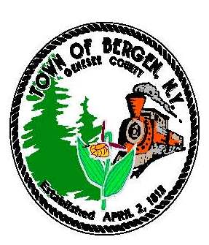

Supervisor Town Clerk/Tax Collector
Ernest Haywood Michele M. Smith

Councilmen Justices
James Starowitz Joseph nenni
Mark Anderson Robert Swapceinski

Councilwomen zoning & code enforcement officer
Belinda Grant, Deputy Supervisor Gerald Wood
Teresa Robinson

Superintendent of highways Assessor
mike Johnson Rhonda Saulsbury

PRESS RELEASE

Final Bergen water sign-up sessions scheduled

Bergen residents who wish to access the new public water line must sign up with the Monroe County Water Authority. The final two sign-up sessions are schedule for:

Tuesday, May 24 between 3 pm and 7 pm
Tuesday, June 14 between 3 pm and 7 pm
at the Bergen Town Hall
10 Hunter Street, Bergen

Residents of Evans Road, North Lake Road, Peachey Road, Clinton Street Road and Buffalo Road will receive packets of information towards the end of May for the June 14 session. All other property owners should have already received a packet from the Water Authority. At the sign-up sessions residents will return signed forms, make connection fee payments to the Water Authority, choose the location of individual services with the town engineer and receive a stake for marking the service site.

Questions may be directed to Supervisor Ernie Haywood at 494-1121, supervisor@bergenny.org; Engineer Scott Mattison at 381-9250, scott.mattison@mrbgroup.com; or Water Authority Representative Virginia Smith at virginia.smith@mcwa.com, 442-2001 x 229.

